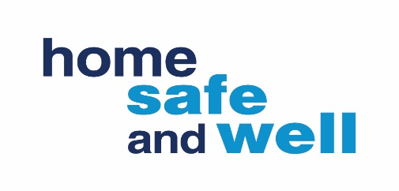
Earlier this year we launched Home Safe and Well and had a great response. One of the Corporate Actions in the approach was;
Supply Chain Engagement and Raising Industry Standards
Set up a senior supply chain steering group, aimed at raising industry standards, through working groups, focused on highest risk.
Enable sharing of good practice, areas for improvement and innovations to raise industry standards.

This activity is looking at how we can improve the way we engage with our stakeholders and raise industry standards across the Highways sector.
During March 2019 the Supply Chain Safety Leadership Group (SCSLG) was established. This group aims to focus on improving safety performance across the Highways England road network through collaborative working with our supply chain where common risks exist. The vision of the group is to create a clear shift in safety performance to stop lives being lost or permanently damaged.
Following a review of current safety work across the supply chain feedback suggests that;
- There is a large number of forums
- Some groups lack strategic direction
- Members don’t know what the priorities are
- Safety and operational meetings could work smarter together
- Frustration that things aren’t moving at pace
- Progress has been made in many groups
- Several forums that HE drives forward look at the risks owned by Principal Contractors
After considering the feedback and the new Home Safe and Well Approach, we are looking to combine the efforts of several Highways England Supply Chain Safety Forums and Meetings focusing on the way in which safety is addressed in the supply chain. To achieve this, we will be using a more focused structure to improve the way we work together in the form of Task & Finish Groups.
How can you help?

To help us achieve our goal we need to hear from you if you are currently a part of, or manage a forum/group that is having conversations or working on safety issues. We need the chairs of these to complete this proforma and send to supplysafetyforums@highwaysengland.co.uk in order that we can start to work smarter together.
As we are unable to do everything at once, Task and Finish Groups will initially focus on high risk areas (listed below) with specific deliverables and within a short timescale.
If you have any ideas, thoughts or want to step forward and feel you can add value to one of the groups, please discuss and agree with your line manager and send an expression of interest to supplysafetyforums@highwaysengland.co.uk

- Improving investigations
- Service Strikes
- 60mph through roadworks
- Highways England passport scheme
- IPV strikes and incursions
- Mental Health
- Plant, people interface
- Excavations and temporary works

Email us any other questions or feedback at supplysafetyforums@highwaysengland.co.uk
Or review our Frequently asked Questions

