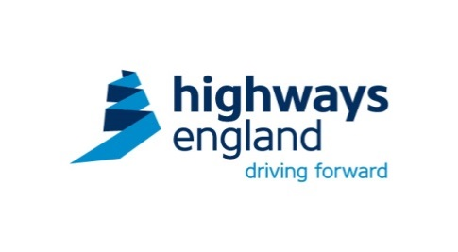

**Occupational Health and Wellbeing**

**Campaign Guide**

This campaign has been developed by the delivery hub to assist your company comply with the latest information and industry best practices. There will be posters, briefing sheets, portal articles, powerpoint presentations and news letters to assist in the promotion of Occupational Health and Wellbeing.

The campaign will run over three months, starting in August with Blood Pressure Awareness, this will be followed in September with Personal Wellbeing. The campaign will conclude in October with Noise and Dust as part of European Health and Safety Week.

**Month 1 - Healthy Heart & Blood Pressure - August 2015 Campaign**

The links below provide access to campaign materials, the size of the contract and preferences on self-delivery or outsourcing will influence the level of resource required. Campaign options are provided below ranging from free leaflets for smaller contracts to British Heart Foundation (BHF) run health and wellbeing days for the larger contracts.

1. Access and Download British Heart Foundation information leaflets. <https://www.bhf.org.uk/publications>
2. Use video clips to <https://www.youtube.com/watch?v=CrDSVpUUbwA&feature=youtu.be> to help reinforce CPR basics during toolbox talks.
3. Make the campaign interactive - ensure the contract has a blood pressure monitor for self-checks. Upper arm style recommended rather than wrist.

Blood pressure monitors can be sourced from most High Street health retailers. For example Boots or Superdrug etc.

Note – these will give an indication of blood pressure, before making any lifestyle changes individuals should consult their GP. Read ‘How to measure BP’ available within the supporting documents.

Pedometers can then continue to be used the following month for the wellbeing campaign.

1. Contact British Heart Foundation for attendance at site, they have two main options:
   1. Heart Health Workshops

* Heart Health Workshops are ideal for workplaces looking for a short presentation (45-60 minutes), for between 30 and 40 employees.
* A BHF experts will come to your workplace and deliver a presentation on heart health and the risk factors for heart disease, followed by interactive activities such as discussions, quizzes and games using 'food cards' and alcohol measures.

These workshops are priced at £300. For more information and to register your interest please visit <https://www.bhf.org.uk/health-at-work/events/heart-health-workshops>

* 1. Health and Wellbeing Days
* A Health and Wellbeing Day is an opportunity to engage your workforce and to show them how important health and wellbeing is within your organisation.
* A team of BHF experts, including a Dietician and a physical activity expert, will attend site to deliver fun and interactive sessions, raising awareness of various health issues and promoting a healthier lifestyle.
* The day focuses on four key areas: physical activity, healthy eating, mental wellbeing, and changing habits in relation to alcohol and smoking.

These days are priced from £1800 – £2900 depending how many staff you want to involve. If you are interested in booking a Health and Wellbeing Day or would like more information please visit

<https://www.bhf.org.uk/health-at-work/events/health-and-wellbeing-days>

**Month 2 – Personal Wellbeing – September 2015 Campaign.**

In order to raise the profile of the personal wellbeing campaign each contract is to run a campaign on one or more wellbeing topics. Suggested topics are given below along with contacts to purchase or hire items to increase the impact of the campaign.

1. 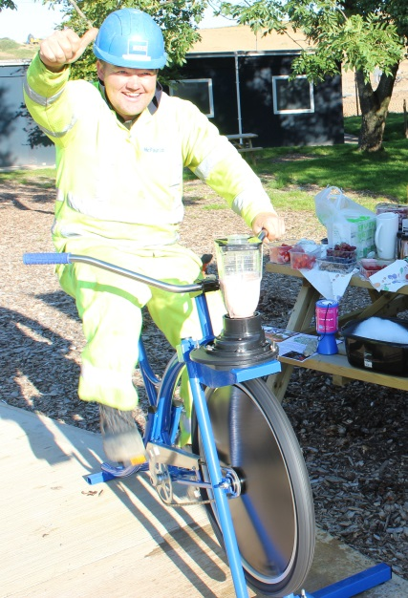**Healthy Eating – Smoothie Bike**

There are a variety of suppliers of smoothie bikes who can help to engage the workforce in discussions on healthy eating and provide smoothies to achieve 5 a day.

Possible Suppliers:

Love Smoothie Bike. Price dependent upon package.

<http://www.lovesmoothiebike.co.uk/smoothie-bike-hire-packages/>

The Smoothie Bike Company. From £325 + VAT for 200 smoothies.

<http://www.thesmoothiebikecompany.co.uk/health-well-being-events>

Smoothie Bike Hire. From £329 (no VAT) for 200 7oz smoothies.

<http://www.smoothiebikehire.co.uk/howtobook.html>

Type ‘smoothie bike’ into an internet search engine for additional suppliers.

1. **Pedometers**

There are a variety of suppliers of pedometers to encourage people to get walking – set a competition between teams and see how far you can walk. Costs will vary dependent upon order size and artwork, however should be c. £4.35 per unit for small orders (250) to £3.46 per unit for large orders (2500).

Challenge Packs can also be obtained for BHF in return for a donation.

<https://www.bhf.org.uk/publications/health-at-work/health-at-work-pedometer-challenge-pack>

1. 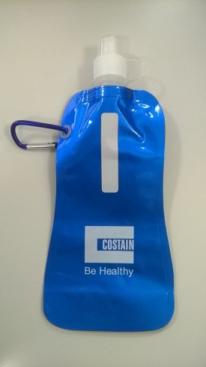**Hydration**

Type ‘Roll up Water Bottle’ into an internet search engine and there are a variety of suppliers who can provide roll up water bottles. Costs will vary on order size and artwork however should be c.£1.70 per unit for small orders (<50) reducing to under £1.00 for large orders (1000+).

These have proved popular on sites where this has trialled with the workforce freezing the bottles at home overnight so they defrost through the day providing cool water.

Posters are available within the resource microsite.

1. **Giving Up Smoking**

There are a variety of tools available

<http://www.nhs.uk/Tools/Pages/iphonesmoking.aspx>

1. **Mental Health Awareness**

Pressure and fatigue can result in stress but it is important to recognise that everyone is different and the same external forces may result in a different outcome for different people.

As a starting point the campaign can raise awareness and get people talking openly about mental health and where they can source help and assistance. A free line manager’s pack is available at <http://mhfaengland.org/files/5613/9101/5215/MHFA_Line_Managers_Resource.pdf>

Employee Assistance Programmes (EAP) can offer counselling and advice for particular cases, each delivery partner would need to provide information on the service available by their EAP service provider who will tailor advice and support to each individual case.

To progress the campaign further, mental health training is available. This will help personnel to recognise signs and symptoms so that proactive measures can be taken.

Mental Health First Aid offer a two-day course at c. £300pp. This may be discounted through local TUC or NHS Trusts.

<http://mhfaengland.org/first-aid-courses/first-aid-standard/>

1. **Skin Cancer Awareness**

Skin Cancer Awareness posters are available in a variety of languages on the MacMillian website <http://be.macmillan.org.uk/be/s-674-cancer-type-s.aspx>. You will need to create an account on the website but this is free to do.

Further free guidance is available to download from Cancer Research.

<http://www.cancerresearchuk.org/about-cancer/type/skin-cancer/>. Each section has a summary document that can be used as a toolbox talk.

**Month 3 – Noise and Dust – October 2015 Campaign.**

1. **Noise**

Supervisors are often unsure if ambient noise levels are above or below the action level. The Oi Noise meter enable a quick check, once activated if it cannot be heard, then hearing protection is required. <http://www.oi-noise.org/>

Video clips can be used to raise awareness and make toolbox talks interactive, one example is <https://www.youtube.com/watch?v=g_NbqGVWsqI>

1. **Buy Quiet**

The buy quiet helps manufacturers, importers, suppliers and users of equipment to work together to reduce the risk of noise-induced hearing loss in the workplace. It supports users in their duty to avoid high noise equipment when suitable lower noise equipment is available and manufacturers in their duty to minimise noise by technical means. <http://www.hse.gov.uk/noise/buy-quiet/index.htm>

During the campaign review equipment on site to look at alternatives that have lower noise emissions ensuring a holistic view is taken (balancing emissions, vibration levels, dust extraction etc).

1. **Dust – Ban the Brush Week**

Choose a week to work without brushes, see what alternatives there are and alternative method, for example vacuuming (industrial not henry hoover), on tool extraction to prevent the dust needing to be swept up.

At the end of the week see what is practical to become a permanent way of working.

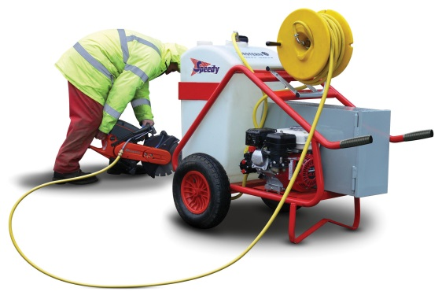

1. **Silica**

Silica is a natural mineral found in rocks, sand and clay. It is contained in many products used in construction such as bricks, concrete, mortar and sandstone. When cutting, drilling & grinding materials which contain silica, it is broken down into very fine dust that travels into the deepest part of the lungs where they can build up in the air spaces in the lungs and lead to lung damage.

Use the toolbox talks available on the microsite to raise awareness.

Further guidance is available at <http://www.hse.gov.uk/pubns/indg463.htm>

1. **Respiratory Protective Equipment**

The legal requirement for face fit testing of masks that require a seal to the face has been widely publicised over the past five years. The reasons for face fit testing each model of mask and the need to remain clean shaven has to be regularly reinforced.

HSE guidance can be accessed at <http://www.hseni.gov.uk/fit-testing-2.pdf>

Testing kits are widely available from most PPE suppliers; one example can be seen at <http://www.arco.co.uk/products/1E1100>

**Review of Campaigns**

Please send feedback on any of the delivery hub campaigns to [DeliveryHubInbox@highwaysengland.co.uk](mailto:DeliveryHubInbox@highwaysengland.co.uk)

Examples of your campaigns in action, any good news stories or suggestions for future improvements are welcome.