(INSERT NAME)
(INSERT ROLE)
National Highways
(INSERT ADDRESS LINE 1)
(INSERT ADDRESS LINE 2)
(INSERT ADDRESS LINE 3)
(INSERT POSTCODE)

(INSERT DATE)

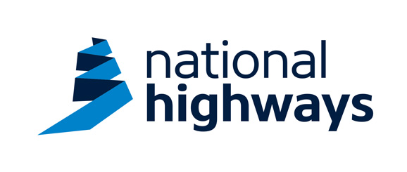

Dear Sir/Madam

NOTIFICATION OF CDM CLIENT

This letter follows the meeting/discussion on (INSERT DATE) between National Highways and (INSERT SU NAME) confirming National Highways’ understanding regarding the Client duties detailed in Regulation 4 of CDM 2015. In accordance with Regulation 4(8) of CDM 2015 it has been proposed that:

- (INSERT SU NAME) will act and be treated as the sole Client under the CDM 2015 for the (INSERT SU NAME) diversionary works.

- National Highways will cooperate with (INSERT SU NAME) and provide pre-construction information and any additional information in a comprehensible format as soon as practicable.

If (INSERT SU NAME) is agreeable to the above proposal I would be grateful to receive confirmation in writing by email (to INSERT CONTACT EMAIL), in accordance with Regulation 4(8)(a).

If you have any queries concerning the above, then please do not hesitate to contact me.

Yours Faithfully

(INSERT SIGNATURE)

(INSERT NAME)
(INSERT ROLE)
National Highways

