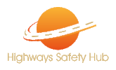
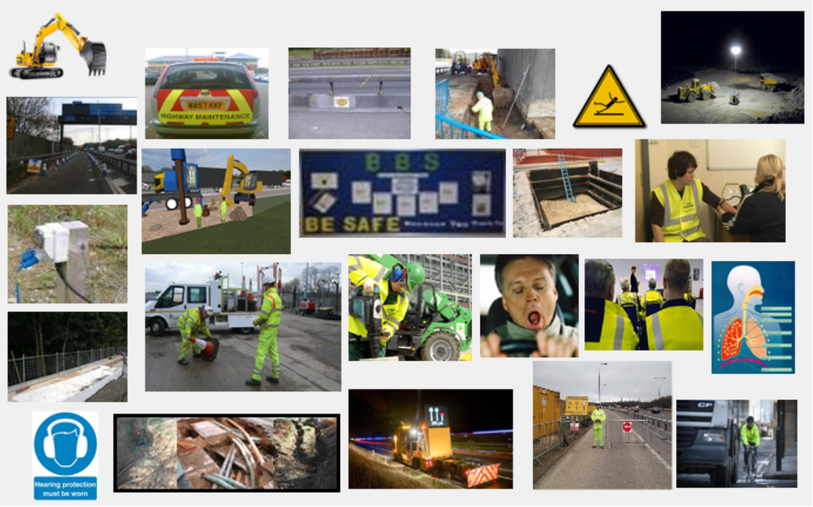

Highways Safety Hub Team Newsletter

October 2021
What BAM Did For World Suicide Awareness Day 10/09/2021
A powerful new video “On The Edge” that aims to raise awareness around the issue of suicide among construction workers, produced with the support of BAM Construct UK, has been released.
The video, which is just over five minutes in length, urges construction workers not to ignore colleagues who they think may be experiencing mental ill-health, but to talk to them and listen.
CTRL click on the link to play the video https://vimeo.com/597358738
The film, made by AKT Productions and Ambanja Films, was prompted by figures showing that the risk of suicide among low-skilled male labourers, particularly those working in construction, is three times higher than the male national average. It was filmed with the help of BAM Construct UK, which allowed one of its sites to be used for shooting and is now available via the link for the wider construction industry to share as a catalyst for conversations about mental health.
Marc Bolton, managing director of AKT Productions said: “AKT Productions Ltd, BAM Construct UK and Ambanja Films very much hope that over the months and years to come, On the Edge will stimulate discussions, offer hope and ultimately change some minds.”

Message from National Highways

We continue to see the use of vacuum excavation across the business which is great as it offers so many benefits, however it has been brought to my attention that we are noticing units being operated by a sole operative.
Unfortunately, the corporate memory of our industry is sometimes short and the past learning from incidents / lesson learnt including the fatality of the vacuum excavator operator on M3 back in 2016 forgotten.
Following that event and subsequent prosecution the industry updated its guidance on the use of such equipment recommending that these are operated by two persons who are deemed to be competent to undertake as outlined below.
http://www.highwayssafetyhub.com/uploads/5/1/2/9/51294565/he158_-_m3_fatality_update.pdf
Could we ask you to review your operation site of such plant, thank you.
New Welfare Vehicle for Warwickshire Police

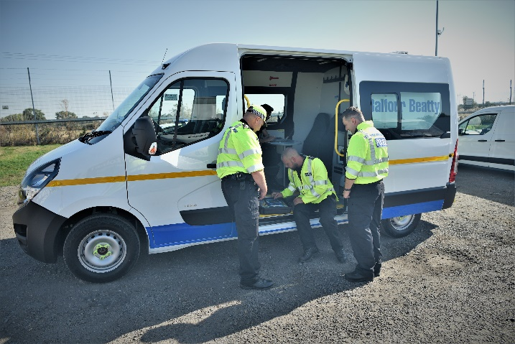
Recently Balfour Beatty delivered a brand new Welfare van to Warwickshire Police Force's commercial vehicle team.
The vehicle will be used to provide a mobile base for Warwickshire Police & National Highways teams when carrying out vehicle road-worthiness checks across the strategic road network.
Alex Clark & John Oakey from the BB Transport Compliance team handed over the vehicle at the A5 Truck stop at Rugby where the Police & National Highways were conducting a combined operation with the DVSA & Border Force.
This further demonstrates BB Highways and Plant & Fleet's commitment to road safety.
Warwickshire Police kindly shared the statement below:
Warwickshire Police’s Commercial Vehicle Unit is privileged to accept the loan of a new Vauxhall Movarno welfare van from Balfour Beatty to support road safety operations.
Due to the size of some of the equipment used by the Commercial Vehicle Unit such as mobile weigh pads, it often takes numerous vehicles to transport the equipment to stop check sites in order for the team to operate. With this new vehicle we will be able to carry all of the equipment in one go, reducing our carbon footprint and making us more efficient. Not only will the van provide a suitable location for officers to process documentation but we can also now keep our electronic equipment in a dry place away from the typical British weather. The van will also help us to be more mobile to target specific issues throughout the county as they arise.
We would like to thank National Highways and Balfour Beatty for their continued support and innovative projects that all contribute towards reducing the number of people killed and seriously injured on our roads and making the roads safer for everyone.

National Highways Launch Sunflower Campaign

The Hidden Disabilities Sunflower for your vehicle discreetly indicates that you may need additional support if you break down or need assistance on a motorway or major A-road in England.
We want you to feel confident that you’ll have the help you need if you get into trouble on our roads. Displaying the Sunflower on your vehicle tells us that you have a non-visible disability, and that you may need help with:
- understanding instructions and communicating your needs
- staying calm at a time of stress
- getting to a place of safety
- moving and recovering an adapted vehicle

Who can use the Sunflower?
Anyone with an impairment, hidden or visible, who may need additional support if they break down or need assistance on a motorway or major A-road can display the Sunflower on their vehicle.

How will the Sunflower help me?
The Sunflower will indicate to roadside and emergency services that you or someone in your vehicle has an impairment which may not be visible.
National Highways traffic officers are often first on scene in an emergency on motorways and major A-roads. If a traffic officer sees the Sunflower on your vehicle, they’ll ask you about what support you need to help keep you safe.
Traffic officers will always:
- ask how they can help
- listen closely to what you tell them
- be kind and patient
- not judge, and treat you with respect
For more information : Hidden Disabilities Sunflower for your vehicle - Highways England

Solar Gates UK Listed for Highways Awards

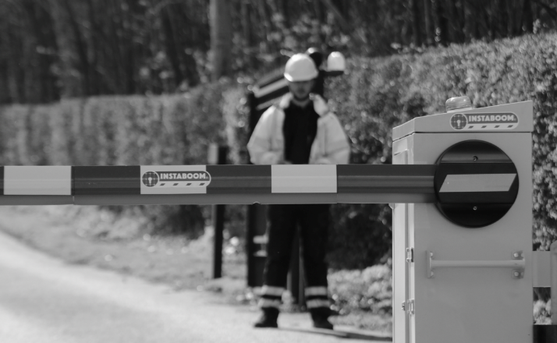
Solar Gates UK are ever committed to improving safety of the highways, we are constantly innovating with key partners to make sure safety is consistently improved upon year on year.
Our nomination for ‘Highway’s Industry Product Of The Year’ is with partners Balfour Beatty and their maintenance teams, managed by Connect Plus Services. They had a daily problem that they needed help with. Protection - to the correct standard - of low hanging high voltage power cables and overhead structures. With every second accounted for Connect Plus needed to see a radical improvement of the GS6 standard pole and tape set up, which they saw as deficient in its ability to actually prevent strikes, as well as a radical improvement in the time taken to deploy such a set up.
Solar Gates UK developed INSTABOOM Lite and Wireless GS6 to meet the problem head-on. Both products are light enough for a two-person deployment, without a tail-lift, and can be set up in minutes. Both units are fully solar powered, the GS6 detector uses a laser scanner to detect any over-height vehicle and signals an automatic lane closure using the INSTABOOM Lite barrier, up to 60m in front of the detection. An audible siren and beacon warn the workforce and instant email alerts are sent to inform the management team. There have been no incidents with over-height vehicles in the works since the barriers have been installed.
We gained the nomination for ‘Site Safety Initiative Award’ with Kier Highways and our development of a brand new safety exit system for the A585 RDP team at Windy Harbour. Kier Highway’s had a problem that posed a major safety risk to road users at various works access points of the 6km project. With low hanging power and telecoms cables spanning several exits and all access points pulling onto busy trunk roads, there were risks that site vehicles could leave compounds in an unsafe or unsecure condition. After cable strikes on another projects, Kier needed to see a radical improvement of the safety and protection over the standard GS6 arrangement, which they saw as deficient in its ability to actually prevent strikes.
Within just four weeks, the SOSEC team deployed a twin solar powered barrier with touch screen panel to control the traffic in and out of the compound. The exit panel requires the driver exiting the compound to stop and answer 4 simple questions about his vehicles’ fitness to proceed, before the barrier will open.

The simple action of requiring the driver to leave his vehicle, creates the time and space for them to ensure a final visual check of their load before pulling onto the network. An over-height detection laser confirms at least one of their answers and the remaining onus of safety is placed into the hands of the driver. There have been no incidents with vehicles exiting unsafely since the barriers have been installed.
Managing Director of Solar Gates UK, Neil Sampson says ‘I am immensely proud of what we at Solar Gates UK are able to achieve with our partners Balfour Beatty, Connect Plus Services and Kier Highways. At Solar Gates UK we have a united passion for protection and safety of the highways and its very valuable workers and users. I am incredibly proud to be shortlisted for not 1 but 2 prominent Highways awards it means a great deal for us to be stood side by side with some of the biggest organisations in the highways industry and developing new products alongside them.’
Source: Safer Highways
Government Takes Legal Action Against M25 Climate Protestors

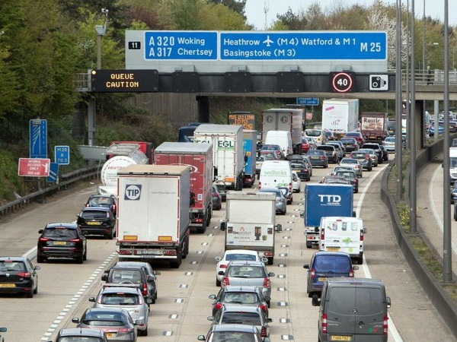
National Highways wins interim injunction to prevent protesters from occupying the M25. Those who breach the injunction will be in contempt of court and at risk of imprisonment and an unlimited fine. Ministers condemn activists for undermining their own cause and endangering lives
Activists who have been carrying out a string of disruptive demonstrations along the M25, causing travel chaos for tens of thousands of people, will be in contempt of court if they breach the terms of an interim injunction won by National Highways today (22 September 2021).
Breach of the injunction can be punishable by up to 2 years in prison and an unlimited fine, serving as a deterrent for anyone thinking of rejoining the disruptive action.
National Highways intends to return to court to extend the injunction and potentially seek additional powers of arrest.
The government’s intervention will help dissuade activists from carrying out any further disruption.

Transport Secretary Grant Shapps said:
We will not let these demonstrators wreak havoc on our roads, disrupt thousands of people’s journeys and put lives in danger. Not only are they creating more traffic and pollution, they are alienating the public from their own cause.
Today, we’re taking action, bringing in further measures to stop those taking part in these self-defeating protests, while we continue the work we’re already carrying out to clean up our air and reach net zero.
Home Secretary Priti Patel said:
This injunction is an important step in stopping these activists putting lives needlessly at risk on our busy roads.
Peaceful protest is a cornerstone of our democracy and there will always be space for people to make their voices heard. It cannot be at the expense of public safety.
The police have our full support in cracking down on this reckless behaviour.
Policing Minister Kit Malthouse said:
These protests have endangered the lives of road users and the police officers who have responded quickly and responsibly.
The police should be fighting crime in our neighbourhoods, not chasing activists across busy motorways. This is why we are taking this action now and we’ll be working with National Highways on a full injunction.
The government is already ending the sale of new petrol and diesel cars in the UK by 2030, investing billions of pounds to help industry and drivers make the switch to cleaner vehicles, and will continue its work to install thousands of chargepoints and boost the development of new technologies to meet ambitious net zero goals.
Campaign group Insulate Britain’s recent demonstrations have led to considerable disruption on one of the UK’s busiest motorways – creating a backlog of traffic and more pollution – as well as blocking the emergency services from reaching those whose lives are in danger.
Over 200 people involved with the demonstrations have already been arrested and previous actions of Extinction Rebellion – of which Insulate Britain is an offshoot – have cost the UK taxpayer £50 million.
Source: Gov.uk

New Raising the Bar Document Issued

Raising the Bar 12 – Fitness to Work. A new Raising the Bar document has been published on the Safety Hub website to clarify requirements around safety critical medicals and drug and alcohol testing. There has been some anecdotal evidence during the Covid-19 lockdown and subsequent release periods of an increase in drug and alcohol abuse. Some projects and contracts have experienced a subsequent rise in drug and alcohol testing failures on site.
It is important that everyone turning up for work is fit to undertake their duties in what is often a very dynamic, high hazard environment. The standards for safety critical medicals reflect those contained in the DVLA Fitness to Drive guidance. Assessments must ensure that someone is not suffering from any medical condition or taking prescribed medication which could lead to the following:
- A sudden loss of consciousness
- Impairment of awareness or concentration
- Sudden incapacity
- Temporary loss of vision
- Impairment of balance or co-ordination
- Significant limitation of mobility or dexterity
- Reduced cardiovascular capacity
- Acute psychological event
It is important to note that the safety critical medical is NOT health surveillance. It may be that organisations combine fitness to work medical assessments with their routine health screening for audiometry, HAVS etc. which is fine, but this new document does not contain any detail on statutory health surveillance requirements.
Drug and alcohol testing is required to be undertaken on all National Highways projects and contracts as part of pre-start arrangements, random testing and “for cause”. The requirement for random testing has increased to 10% of workforce per year to reflect concerns that this is now becoming an increasing risk on National Highways sites.
There is also a new requirement for ALL supply chain working on National Highways sites to ensure they have their own Drug & Alcohol Policy in place. The Policy must cover:
- Purpose and Scope of the Policy
- Arrangements for testing – pre-start, random and for cause
- Consent for testing
- Record keeping
- Individuals seeking help for substance abuse – rehabilitation etc.
- Link to disciplinary process for confirmed positive results

The full guidance can be found here: https://www.highwayssafetyhub.com/uploads/5/1/2/9/51294565/b12_fitness_to_work_sept_2021.pdf
Any questions or comments on the document can be sent to Liz.Brathwaite@skanska.co.uk
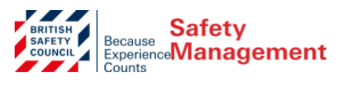
The creation of a new Office for Health Improvement and Disparities (OHID) in England is expected to lead a cross-government effort to address the wider factors that contribute to peoples’ health outcomes. The office, which begins work on 1 October, will tackle the top preventable risk factors for poor health, including obesity caused by unhealthy diets and lack of physical activity, smoking and alcohol consumption. Its creation is a recognition by the Government that health problems depend on one’s job, housing, environment, and education. The ambition is to level up health. Watch this space. British Safety Council’s view is that for OHID to make a tangible difference, it will need to address wellbeing in its broadest sense.
Update from British Safety Council (Sept 21) re Covid 19
According to new figures from Public Health England, the vaccine rollout in England is estimated to have directly prevented around 230,800 hospital admissions among people aged 45 and over, and among people aged 65 and over, some 178,900 admissions have been avoided, with a further 51,900 among people aged 45 to 64. PHE estimates for the number of deaths prevented by vaccinations in England are unchanged, at 112,300. Rollout of a booster programme in England and Wales for NHS staff and the over-50s has begun.
On the international front, India is ramping up its vaccination drive, administering some six million jabs on average every day in August, compared to 4.3 million daily jabs in July, according to official data. However, experts say India needs to administer more than 10 million doses a day consistently to fully inoculate all eligible adults by the end of this year.
In the US, nearly 179 million Americans (54% of the population) have been fully vaccinated, according to the Centers for Disease Control and Prevention (CDC). Despite widespread vaccination efforts, 54% of US adults say the worst of the outbreak is still to come, according to a survey by the Pew Research Center, while about a quarter of adults say they have not received a vaccine.
The relaxation of COVID restrictions, the on-set of winter, uptake rates for the ongoing national COVID and flu vaccination programmes, the reopening of indoor and outdoor venues where large numbers of people gather will remain a challenge in the coming months and, depending on infection and hospitalisation rates, may see some of the previous restrictions re-introduced. That said, it has been a welcoming change to attend events, conferences and exhibitions once again in person and to have long overdue human interaction.
Hakuna Matata!

Back Care Awareness Week

These days, more people than ever are working from home, either temporarily due to social distancing (also called physical distancing), or permanently as a remote professional. If you’ve found yourself and your laptop at the kitchen table or at a makeshift desk, do what you can to make your workspace as supportive and comfortable as it can be. After all, you don’t want working from home to be a pain in the neck — or shoulders.

Position Yourself for Success
How you sit while working makes a difference. While your home may not be the best work environment long-term, do the best you can to safeguard your joints and muscles. It might be a good idea to check your home for props, such as stacks of books to raise your monitor and to get yourself and your equipment positioned the right way.
If you can, work from a firm chair positioned at a desk or table. A soft couch isn’t your friend for hours on end. Sit right, and don’t forget to get up and shake it out to avoid aches and pains.
Set a timer to remind yourself to get up once an hour to:
- Stretch and walk around
- Bend over and touch your toes
- Do some jumping jacks
- Run in place
- Roll your shoulders slowly
- Do arm circles to get your blood flowing
These activities won’t just help your body, they will also help your mind and concentration. If you use a lumbar support cushion, change its position on your chair. If you can, do some of your work, such as phone meetings, while standing or even walking.

5 Ways to Avoid Neck and Shoulder Pain When Working from Home

Tip 1: Feet firmly on the ground
Keep your feet flat on the floor and slightly ahead of your knees, which are bent at a 90- to 120-degree angle. Use a lumbar support cushion or if one is not available, grab a small throw pillow to alleviate back pain.

Tip 2: Shoulders relaxed and natural
Shoulders are relaxed, upper arms fall normally at your sides and elbows are close to your body. Head is generally in line with your body — not thrust forward — and the middle of your computer monitor is at eye level

Tip 3: "Arm" yourself for success
Hands and forearms are parallel to the floor. The ideal keyboard position is slightly below the height of your elbows and sloped slightly away from you. This position allows your upper body to relax and keeps circulation from being cut off in your lower arms and hands.

Tip 4: Neck-free when talking
Use earbuds, a headset or speakerphone so that you don’t have to tilt your head and hold the phone between your neck and shoulder.

Tip 5: Keep moving
Even with the best posture, you can get aches and pains from sitting in one position for too long.

Other Ways to Relieve Neck and Shoulder Pain
If you do develop neck and shoulder pain that you can’t manage from your home office:
- Take a hot bath with magnesium sulfate (Epson salt)
- Alternate ice, then heat on the affected area
- Have your family member give you a massage

National Highways Industry Awards

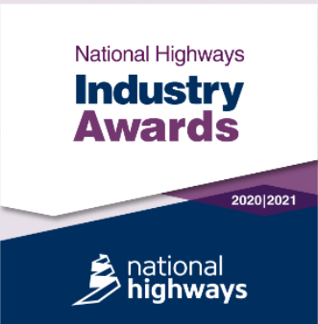
The 2020-2021 National Highways Industry Awards are now open for nominations!
With a new focus on industry partners, we have 15 awards categories celebrating the best in project design and delivery, carbon reduction and environmental stewardship and customer focused teams across our supply chain.
Everything you need to plan your application is on this page, including details of each category and the entry highlights that we are looking for in winning nominations.
Award submissions are open from Wednesday 15 September 2021 and remain open for 5 weeks.
All submissions must be completed by 17:00 Friday 22 October 2021, to be considered.
For more information : National Highways Industry Awards - Highways England

Raising the Bar Checklist

This will help check compliance with the guidance by highlighting significant elements. A link is posted below that will direct you to the Highways Safety Hub website where there are also a lot of interesting items. Also consider joining the Twitter group which gives out lots of useful information regarding changes and uploads including the latest safety alerts.
https://www.gov.uk/government/collections/health-and-safety-for-major-road-schemes-raising-the-bar-initiative

