How much should we drink?
To stay healthy, it's important to replace the fluid we lose when we breathe, sweat or urinate. We get some fluid from our food but most comes from drinks.

The European Food Safety Authority recommends that women should drink about 1.6 litres of fluid and men should drink about 2.0 litres of fluid per day. That's about eight 200ml glasses for a woman and ten 200ml glasses for a man.
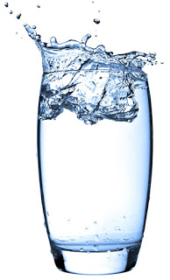
However, the amount a person needs to drink to avoid getting dehydrated will vary depending on a range of factors, their size, the temperature and how active they are.

All drinks count, including hot drinks such as tea and coffee, but water, milk and fruit juices are the healthiest.

Avoid sugary, soft and fizzy drinks that can be high in added sugars. These can be high in calories and bad for teeth.

Signs of dehydration
- dark urine and not passing much urine when you go to the toilet
- headaches
- lack of energy
- feeling lightheaded

Drink plenty of water
Water is the healthiest choice for quenching your thirst at any time. It has no calories and contains no sugars that can damage teeth. If you don't like the taste of plain water, try sparkling water or add a slice of lemon or lime. You could also add some no-added-sugar or reduced-sugar squash or fruit juice for flavour.

