Form Ref:  HSI-10 | 4D Modelling – Blue Star Item | Version: 2.0  Jun 2015

Awarded for Exceptional Performance or New Initiative not widely used on other sites

Project | Principal Contractor (PC) | Date of Inspection
M4 SMP | BBV
Site Contact | Email Address | Telephone Number
Matt Birchmore | Matt.Birchmore@bbv-jv.com | 07976 034273

Description of Blue Star Item | The M4 SMP team has taken active steps to improve its performance through the use of digital tools and systems.  The project has invested in immersive technology to allow the team to utilise the 4D modelling content being developed by the Building Information Modelling (BIM) team. This journey commenced in 2019, and was fully utilised throughout 2020 and especially the Covid 19 Pandemic, heightened its use.  The 4D modelling results in a video to peer review the schedule of works and activities to be carried out, which is then used to communicate safety critical works, such as demolition, bridge beam installation, full weekend closures. With multiple parties contributing to the planning and review of the activities the project is more likely to identify health and safety, environmental, quality or programme issues before works take place on site.  This has proven to be a great success for multiple weekend carriageway closures being completed with the confidence they had been planned to the highest quality of detail by first seeing the high-quality digital twin in a 4D model. (see supporting information). The team also took this to the next level by using this technology to safely plan activities with regards to Covid 19 restrictions and social distancing, identifying tasks where 2m distancing couldn’t be achieved and re-planning these using alternative work methods to keep everyone safe. A key feature to using the mission room to plan works is the content which is supplied by our expert BIM team and integrating the supply chain’s plans into the 4D animations, we create a master plan and produced synchronised animations showing the safety critical works. An example of this is the full weekend closure of the M4 between junction 6 to 8/9, from 15 to 18 November to install a temporary bridge, install the new beams across the M4 and demolish a bridge were all successfully completed with no incidents. The 4D model created for this closure showed the multiple activities being progressed on one screen.  By bringing in the work activities and review processes with our supply chain, the M4 is driving collaboration and innovation to raise the bar in the health, safety and wellbeing of our people and customers.
Benefits of Blue Star Item | The 4D modelling systems allow our teams to carry out clash monitoring, plan activities taking into consideration social distancing and Covid-19 control measures, and to identify risks that may not otherwise be seen.  The technology enables the construction team and key stakeholders to fully interrogate the plan and to create contingency procedures before executing the works on site. The modelling process drives collaboration across the project, therefore improving performance and execution of safety critical works.  For every 4D planning session we created “spin off” animated videos showing sequence of work whilst preserving the 2m rule during major operations such as beam lifts. Where workers had to momentarily be closer than 2m we developed additional forms of protection, consistent with industry best practice and illustrated them as well. An example of this can be viewed here:  https://bit.ly/2NIfzMd for the Thames Bray weekend lift.  The 4D modelling systems have proven to be a great success, being used for each of the eleven separate weekend carriageway closures, where multiple activities have been scheduled, along with high risk activities including bridge demolitions and installations. The technology allows activities to be planned in the highest quality of detail by first seeing the works in a virtual environment. This level of planning and virtual modelling have given clear health and safety, as well as customer, benefits, with all these planned weekend closures on the project being completed with zero health and safety incidents and being open for traffic on time, ahead of schedule and without safety incidents.
Details and Cost of any Specific Product | The software Autodesk and Synchro are used to generate these models, the software is already in use and paid for by the company. Each time a model is created it costs approximately 40 working hours at Manager grade level.

Photograph | Example of 4D modelling incorporating planning for Covid 19 restrictions.  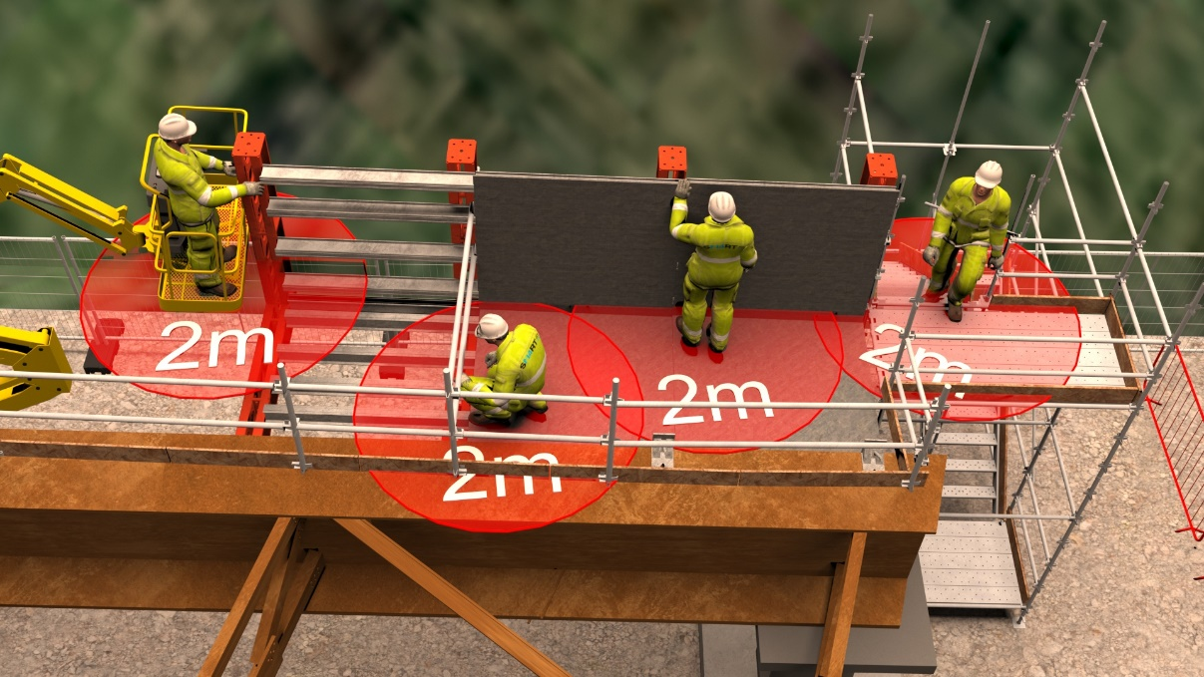  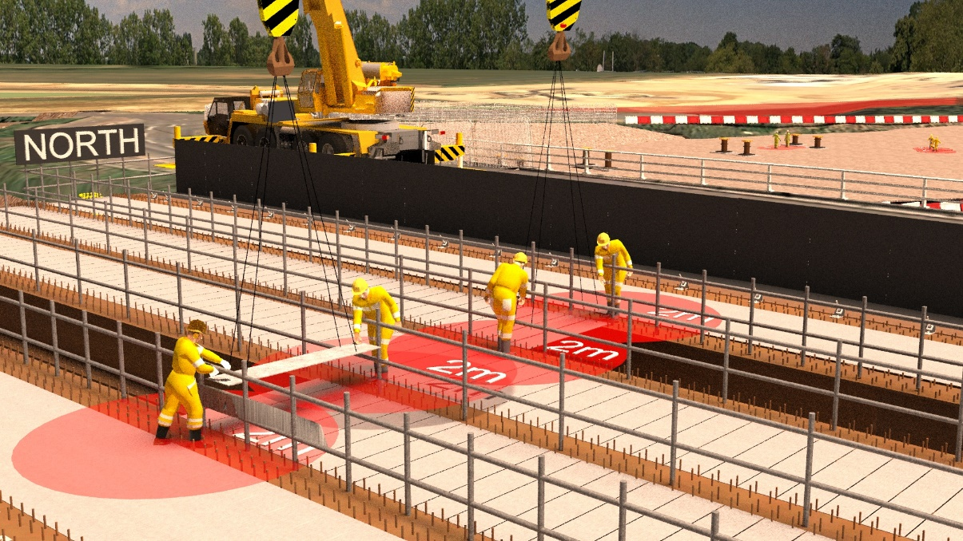
Photograph | Mission Room  The digital planning room has multiple touch screens and the Mission Room (semi-immersive) enables groups containing key stakeholders to fully interrogate the plan and create contingency procedures before executing the works on site.  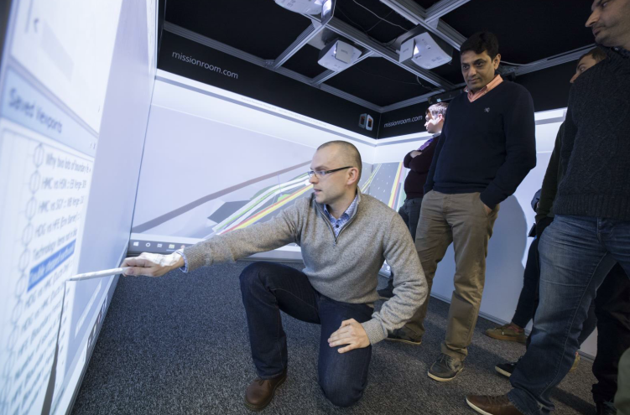  Peer Review  Each 4D model undertakes a Peer review to ensure that all details are correct and picks up all restrictions, correct methodology, risks and hazards.  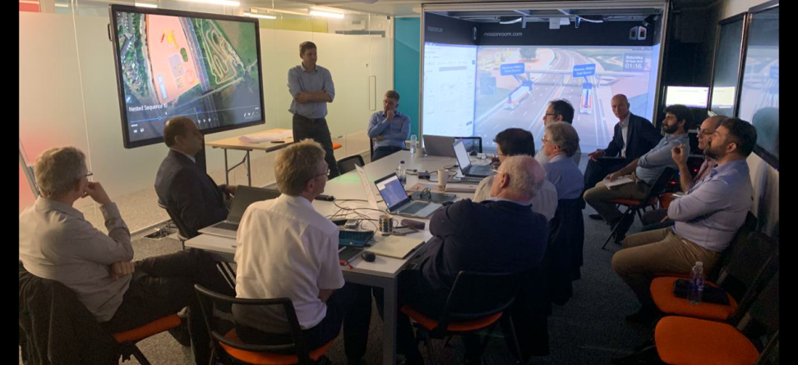  (Note: Above photo’s taken pre-Covid 19)

Photograph | 4D Modelling on the M4 J3-12 SMP  A great example of this is the full weekend closure of the M4 between junction 6 to 8/9, 15th to 18th November successfully completed with no incidents. The 4D model created  for this closure showed the multiple activities being progressed in one screen.  Stills taken from the 4D modelling video of a bridge demolition, new bridge beam installation and temporary bridge installation over one full weekend closure of the M4 between junction 6 to 8/9, 15th to 18th November 2020.  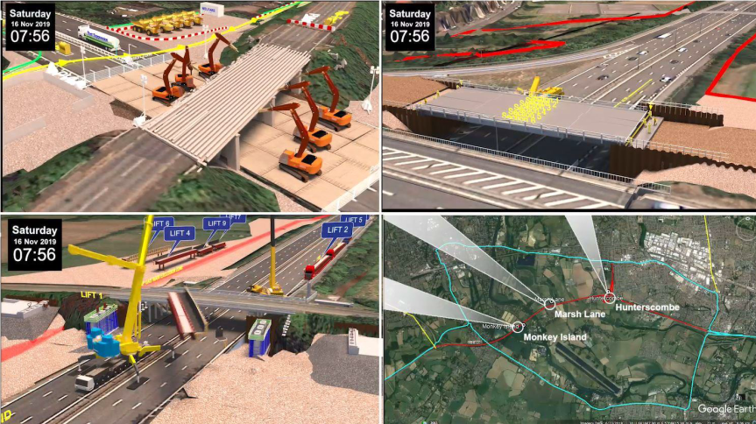
Photograph | 4D Modelling on the M4 J3-12 SMP  The video is also then shared with the entire project team through digital notice boards located within offices and outdoors in compounds, as part of the pre-work briefing to ensure everyone is informed of plan and potential risks associated with the work.  