Highways England
Principal Designer Working Group
Meeting No.21

Thursday, 26th March 9.15 am – 12.30 pm.
(Teams Call)

Attendees
Name | Initials | Position | Organisation
Richard Wilson (Chair) | RW | H&S Director (Major Projects) C&P | Highways England
Mark Byard (Part) | MB | Head of H&S | Highways England
Nina Warminger | NW | H&S Manager SWAD | Highways England
Doug Potter (Secretary) | DP | TA HSW Lead - Principal Designer Manager | Arcadis
Mark Lamport | ML | Technical Director / Principal Designer Manager | Arcadis
Pav Singh | PSi | Technical Director / Principal Designer Manager | Arcadis
Natalie Mansell | NM | Head of Safety – SR, H&LT | Atkins
Tim Bowes | TB | Principal Designer Manager | Atkins
Greig Houghton | GH | Design HSE Lead | Jacobs
Paul Brown | PB | Technical Manager | WSP Group
Nicola Knowles | NK | Principal Designer Manager | Arcadis
Andrew Finch | AF | Director of Operations | Jacobs
Roger Swainston | RS | PD / CDM Advisor | Jacobs
Dave Avery | DA | H&S Manager | Arcadis
Mike Boyland | MB | Project Manager | Highways England
Tim Goddard | TG | Principal Designer Manager | Arcadis
Toria Thomas | TT | Principal Designer | Arup
Mark Bridges (Part) | MB | H&S Hub Lead | Galliford Try
Jordan Flint | JF |  | Kier
Sulagna Ghosh | SG | Ass. H&S Rep Leeds | WSP Group
Abbey Featherstone | AF | Technical Lead | Connect+
Patrick McNulty | PM | BIM Lead LTC | Arcadis
Robert Butcher | RB | Technical Director CDM | Jacobs
Paul Dennis | PD |  | Arup
John Quarless | JQ |  | Kier
Paul Watson | PW |  | Amey
Mark Hawkins | MH | GI Framework Lead | Arcadis
Jim Gallagher | JG | Prin Structures Advisor (SES) | Highways England
Ken Harrison | KH | Principal Engineer | Amey Consulting
Tony Lewis | TL | Principal Designer Man. YNE | Costain
Stephanie Goldsmith | SG | Senior H&S Advisor | Skanska Infrastr.
Martin Partington | MP | Principal Engineering Man. | Jacobs
Jon Webster | JWe | Safety Lead | Kier
Nick Boyle | NB | Technical Manager | Balfour Beatty
Malcolm Shaw | MS | Principal Designer Manager | Arup
Ed French | EF | Principal Designer Manager | Arcadis
Chris Gee (Part) | CGe | Head of Utility Diversions | Highways England
Liz Brathwaite | LB | H&S Lead | Skanska
Clare Brown | CB | Safety Lead | Link Connex (Bam Nuttall)
Robert Legg | RL | Highways Safety Co. | Motts
Dave Owen | DO | Regional Director | Galliford Try
Sean Connon | SC | Principal Designer Manager | Costain
Tarandeep Atwal | TW | Associate Director | Arcadis
Richard Delaney | RD | Senior H&S Consultant | Capita
Elizabeth Bennett | EB | Director | Safety in Design
Ali Chaudhary | AC | Principal Designer | Galliford Try
Katie Harman | KH | YNE Safety Lead | Highways England
Apologies:
Paul Boddy | PB | Director | Interserve
Clare Brown | CB | H&S Advisor | Bam Nuttall
Katie Swanick | KS | Contracts Manager | Motts
Aimee Blay | AB | Design Manager | Galliford Try
Thomas Merry | TM | H&S Lead | Highways England
Ronan Finch | RF | Principal Designer | WSP
Shaun Pidcock | SP | Director LTC | Highways England
Paul Claydon | PC | H&S Manager | WSP Group
Phil Samms | PS | Engineering Man. (Area 3) | Kier
Dave Olorenshaw | DO | Area Manager | Keir
Kevin Morgan | KM | PD / CDM Advisor | Jacobs
Mark Riordan | MoR | Principal Engineering Man. | Amey
Paul Wilkins | PW | Ass. Tec. Director Structures | Arcadis
Dave Townsend | DT | H&S Team Standards | Highways England
David Owens | DO | Data Manager | Costain
Paul Whitehead | PW | Structures Category Lead | Highways England
Jon Horrill | JH | Principal Designer / H & S | WSP Group
John Migoski | JM | Technical Manager | Network Rail
Suryakant Patel | SP | Principal Designer Manager | Costain
Amy Williams | AW | HE SES Data Link | Highways England
Tom Bolton | TB | Principal Designer Manager | Amey
Steve Ristow | SR |  | Transport for London
Euan McRobie | EM |  | Capita
Ben Moult | BM | Safety Lead | Balfour Beatty
David Lumb | DL | Health and Safety Business Partner – RIP North | Highways England
Rob Eagles | RE | Temp Works Designer | MGF
Jim Tod | JT | Temp Works Designer | Tony Gee/Twf
Samuel Hogan | SH | Principal Engineering Man. | Balfour Beatty
Chris Griffin | CG | Design Innovation Manager | Highways England
Lawrence Weller | LW | Safety Manager | TfL
James Washington | JWa | Safety Lead | Kier
Darren Allen | DA |  | Tellent
Jason Glasson | JG | Asset Information Manager | Highways England
Simon Wilkinson | SWi | Technical Director | AECOM
Ian Scott | IS | SIP H&S Lead CIP not SIP | Highways England
Robert Mullen | RM | Asset Information Group | Highways England
Owaiz Khan | OK | Technical Manager | MGF

1.0 | (9.15 – 9.30) Welcome and introductions (Richard Wilson)  Note: All presentations will be made available on the PDWG tile on the H&S Hub Web Page  HS and Wellbeing Moment provided by Richard Wilson.  Key Actions and matters arising from PDWG 20 – 22/01/21.  Minutes  1.1 Competency - Tom Merry and Richard Wilson have been liaising with Gordon Crick from the HSE with regard a Risk Treatment Tool – SM Alliance are not taking this forward.  1.5. Near Misses and Close calls – This will be taken forward by Tim Goddard as part of the AIRSWeb Improvement Group and Martin Partington as part of Safety Share initiative. – Both actioned and feedback will be provided in the later presentations  1.6. Pav Singh will provide feedback on the recent LTC Gas Main strike – PS to cover within the Accident Investigation Section.  1.19. Asset Data Management Group issues meeting – ML will provide a progress update.  2.0 Support to Chris Griffin – No feedback – DP to follow up with CG.  3.0 Membership of SCSLG be added to the Safety Hub web page – MB confirmed that he would provide details on the webpage.  3.0 Feedback on the good utilities work being undertaken on HS2 and greater feedback from the utility companies – Chris Gee will provide an update.  7.0 New H&S / CDM Standards – RW is to provide an update within the agenda.  Chat Room Feedback  Safety in Design feedback – DP to obtain feedback from Chris Griffin for next meeting.  How will HE coordinate and communicate the numerous HE initiatives and agree themes that PDWG can focus on – RW will review and feedback.  Statutory undertaker’s feedback – Chris Gee to comment later in the Agenda.  GPR – Lots of positive feedback and interesting comments  GPR – Number of Technical comments – comments from Craig Simmonds included below: |  | DP/CG  MB  CGe  DP/CG  RW
1.0 Is HDA GPR becoming more frequently available as this technique develops? |  | Undoubtedly, between 2004 and 2014 we were the only company using array technology for these kinds of applications in the UK. Now there are at least 20+ systems operating in the UK – However, most are 600Mhz Impulse systems that are hand pushed, whilst still being a generation ahead of the standard systems, there are only a handful of the latest UWB systems operating at the moment.
2.0 Often the uncharted cables lie in the verges and soft estate. GPR type equipment needs a high level of vegetation clearance, which give us a programme conflict for early surveys. Is this an issue? |  | Yes, but there are ways around it such as the creation of bespoke systems such as this one. If the antenna is having to search through long wet grass, its ability to locate targets will be compromised though. We are currently looking at developing a new Antenna specifically for approaching this kind of environment… When I get the chance, I will be looking to get funding for the R&D involved! 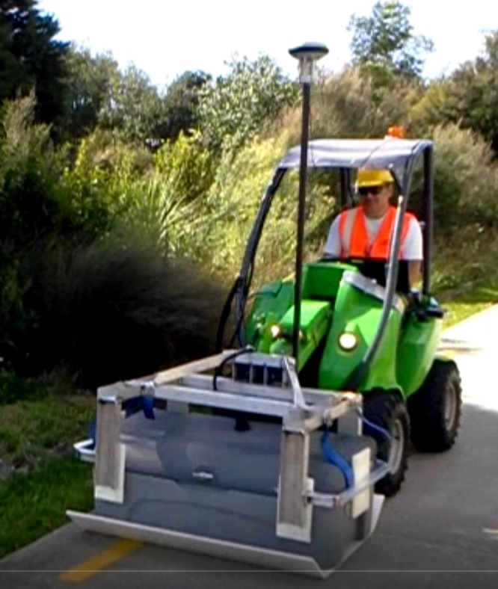
3.0 Do you have a cost per m squared or km squared for example to provide designers and or procurement, ideas of how much this type of survey would need to be budgeted for, on their projects? How applicable is this for long linear sites like highways and verges? |  | We do, but it will vary, depending on the survey area and how far we have to travel to turn around at the end of each acquisition. It also depends on what we are looking for, if we want rebar detail in the bridge structures, we will need to decrease speed, if we are looking at pavement details, we can collect data far faster. For long linear (straight line) highways we can cover a huge area in a shift – possibly up to 10km – But for a complicated junction, looking at the structures and utilities the coverage will be significantly less. Footways are slower (hand pushed) and verges even slower – at the moment!
4.0 What is the accuracy of the below ground surveys? |  | Positioning is key, if we have good satellite coverage, we can cover a greater area more quickly, if we have not, then we have to use a robotic total station to track the system(s) meaning we can only scan as far as we can see before having to stop and re-locate the Total station. The reason this is pertinent is that the data will always be accurate to within 10cm max, more likely 2-3cm – if we can see a target, it is where we say it is, if our positioning is off, the data is scrapped and re-captured. GPR only will show a bank of ducts as a single large entity, it will struggle with small cables at depth – it does have its limitations which is why it is used in conjunction with EML in complicated environments. In isolation however, it can provide up to 80% of the required data in a fraction of the time (usually less than 1/3) of a full survey, allowing targeted EML works to concentrate on just where the additional data is needed.
5.0 Can it detect asbestos in abandoned water pipes, or detect the types of material used in the verge? |  | Theoretically it is possible to ‘sometimes’ determine material types and a trained analyst can spot or at least gain an idea of material types from the data on occasions, it’s not something that we would rely on as there are simply too many variables in the ground to distort the readings we obtain. Comparison to records and investigation of inspection covers are activities that can help confirm these details from a GPR only survey.
2.0 | (9.40 – 10.10) Home Safe and Well (Mark Byard)  MB acknowledge the great work PDWG are doing, the future potential we offer and the massive difference we are making!  - MB felt Home Safe and Well is standing the test of time and the guidance document should be a constant source of reference.  - A key element is HS and Wellbeing by Design which encompasses employees, supply chain construction and maintenance staff and road users, who should all be considered from the outset.  - Risk should be considered and eliminated where-ever possible from the outset – reference was made to the Eliminating Risk from the Outset piece of work developed by PDWG.  - Key elements  - What are the levels of competency within the industry and how are we going to improved them?  - We should all be learning organisations – always seeking improvement – what systems are in place to ensure this?  - Improvement in Reporting and management of organisational data.  - Key Driver – Zero Harm 2040 Target - No one will be harmed working on or driving on the strategic road network.  - We need to recognise there will be a change in the basic driving parameters – autonomous vehicles / smarter vehicles etc.  - We need to think of every way in which we can achieve Zero Harm.  - Current stats are 210 Killed – 1948 killed or seriously Injured.  - We need to recognise that we are building the roads now that we will be using in 2040 – the journey starts now!!  - This means we need to be thinking about whole of life design – construction, maintenance, operation and use.  - We need a forgiving network – designers need to deliver a network that delivers this.  - Eliminating Risk from the Outset  - Implementation of the Hierarchy of Control  - Remove people from harm.  - Removing people from procedural controls (PPE).  - Too much reliance on the individual doing the right thing in the moment.  - Improved procedural control.  - Investigations  - Being a learning organisation  - Understanding how far back the investigation should go – i.e., as far back as possible – back to the design and basic principles.  - Common Intents /Raising the Bars  - Are they making a difference and if not, why not?  - Collaboration  - We need to be better at sharing lessons.  - How wide do we look? Do we consult with HS2, Network Rail etc?  - Q&A Session followed – see Chat Room comments
3.0  3.1  3.2  3.3  3.4  3.5 | (10.05 – 10.30) Safety Standards / new Supply Chain Maturity Matrix (SCMM) (Richard Wilson)  (See presentation attached)  New SCMM Launch  Old HSMM format had 228 questions using an .xls formatting system.  • The new SCMM has been revised and is now down to 30 questions  • Revision has included comments from PDWG, Designers, PC's and Tier 2's for input.  • It is aligned with HSW  • Microsoft forms the platform - with Power BI sitting in the background which produces a report with actions and spider diagram for analysis purposes.  • It forms part of Annex 15 of HSW.  • The intention is that it should be prepared within the first 6 weeks of starting on site during Stage 6.  • The HSMM was not always included in previous contracts. The SCMM will be included in all contracts going forward.  • An opportunity for designers to shine and demonstrate what they are doing to eliminate risk and reduce risk.  • The swim lanes demonstrate the maturity matrix process. They show the review process once submitted to HE.  • Plan is that briefings will be provided on its use internally within Major Projects from 12th April 2021.  • It will be launched in a phased approach as new contracts are awarded.  • ML - organisational assessment - can it also be used for JV's and also project maturity. RW - this is intended to be completed based on project teams rather than the individual organisations. The JV members can undertake the assessments separately and share the outcomes, and agree an approach going forward.  • MP - RDP north project combined the Jacobs and Costain maturity matrices to get an overall project maturity.  Withdrawal of IAN 105 and status of GG106  - RW raised the question as to whether it was needed? When we have L153 and the CDM 2015 regulations themselves?  - Concern was expressed that without guidance organisations would start to diverge and inconsistencies would build in delivery of CDM across projects and H&S documentation.  - There was also a feeling that without guidance HE PM’s may not fully understand the duty holder requirements.  Additional PD services on projects  - RW would like a list of all projects with Additional Services currently instructed as these duties should now have been taken back in-house by the HE.  New HE Internal CDM Processes and Procedures  - The new CDM Processes and Procedures are due to be released in phases from July onwards. It is recognised that documents specified within the new procedures will require an update of the PCF product guidance to bring them in line with the new proposals.  - Action to make sure that the PCF and CDM are embedded and mirror one another.  - Historic schemes are tricky as retrospectively applying new standards late on is difficult and some flexibility will be required here.  - DP and RW will take the GG106 issue off-line and include the comments from today and prepare a paper to take back to Jo Goulding.  New Asbestos Standard  - Asbestos procedure has been prepared and training is being rolled out this year. NW to speak to Bob Watson to identify the people who have received the training and are responsible for this. Regional Asbestos Management Contacts are set out in Appendix A |  | All  DP/RW
4.0  4.1  4.2  4.3  4.4  4.5  4.6  4.7  4.8  4.9 | (10.30 – 11.45) T&F Group Updates - (SCSLG – H&S Hub Support)  HS Wellbeing by Design - CG unable to attend - DP to contact post meeting.  H&S File Digital Development – T&F Group (Mark Lamport - Arcadis)  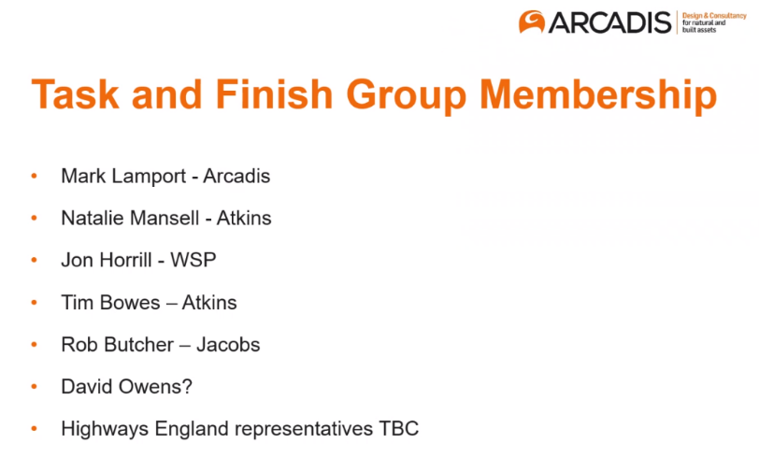  ML apologised that he had not been able to set up an initial meeting, but further discussions had taken place with Jason Glasson and Sarah Bull – ML was looking for a HE representative to support the group.  A number of PDWG volunteers had come forward to join the group (as above). Anyone interested please contact ML.  The draft terms of reference below are to be reviewed by RW before the task and finish group take the matter further.  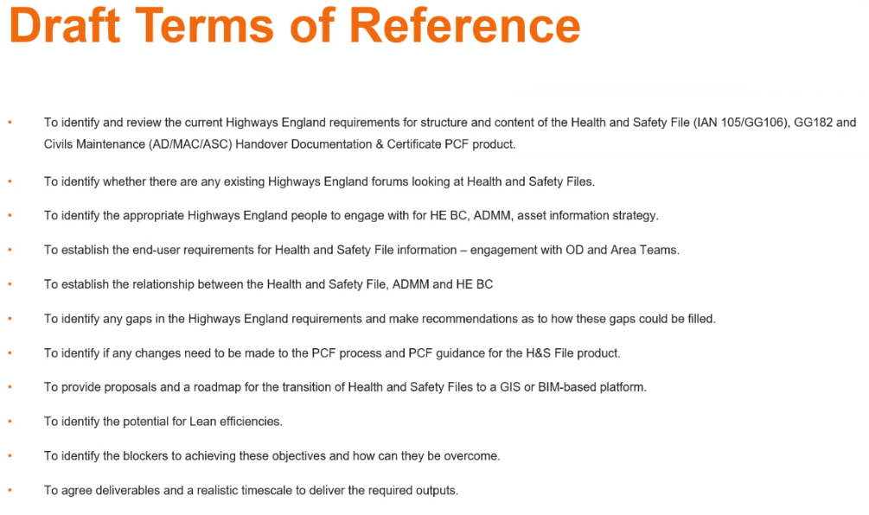  ML explained that various challenges lie ahead that need to be looked into as set out below.  .  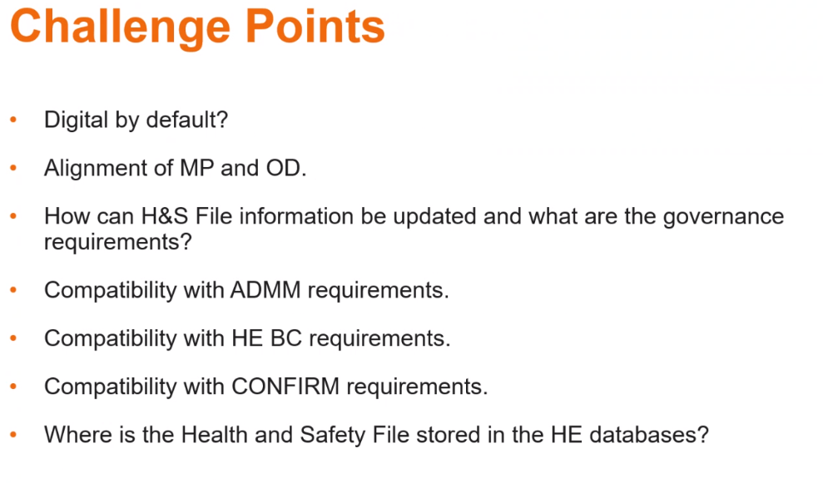  A proposed 7 Volume Handover Document structure had been identified about 3 years ago with Volume 2 being the H&S File. This needed to link up to the ADMM, PCF Guidance, OD and CDM requirements and any replacement of IAN 105.  This has never been formally mandated across projects through an update of IAN 105 or the PCF Guidance although it is increasingly in common usage where accepted by the HE PM and H&S Team.  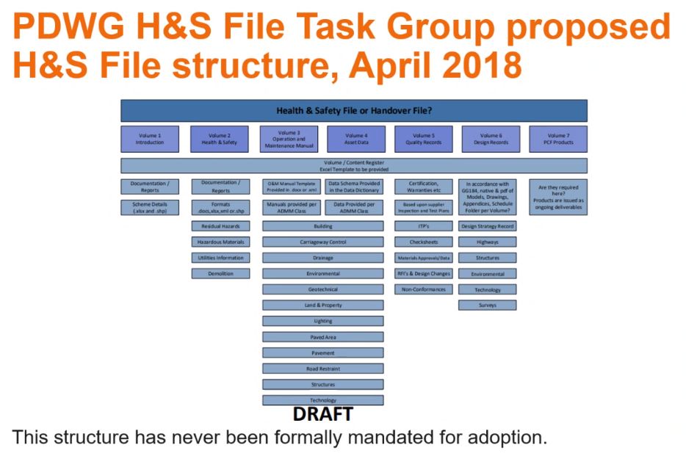  ML noted that the Civils Maintenance Handover product (below) specifies a different H&S File content structure arrangement to that proposed in the current H&S File Product Guidance document  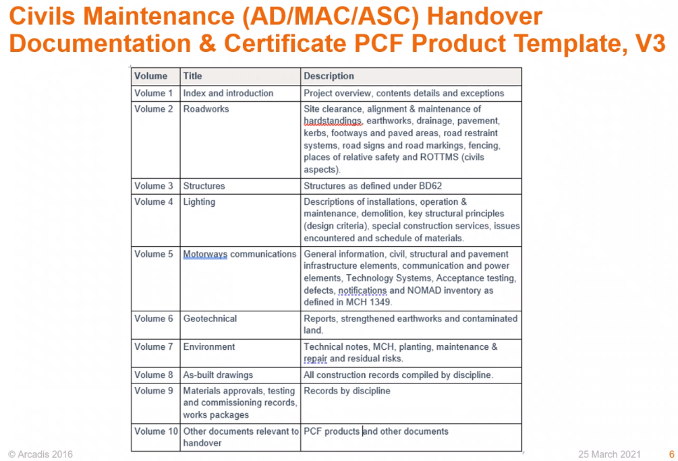  ML noted that the above format sits in alignment with the HE BC file structure.  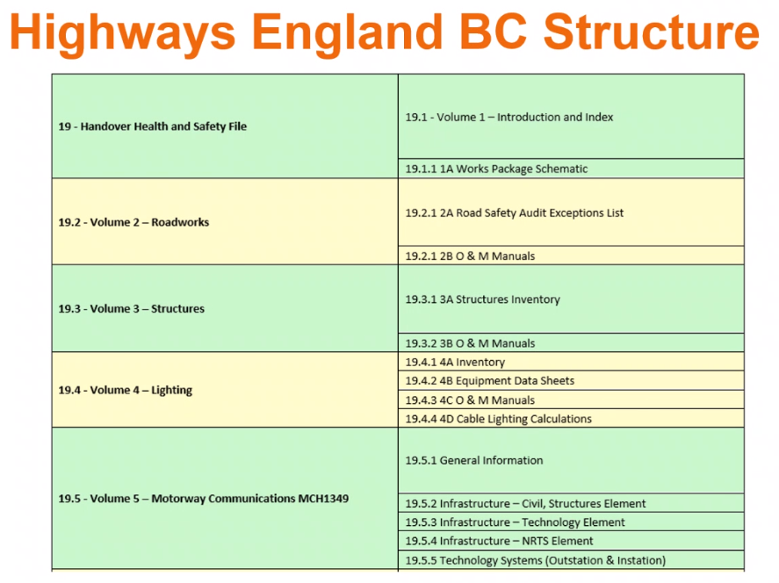  ML indicated that the key was how to untangle HSF from the asset data as the H&S File is the legislative document and needs to be a standalone entity.  Objectives -  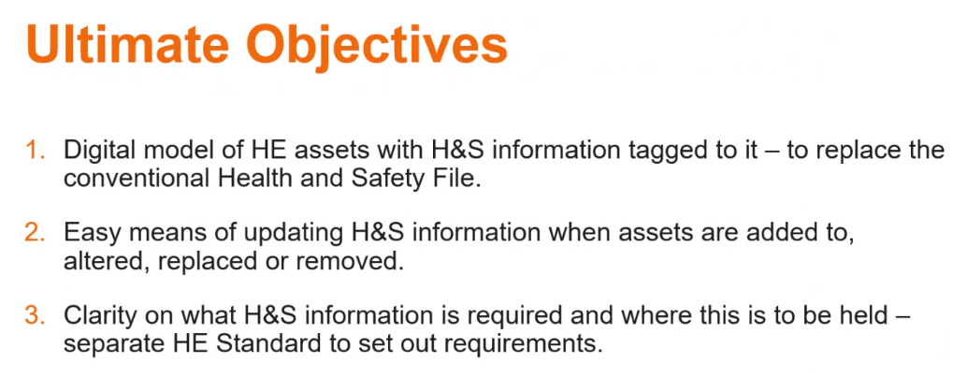  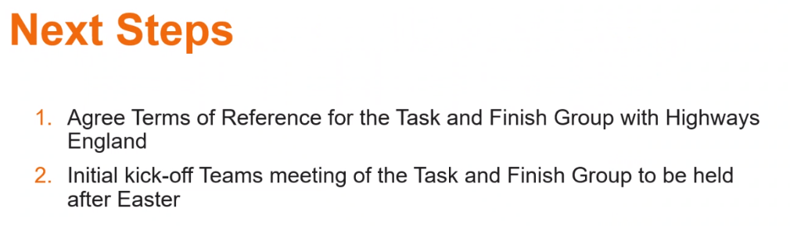  - S  Update from SCSLG – (Mark Bridges – SCSLG/H&S Hub)  - MB confirmed that the Roadworks Common Intent document has been issued since our last meeting. Now 9 in total.  - We need to be looking at offline working and limit the working around live traffic.  - Working widths and construction methods need to be reviewed as this is a massive constraint.  - SCSLG have update to RTB 3 which is now on the website. https://www.highwayssafetyhub.com/  Next steps in 2020/2021:  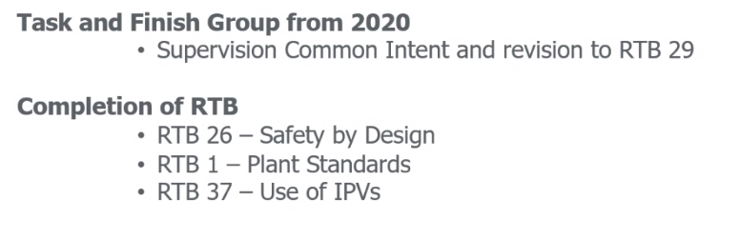  - Commitments for this year:  - No sponsor for excavations currently – one is required.  - Phil Clifton leading on Commercial Vehicle Breakdowns  - Health document - do each topic area need a document each? This group is being picked up by Adam Green.  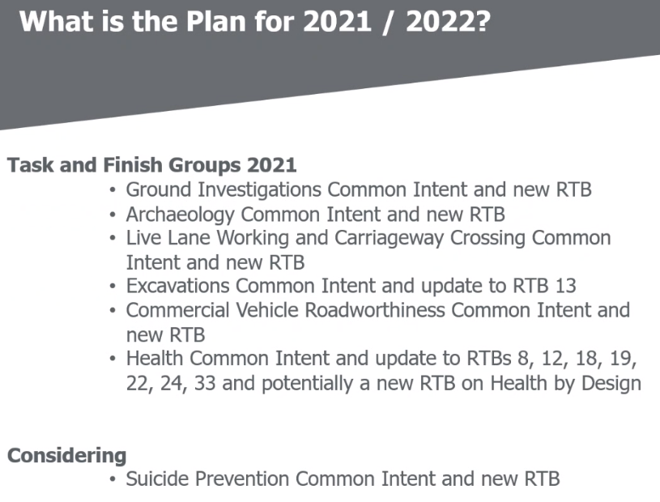  Other Initiatives:  - New case study pro-forma issued - created to keep a library of issues and examples to keep the Common Intent documents fresh and up to date. To drive continual improvement across projects rather than meeting a level of compliance behaviour as the RTB docs may have encouraged in the past.  - Capturing learning toolkit - to create a corporate memory of lessons learned across the sector. We need to get better at learning from past experience, this will gather trends from the sector that we can learn from and prevent from happening again.  - Suicide prevention page to be set up on the Highways safety hub. Action with Mark Bridges.  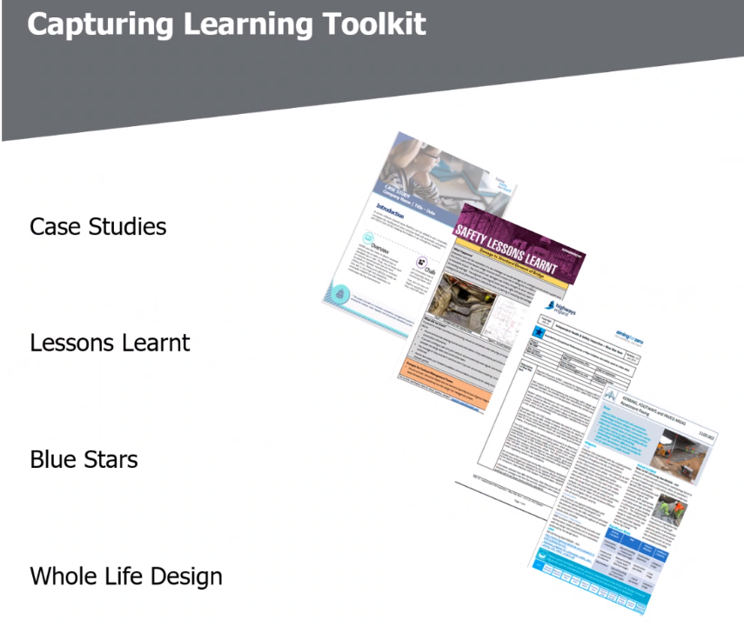  Accident Investigation - (Common Intent) – (Tim Goddard - Arcadis)  AIRSWeb Improvement Group  TG has met with Adrian Lewis to discuss actions coming out of previous PDWG around improving Safety Alert and Near Miss reporting. AL is meeting a number of groups to obtain feedback and gain a better understanding of what is required. Initial thoughts set out below.  This will feed back into the AIRSWeb Improvement Group. TG to continue to liaise with AL but also engage with Stewart Evans to provide feedback into the AIRSWeb Improvement Group who are yet to meet.  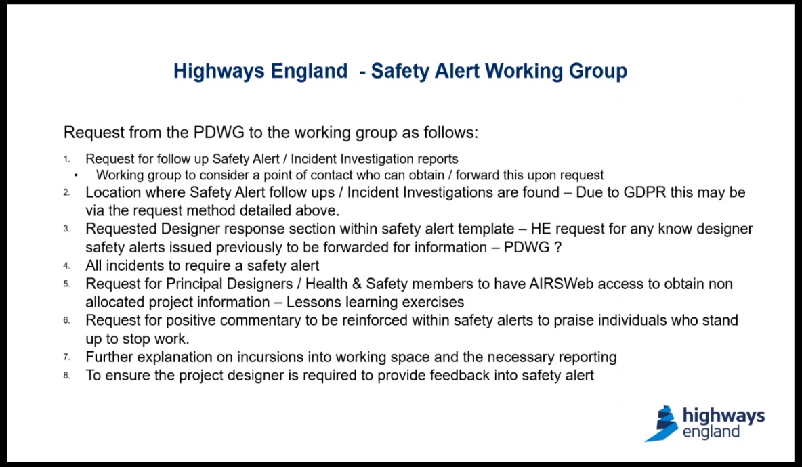  Safety Alert Reports in period  TG reported that there have been a number of Safety Alerts in the last period which have been of interest. Arcadis have collated these and provided thoughts based on the base Safety Alert data sheets. See presentation attached for latest stats and detailed feedback.  TG has asked for any feedback/evidence of design root causes - welcomed from the PDWG.  - Of note an Excavator driver had instigated a stop work – and had been highly commended for his action – the activity had been close to scraping over a gas main.  - HEi 207 – Bridge Foundation Strike – This had had a number of root cause issues including GPR which had missed 6 buried structural bridge elements - What was the brief for the GPR? - Was the right equipment being used? PCI had also been missed - As built Info was available but limited which contributed to structural elements having been missed. Swiss cheese model. This is to be used as a Safety Share.  - Katie Harman has the findings from this and shared with Doug Potter. The GPR perspective has not been clarified. MP – is looking into the background to help develop the safety share - maybe an agenda item for the next PDWG call as more issues may be identified. MP queried if we take the incident investigation far back enough. Root cause analysis.  - AF was aware of the original build and flagged how crucial the historic data is on as builts. Our as builts will of course become the future historic data. It is essential that we need to ensure our as builts have the right information for legacy assets, buried structures and significant or unusual risks that a future contractor wouldn't be aware of.  - AF – is looking to undertake a Design Close Call session at the next PDWG – noted that red line boundaries features quite heavily - was enough space considered for working room - working room constraints cause hazards. Also covered:  - HEi 210 – Live Lane Crossing  - HEi 211 High Pressure Gas Main Strike – LTC was covered by PS (further details at PDWG 22)  - HEi 214 CCTV Bracket  - HEi 215 Gantry sign fixings  ML - Safety Alert - M4  - Ditching bucket too large for the plant it was attached to.  - Immediate actions taken - prohibit the ditch maintenance bucket for all operations higher than the swing centre post. This still leaves an instability hazard as unfamiliarity re the swing centre post. The piece of plant needs to design out the fitting of the larger buckets.  - This action is to inform there is still a residual risk with the plant. Needs to be eliminated and reviewed.  - Balfour Beatty have launched a review on the small plant use across their sites.  - Liz Brathwaite - proper plant standards need to be implemented and sometimes small plant does not have a standard to follow. Liz has seen this sort of thing happen on small plant overturning on post drivers.  - This type of plant should be banned until the inherent risk can be eliminated.  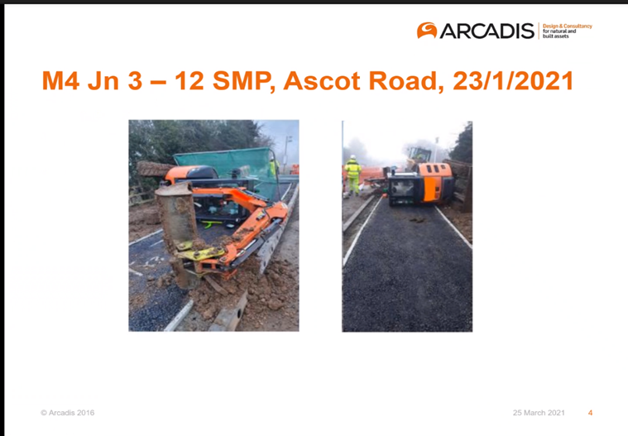  Safety Alert – Design Safety Template) - (Stephanie Goldsmith – Skanska)  SG shared Skanska’s Designer Safety Alert template which had been developed and used on A14.  - Skanska plan to share with the whole supply chain and the design community.  - Consistency of information for communication was key.  - Communicate elements from previous design issues or incidents that have a design background.  - This has been trialled internally with internal issues and external safety alerts, which had led to further developments of the template.  - Internal design team have fed into the design safety alert template – which is being rolled out now across all Skanska HE schemes.  - Liz Brathwaite is happy to share the template in word format for use across the schemes.  - It was recognised that this crossed over with the work that the WL Safety Share team are undertaking so a link-up between the docs would be good. SG to be invited to next call.  - DT - this is a great start, and we also need to look at what Network Rail are doing to continue to iterate this process.  - MP to feedback on the work of the group at next meeting  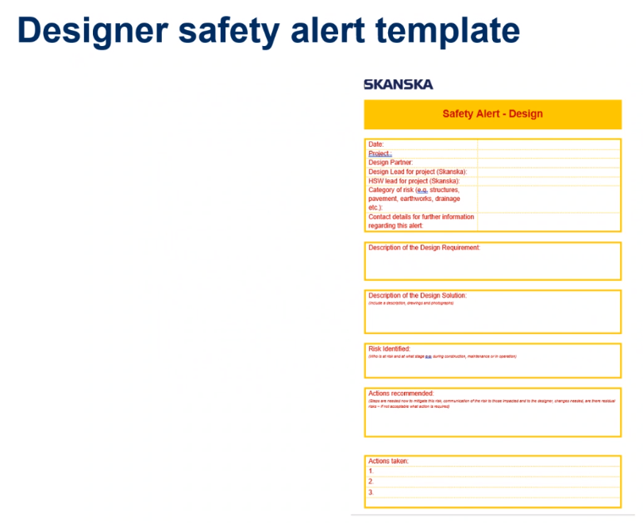  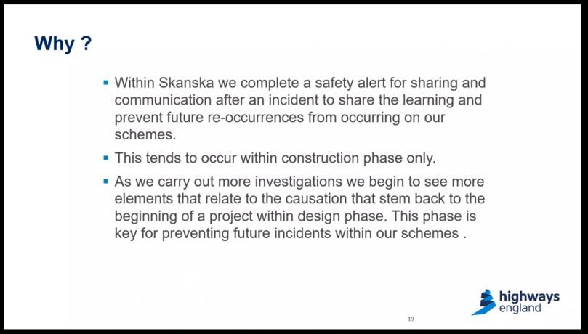  Safety by Design  RTB 26 Safety by Design T&F Group – (Paul Brown - WSP)  - PB is looking to finalise the document – he thank those for their comments so far and would circulate – he would like it to be easily usable on tablet and on phones.  - He planned to add use of more digital tools as a feature.  - Health aspects from previous version to be pulled out and provided to the Health Task and Finish group.  - The RTB 26 Task and Finish group had already been set up and he would be in contact shortly.  - Any further volunteers for this group are welcomed.  Whole Life by Design – Safety Shares (Martin Partington - Jacobs)  - First meeting has taken place and monthly follow on programmed is in place.  - A referencing system has been agreed.  - Topics have been identified were we are trying to develop shares.  - Meeting next week to review the outputs so far.  - A way forward has been agreed and progressing.  - Any volunteers for this group are welcomed.  Eliminating risk from the outset – (Mike Boyland – HE)  - TT indicated Arup had undertaken some further development work through SP&TS.  - Recommendations from the end of the current SPaTS to incorporate outputs from the eliminating risk from the outset task and finish group and this will be issued out as a follow-on project.  Utilities Avoidance – (Chris Gee – HE)  - How are we engaging better with our utility friends?  - Trying to gain visibility of the information that is available on LTC.  - CGe is trying to engage with utility companies that we are working with - so this does mean that some utilities are not engaged with us as much as others.  - CGe is identifying many opportunities for doing things better and getting utility companies to support in the design phase.  - We need to understand their broad principles on outages and diversions and what can we do to understand their constraints?  - Why can't projects have better access to their records? Can we cut out the middleman so to speak?  - This would provide designers with earlier opportunities to eliminate clashes with utilities from a very early stage.  - Where are the utility safe working practices on their websites? How can we understand better why and what their working space requirements are around their assets?  - There is intent within the utility companies, but we need some momentum now to implement a way forward.  - CGe is pleased that the top 10 utilities being engaged.  - ML - have the CDM duties been discussed and agreed with the utility companies yet? CGe indicated that no not yet - this is something that is on the agenda. It is currently typically covered at the moment with the use of Memorandum of Understanding (MoU).  - CGe spending most of the time liaising with LTC utility companies to determine their touch points. Also trying to support operations that have utilities within their schemes and issues emerging later on in the process.  Incursions and IPV’s – (Dave Avery) – not covered see presentation.  Passport Scheme – (Dave Avery)  - Couple personnel in the passport group have changed - Clare Brown now chairperson.  - Virtual card on smart phones now available.  - Liz Brathwaite - designers who visit the strategic network need a passport and common induction. LB is trying to get a picture together of all organisations to see how well the journey is progressing. Some messages will be sent out requesting passport journey updates. DA to help with this.  - CB, as chair of the passport group, to provide an update at the next PDWG session.  - FAQs are being uploaded to the hub website.  - NB - Balfour Beatty has started to get people on to the passport scheme. Simple issues like having to use internet explorer as a browser to access the site. Some of the induction he feels is too long and maybe better as toolbox talks. Feedback like this will be picked up by the steering group and amend future updates.  - CB will provide a full update at next group meeting.  GI and Archaeology - (Richard Wilson) – No update at this time |  | CG/DP  ML  All  ML/  RW  MB  TG  All  MP/DP  LB/SG  MP/DP  MP  PB  All  MP  LB  CB
5.0 | Temporary Works Forum Update – (Dave Thomas – TWf Secretary)  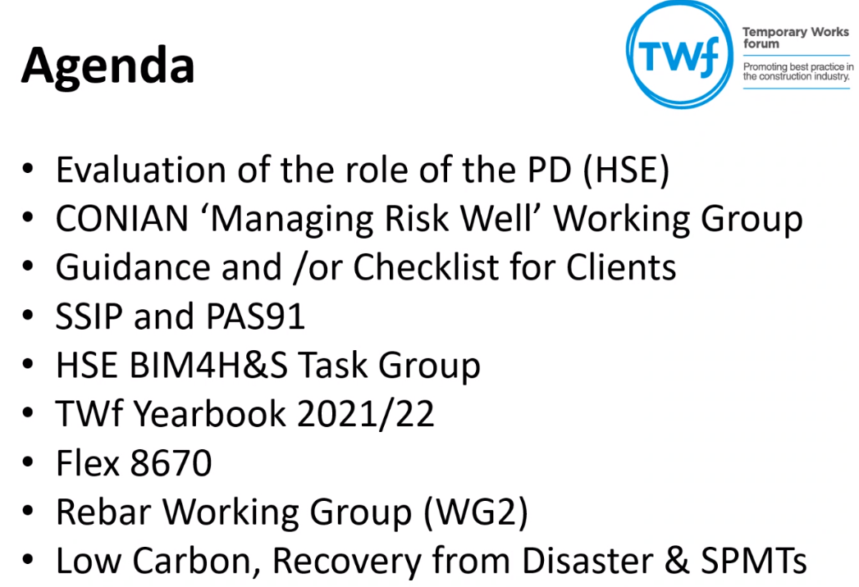  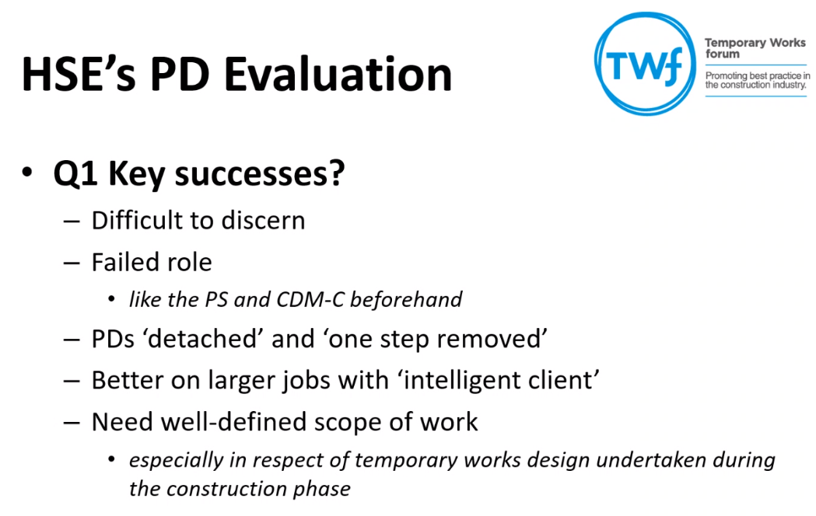  DT explained that in the world of CDM from a TW perspective – it is not good – TW see PD role as a failed role.  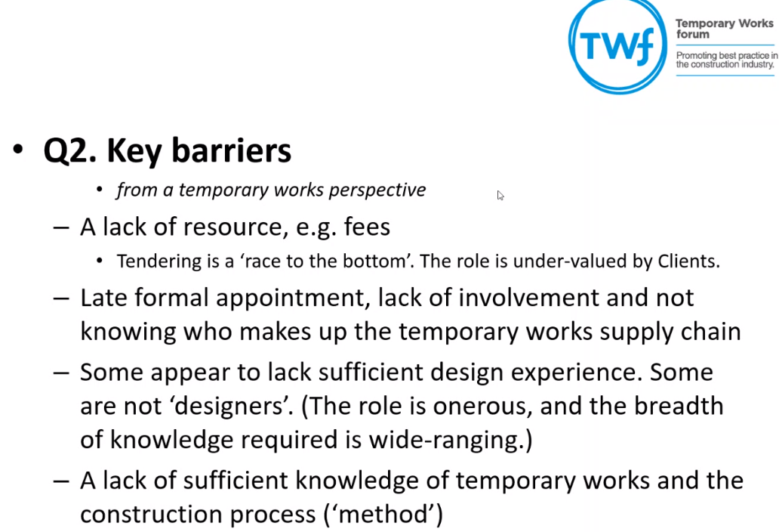  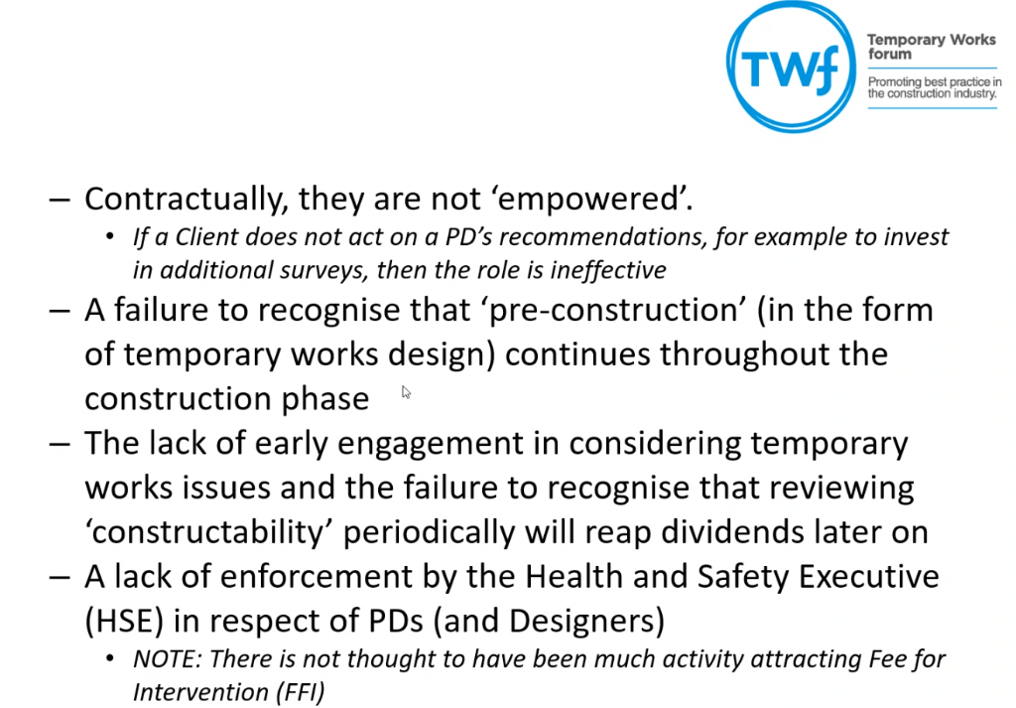  Early engagement with TW's issues will pay dividend further down the line.  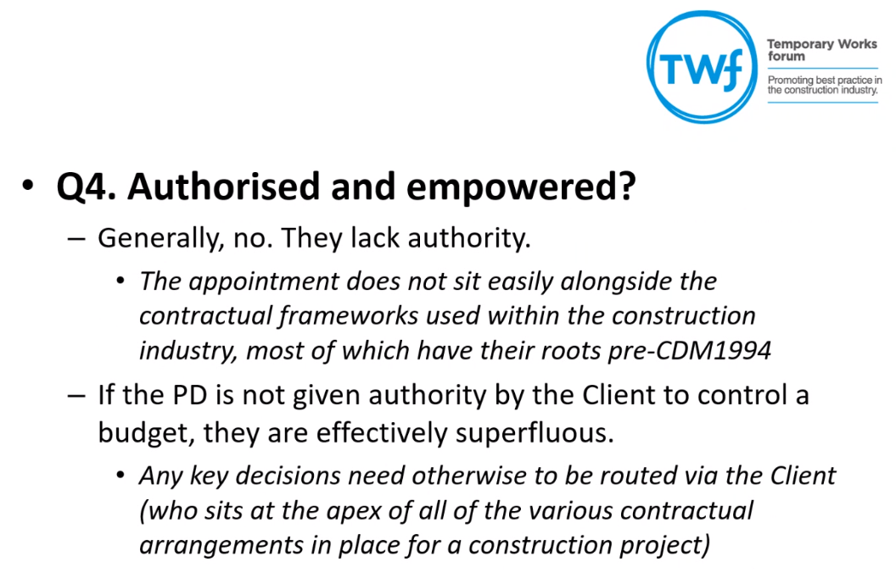  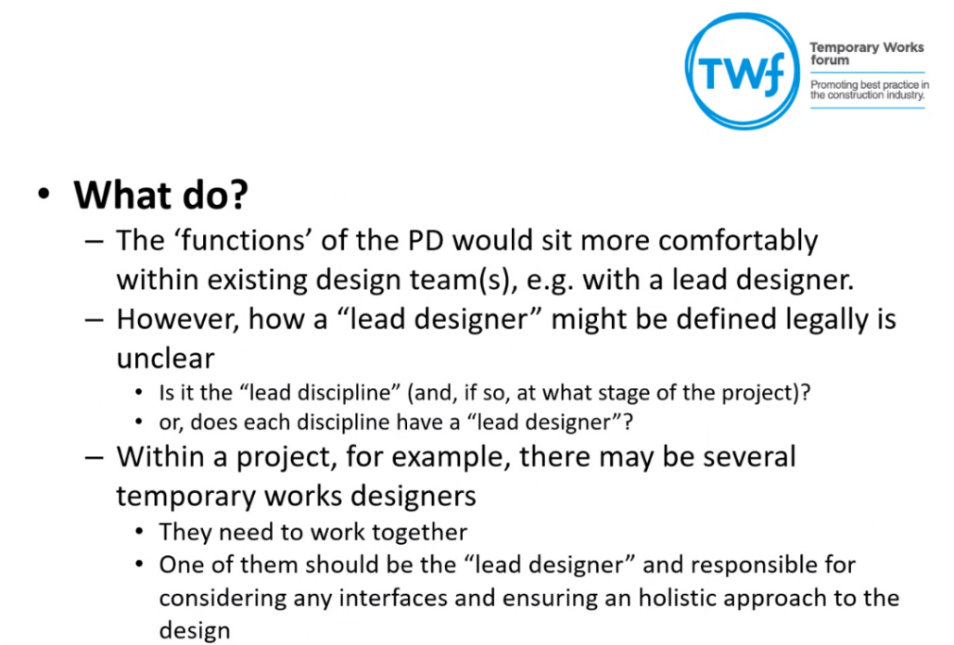  - DT will be happy to send a copy of the submission upon request.  - CONIAN is subservient to CONIAC.  - DT would welcome feedback from a Client perspective - what sort of guidance would be useful from a TW perspective? – Please drop thoughts to Dave.  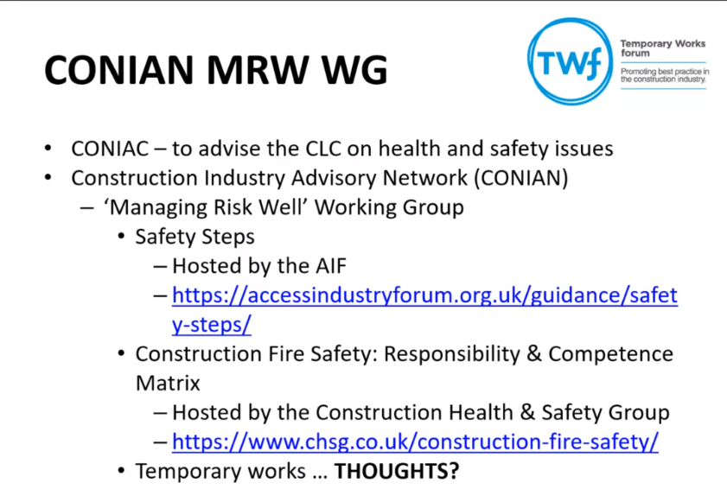  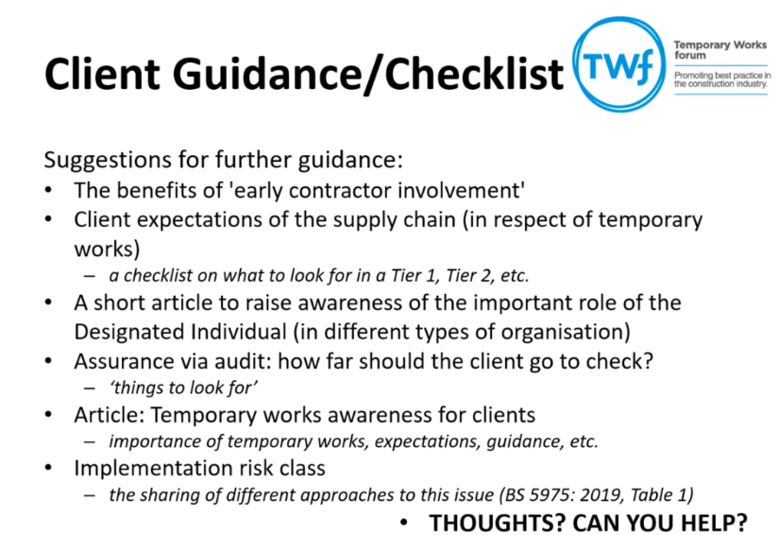  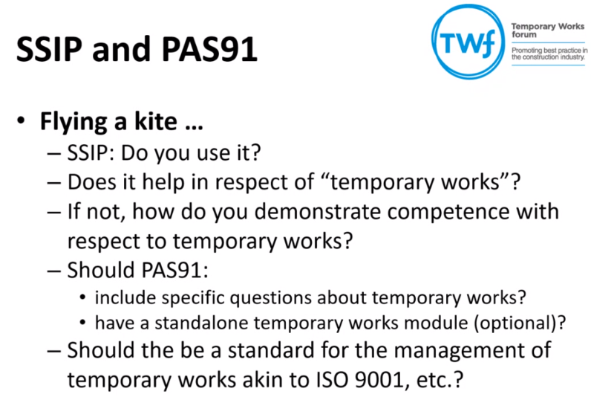  - PAS91 does not mention TW's. Should there be a standard for management of TWs like an ISO?  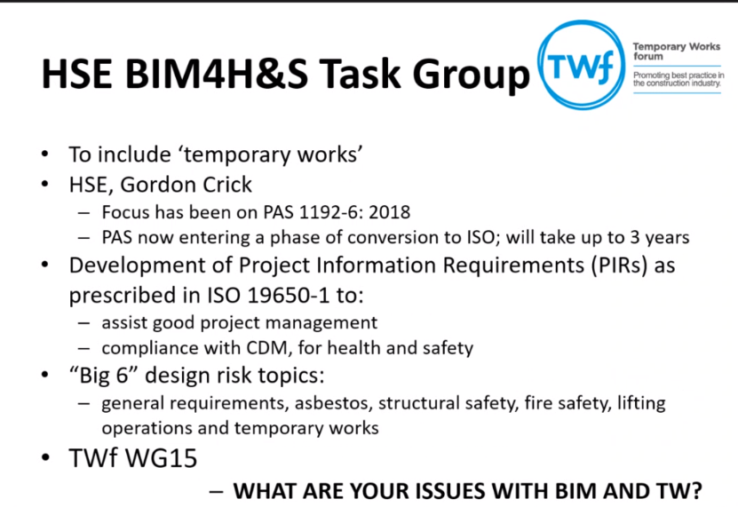  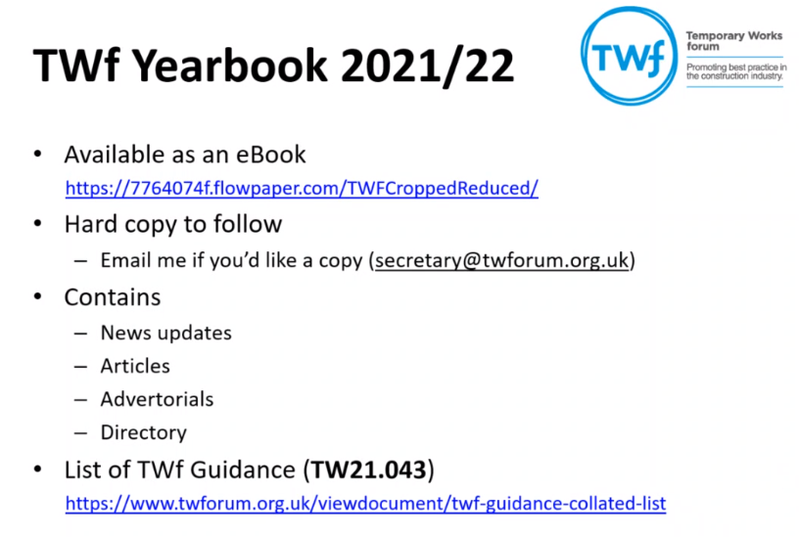  - Twf GUIDANCE all free to download from the TW website.  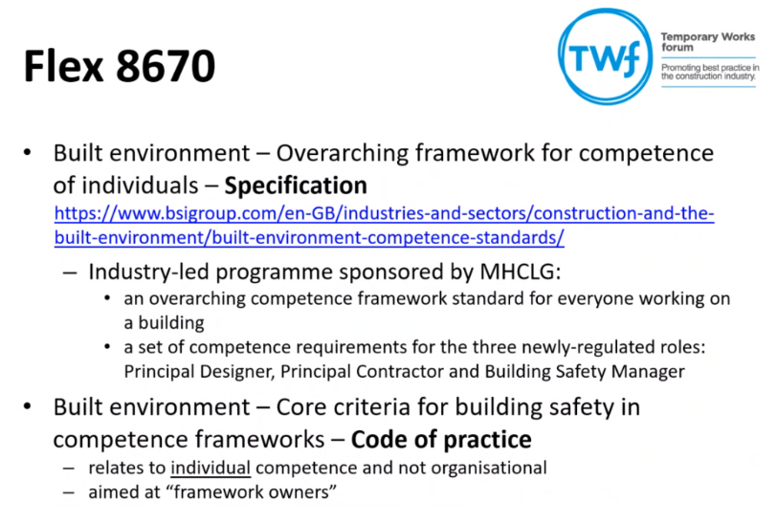  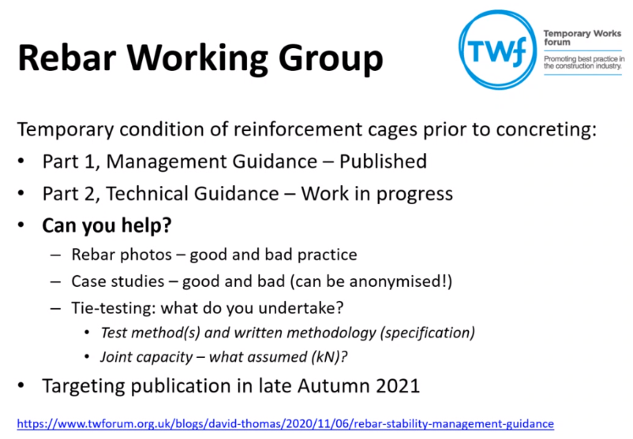  DT requested any rebar photos - good and bad examples for the library. Tie methods and results would be useful too, to input into document due for publishing in August this year.  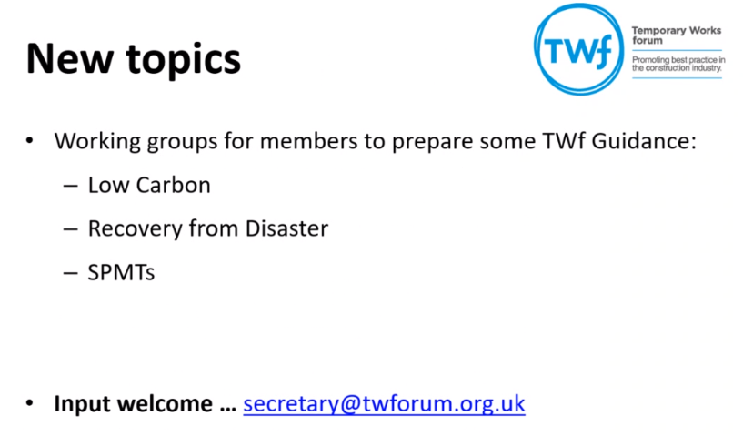  Final Thoughts  - We all need to be better at sharing safety alerts – it is actually difficult to analyse them from a TW perspective as the alerts are not all written in that detail. Recording of reports to help search them and make them easier to identify lessons learnt for a topic would help greatly.  - DT to identify any potential Safety Shares and feed back to the group.  - Common intent documents - do any cover TW's?  - AF - future digitisation - links with Gordon Cricks HSE group. Virtual rehearsals to understand the TW situation. TWf need to be a more of a focal point in projects and design community need to access the TWf resources and make use of them.  - DT would like us all to promote the TWf to all projects and designers.  - Slides to be uploaded to the minutes and included on the Hub website. |  | All  All  DT  MB
6.0 | Next Meeting – 20th May 2021 – Virtual meeting via Teams

Appendix A
Regional Asbestos Management Contacts
Name | Email | Responsibility
Ian Wood – Duty Holder  Julian Jones – Duty Holder | Ian.wood@highwaysengland.co.uk  Julian.Jones2@highwaysengland.co.uk | Facilities  Management
 |  | Major Projects
Ben Lavelle – Duty Holder.  Graeme Watt –  Asset Needs  Manager. | Benjamin.Lavelle@highwaysengland.co.uk  Graeme.Watt@highwaysengland.co.uk | Yorkshire North East –  Areas 12 / 14
Dave Shaw – Duty Holder  Gareth Ramsdale – Duty Holder  Kevin Clague – Asset Needs manager | Dave.Shaw@highwaysengland.co.uk  Gareth.Ramsdale@highwaysengland.co.uk  Kevin.Clague@highwaysengland.co.uk | North West –  Areas 10 / 13
Alun Jones – Asset needs manager & duty holder  Graham Gould – Duty Holder | Alun.Jones2@highwaysengland.co.uk  Graham.Gould@highwaysengland.co.uk | East –  Areas 6 / 8
Malcolm Dangerfield – Asset needs manager & duty holder  Louise Garbett – Asset needs manager | Malcolm.Dangerfield@highwaysengland.co.uk  Louise.Garbett@highwaysengland.co.uk | East Midlands –  Areas 7 / 9
Alan Whitworth – Duty Holder  Christopher Fuller – Assets needs  manager | Alan.Whitworth@highwaysengland.co.uk  Christopher.Fuller@highwaysengland.co.uk | South East –  Areas 3 / 4 / 5
Marcus Anning – Asset needs manager and duty holder  Mike Parsons – Duty Holder | Marcus.Anning@highwaysengland.co.uk  Michael.Parsons@highwaysengland.co.uk | South West –  Areas 1 / 2

