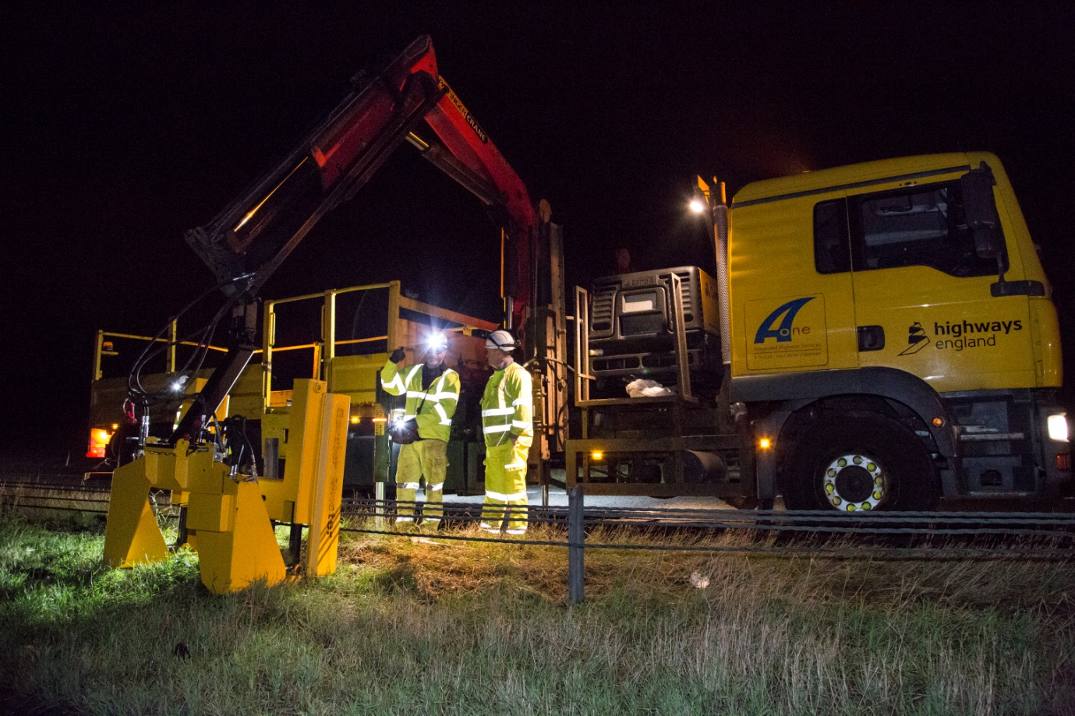
Following several serious accidents across the industry in recent years, A-one+ worked with the supplier to create the automated Barrier Master, which completely controls the post during the pulling process and removes the risk of overloading cranes or flying objects.

We worked with Post Pullers UK to develop a simple but effective piece of equipment that completely removes the risk to operatives of removing safety barriers.

A-one+ with PostPullers (UK) has successfully challenged the well established industry normal practice of crash barrier post extraction and developed a new innovative cost effective, efficient and economical solution which represents an industry wide game changing development
We believe this piece of equipment has the capacity to be an industry game-changer, as the Barrier Master operation transmits 100 per cent of the pulling force back into the ground, thus eliminating any stored energy. If a post should break then there is no danger of any ejected parts as there are no lifting accessories and the broken piece of post is held by the machine.

