Summary of Idea Form
Lesson Reference No: (To be entered by MP Knowledge Team)

Idea/Lesson Learnt Title:
Building Information Modelling (BIM) - Clash Prevention
Please enter a meaningful
title for the idea/lesson here:
Scheme | M1 Junction 19 Improvement
Approximate Scheme Works Value (£M) | £230m (MAB)  £128.5m construction.
To help others find the idea in the Knowledge Bank:  Which Project Control Framework (PCF) Stage does the idea relate to?  And at what PCF Stage should this idea be considered?  Design or Construction Stage?  Key words/Key phrases? | PCF 3 to 6  At the earliest possible stage during feasibility and design development when use of 3D modeling (BIM) can be used. PCF3,4,5,6  Design development, detailed design and construction  3D, BIM
Evidence Coordinator Name | Robert Hicks/Steve Hamer
Date of Submission | 31 January 2014
Project Information
Please rate your idea/lesson using the selectivity criteria and place a tick √ in the relevant boxes below to indicate the impact it has. ** Refer to Selectivity Criteria on attached sheet
Selectivity Criteria

Rating | Cost saving for Project | Delivery | Journey  Reliability | Health &  Safety | Reputation/Diversity & Integration | Sustainability/Environment
Highly Beneficial
Medium Beneficial
Low Beneficial
Neutral/No Impact
Adverse Impact

Commercial Sensitivity – Please indicate if the idea has commercial sensitivity and therefore does not merit wider visibility by stating yes/no in the attached box:
x

Yes No (please enter a X in the appropriate box)
Details of Idea/Lesson Learnt
Key Issue/Executive Summary: | What prompted the initiative?  Describe the circumstances that led to the issue | Introduction  The benefits of using Building Information Modelling (BIM) is very well developed, documented and recognised within the Building Industry but less so within Civil Engineering particularly Highways.  The development and use of a 3D BIM (virtual design) model on M1 J19 was considered to be highly beneficial to achieving efficiencies. Also the successful management of the interfaces between design, construction and procurement with the various suppliers and consequently the delivery of the project.  The delivery of the 3D model during the detailed design process is becoming more recognised as the project develops and the M1 J19 project is now leading the way in which BIM is used and has been put forward as an HA “Demonstrator” project.  This particular initiative described in this Knowledge Idea is the use of BIM 3D modelling for early identification and prevention of clashes in the overall project design “Clash Prevention”.  Previous design processes relied upon discipline teams in highway design working in isolation and coming together at key delivery milestones to review and coordinate across disciplines. If a clash was not detected at those milestone reviews it was possible for the clash to go undetected until construction potentially causing significant delays and costs while the clash was resolved.  Government BIM Strategy  The Government Construction Strategy, announced in May 2011 included plans to mandate the use of BIM on all public sector contracts within a 5 year horizon by 2016. The Strategy sets out a series of strategic objectives that aim to reduce construction costs on public sector projects by up to 20%.  Government require supply chain partners (Skanska and Jacobs) working on Public Sector projects (M1 J19) for public sector clients (Highways Agency) to achieve certain standards each year reaching a defined standard of “Level 2” BIM with fully integrated 3D (Virtual Design) BIM models by 2016.  Skanska BIM Strategy  Skanska has established their own very clear structure for BIM deliverables within which there are 16 Areas of BIM listed below in Figure 3.  Clash Prevention, the subject of this Knowledge Idea, is one of the 16 Areas of BIM identified as overall Best Practice.  M1 J19 Project BIM Strategy  The M1 J19 Improvement project involves the Design and Construction of works which are highly complex and complicated, of a high structural content with significant earthwork and TM implications, all in a very confined, congested and constrained area. Refer Figure 1.  Consequently the production of a single 3D BIM model which can be used for visualisation, Clash Prevention, planning and phasing of construction, traffic management and earthworks strategy and temporary diversion of traffic, is absolutely critical to the safe and timely construction of the scheme. Refer Figure 2  A BIM Business Case and Strategy was submitted to the Project Board and endorsed by them in July 12.  A BIM Workflow was produced for the project, refer Figure 4 and Detailed Design commenced in April 13.
Short Overview of Initiative to solve the issue | How does this initiative work and how was it put into practice?  Why was a different way of doing things seen as necessary/a good idea?  What did you do differently? | A commitment to delivering the M1 J19 in a BIM environment was made by Skanska and Jacobs. That commitment was to deliver a single 3D model as part of the new design process to take place.  The objective of the single 3D detailed design model is to provide a final design of all Civil works that incorporates and integrates all the individual design elements (alignment, fencing, safety barrier, drainage, lighting signs, etc). Each individual design layer can be overlaid in the 3D model at any time and checked for clashes.  Using BIM as an overall approach to design (full 3D models shared and coordination throughout the design process, based upon BS1192) gave better visibility to other design disciplines and to the other members of the delivery team.  A review of clashes at key gateways has been replaced with continuous formal and informal design review processes based entirely upon BIM. The term Clash Prevention has been used to reflect this change in approach.  The sharing of the 3D models throughout the design team and the delivery team gave early visibility to Design Options from all disciplines. These are continuously checked against existing assets and against all elements of the design.  Rather than waiting for key design gateways to share design proposals, 3D models have enabled rapid and better informed decision making to take place.  The ad-hoc review process happens at all points in the process, with specific gateway events still used to run more formal Clash Reviews to try and capture as many issues and problems as possible.  A Clash/Issues tracker is maintained by both Jacobs and Skanska and is used to formally identify and monitor issues. Refer Figure 6. Over 100 clashes have been recorded to date. Examples of Typical clashes are shown in Figures 7 and 8.
 | Please state if departures to standards were required and what approvals were sought for those departures.  What difficulties did you encounter when requesting departures? | Not applicable
Justification of Selectivity Matrix Indicators | Please ensure your justification is robust and that the issue has a proven track record. If the idea is new ensure it is reliable.  Provide your reasoning why you have assessed any of the selectivity criteria as highly beneficial:  Note £ Savings:  Note savings to the schedule of programme and efficiencies against budget :  Note impact on journey reliability:  Note benefits to Health and Safety:  Note benefits to Highway Agency Reputation and impact on diversity and integration  Note contribution to sustainability/ the environment | Costs  Statistics show that greater benefits can be derived from using BIM over traditional methods as this shifts the level of effort to earlier in the project when the ability to impact project cost and performance is high and the cost of making design changes is low. Refer Figure 5.  The use of BIM facilitates Jacobs and Skanska being able to review and influence the design prior to the production of drawings. This enables construction and constructability issues to be considered earlier in the design process and reduce the number of drawing iterations and delivering savings of the drawing production.  This is vital in contributing towards achieving project cost and programme efficiencies on the M1 J19 and seeking maximum benefit from a return of investment.  As more elements of the design are undertaken in 3D and included in the single model, Clash Prevention is more readily undertaken at design stage to help highlight and understand potential design conflicts and resolve them prior to construction.  Finding and fixing of design clashes during the design phase reduces rework and disturbances on site, and enhances the ability to prefabricate components off site e.g. Temporary Works.  Delivery  The impact of Clash Prevention and the identification of potential Design and Construction issues at an early stage of Design has reduced programme risk significantly.  The approach has underpinned a more collaborative approach to design and given all parties a better understanding of the design than with previous approaches.  Bringing Contractor and Supply chain expertise into the early stage Clash Prevention process has resolved issues at a stage where they can be reviewed and rectified prior to construction.  BIM permits the checking and reviewing of the design both internally within Jacobs and externally for the Highways Agency and URS with improved and reduced time frames.
If able to, please provide an indication of the cost benefits if the idea was used many times.
Please explain how you reached your conclusion and ensure that it is quantifiable.

If able to please predict how many times this idea could be re-used.

Does this idea have links to any other ideas already on the Knowledge Bank or the HA Toolkits? | If your answer is yes please give details of the links.  If your answer is no, please say so to show that possible links to other initiatives have been considered. | No, however other HA projects e.g. A180 Immingham, A556 Knutsford to Bowden and M6 Smart Motorway 16 – 19 are already benefitting from the learning of the M1 J19 BIM initiatives.  The initiatives are also disseminated and discussed at the HA BIM Working Group which Skanska attend and also shared with representatives of the Government BIM Task Group and HA Lean team.
Please provide any supporting evidence: pictures, graphs, figures, documents or other evidence | Provide examples that clearly demonstrate the issue, new way of working and how it is making a difference. | See Figures below
Verification Group Decision

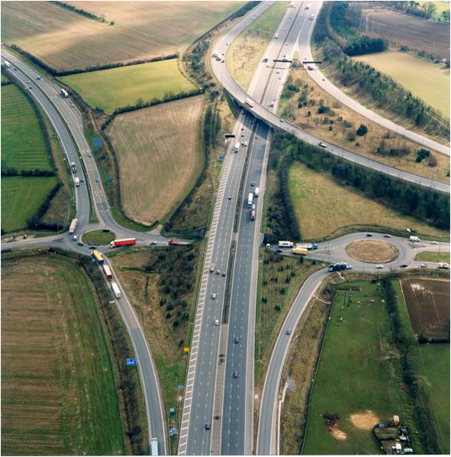
M6 to B/Ham
Ports
M1 to Leeds
Ports
M1 to London
Ports
A14 to Ports
Ports
Figure 1 - Existing M1 J19
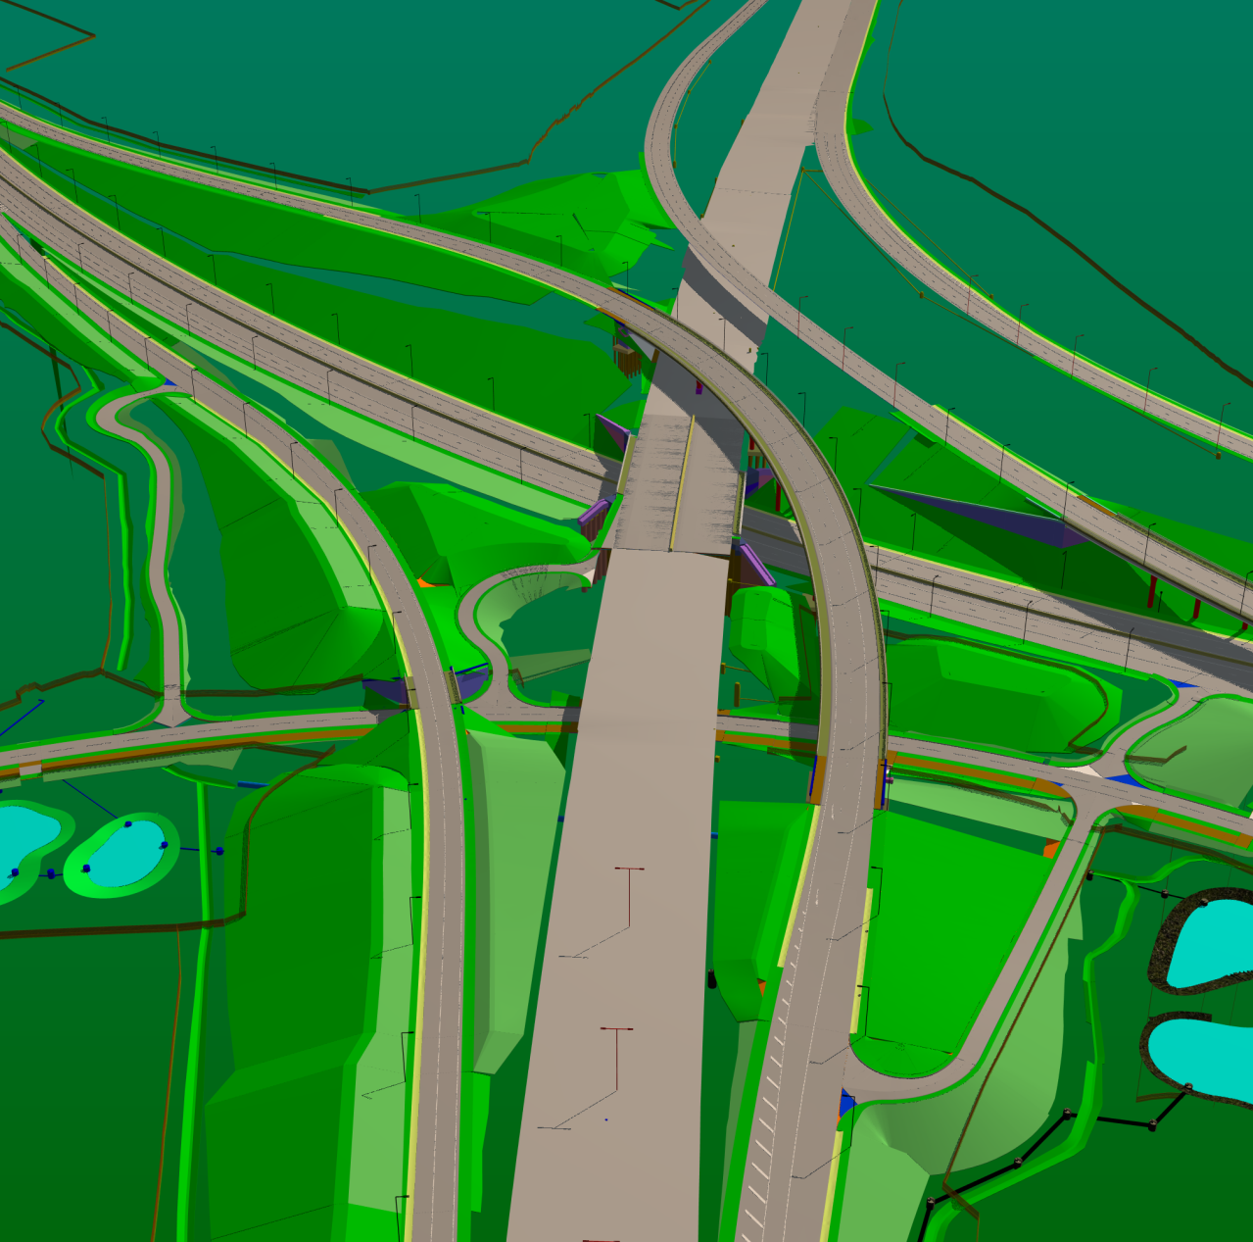
Figure 2 - Proposed M1 J19 Improvement Scheme – 3d Model
A14 to Ports
Ports
M1 to Leeds
Ports
M6 to B/Ham
Ports
M1 to London
Ports
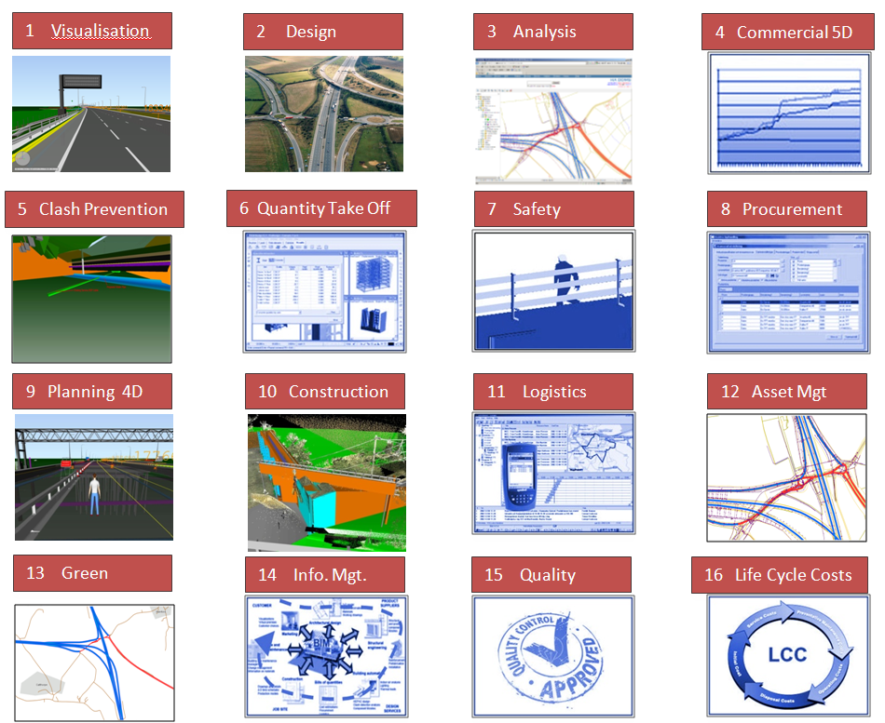

Figure 3- Skanska 16 Areas of BIM

Design
Construction
Asset/FacilitiesManagement
QTO
Clash Prevention
5D Commercial
Logistics
Analysis
4D Simulation
3D
2D

Safety
Green
Information Mgt.
Life Cycle Cost
Quality
Procurement
Visualisation
Jacobs
M1 J19 - BIM Workflow

Figure 4 - BIM Workflow

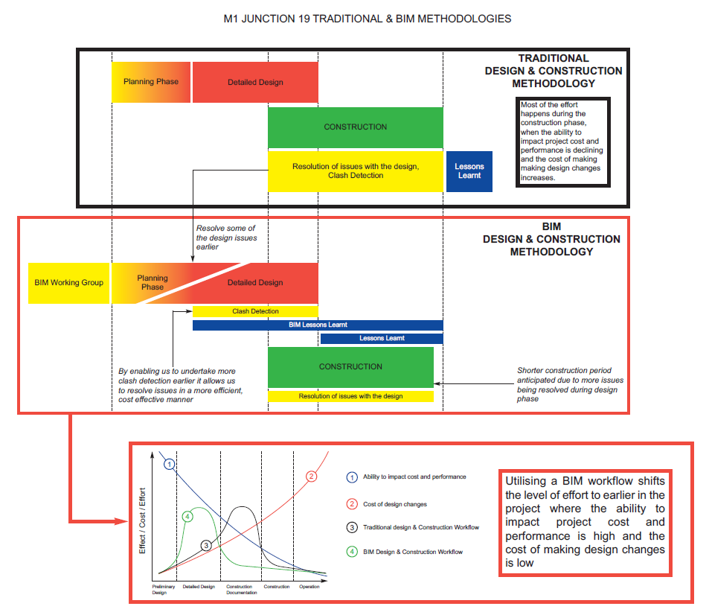
Figure 5 - Overall approach to Design

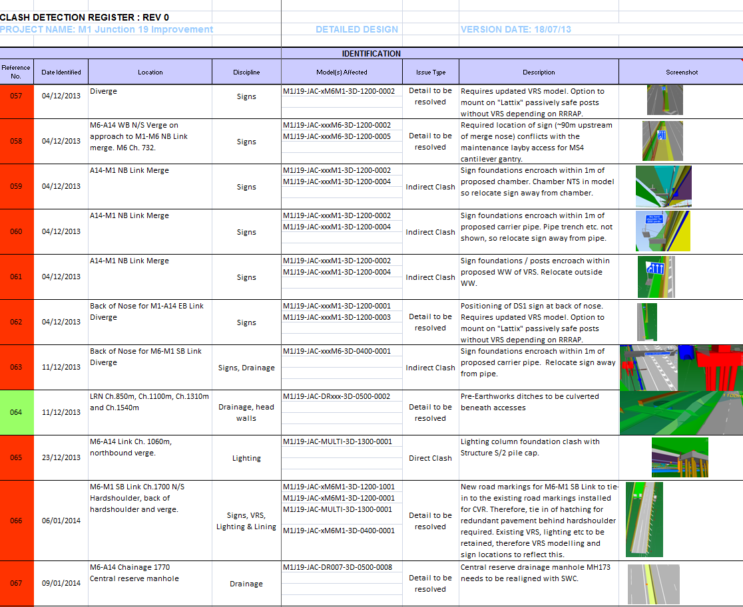
Over 100 clashes recorded to date

Figure 6 - Extract from the Clash Prevention Register

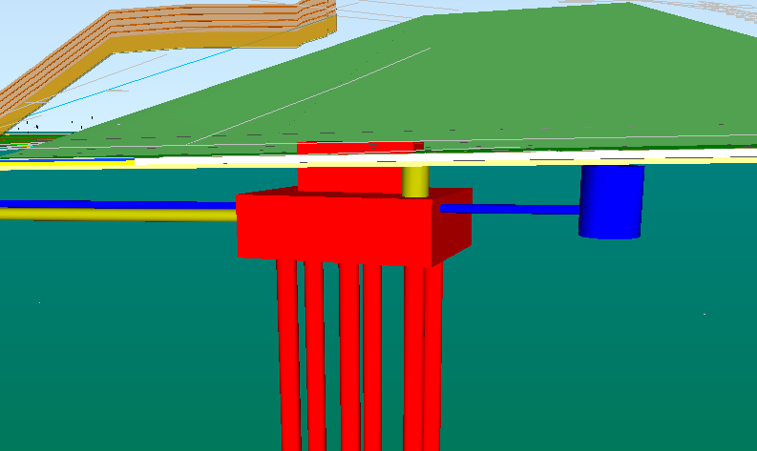
Date: 10/09/2013
Location: M1 Chainage 1900
Description: Proposed Gantry G6 clashes with existing drainage
Resolution: Gantry moved 15m north to avoid drainage

Figure 7 - Typical Issue picked up through Clash Prevention Process

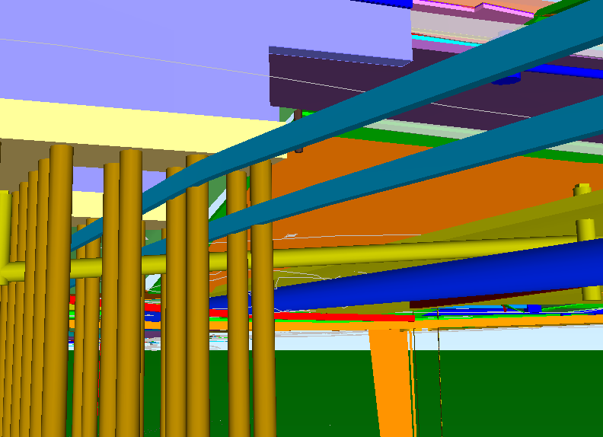

Date: 12/02/2014
Location: M1 and S2 Piles
Description: Stats clashing with substructures, proposed STW Directional Drill clashing with S2 Piles
Resolution: Directional drill to be relocated and confirmed with Severn Trent

Figure 8 - Typical Issue picked up through Clash Prevention Process and Supply Chain/Contractor engagement

Major Projects Knowledge sharing project ground rules and selectivity matrix

- The idea/lesson learnt must fit with one or more Highways Agency (HA) Strategic Plan goals and measures. These are as follows:

- Provide a service customers can trust by improving the reliability of journey time.
- Set the standard for delivery by producing deliverable, affordable and value for money services.
- Deliver sustainable solutions by reducing carbon emissions from our activities.
- Deliver the safest roads in the world by reducing deaths and injuries in line with Government targets, including risks for our own on-road workforce.
- Reducing the cost of improving, maintaining and managing the Strategic Road Network.
- As part of the strategic vision we must also meet the diverse needs of all our customers with due regard to those with protected characteristics under the Equality Act.

- The idea/lesson learnt must be transferrable to other projects as follows:
  - Major Improvement
  - Small Improvement
  - Maintenance
  - Technology
  - Managed Motorways (this is the accepted umbrella term for HSR/MM etc)

- The idea/lesson learnt must be innovative and not standard industry practice.

- The idea/lesson learnt must meet the selectivity criteria. (See Table below)

- Ideas/lesson learnt must not refer to or promote proprietary products.

Criteria for selection

Consider
- 1 High or more boxes, irrespective of any neutral/adverse impact.
- More Moderates than neutral/adverse impact.
- Ideas that may have low initial cost value, but could bring greater cost benefits if re-used many times

Discount
- Any combinations of Low and/or neutral and/or adverse impact.

Use the ideas/lessons learnt pro-forma to submit those that meet the criteria as set out above for consideration by the Verification Group. Please provide sufficient detail that the idea/lesson learnt can be applied elsewhere.

Rating | Cost saving for project | Delivery | Journey Reliability | Health and Safety | Reputation/Diversity and Integration | Sustainability/Environment
High | £1M + Saving | Significant savings to agreed schedule of programme and target of 20% efficiencies against budget have been exceeded | Significant Improvement to journey time that exceeds the average of 3 minutes during peak time  - Traffic Flow  - Accident Frequency  - Incident Clear-up Times | Significant improvement where the accident frequency rate target 0.10 has been greatly reduced | Potential National/International Media Interest  Advance equality of opportunity | Significant Enhancement (of any 1 with no detriment to rest)  - Carbon  - Waste  - SPAs, SSIs etc  - Air  - Noise
Medium | £0.1 - £1M Saving | Moderate savings to agreed schedule of programme and target of 20% efficiencies against budget | Moderate Improvement in journey time that meets the average of 3 minutes during peak time  - Traffic Flow  - Accident Frequency  - Incident Clear-up Times | Moderate improvement where the accident frequency rate target 0.10 has been reduced | Regional Media Interest  (Government Office Regions)  Prevent discrimination | Moderate Enhancement (of any 1 with no detriment to rest)  - Carbon  - Waste  - SPAs, SSIs etc  - Air  - Noise
Low | < £0.1M Saving | Slight savings to agreed schedule of programme and target of 20% efficiencies against budget  . | Slight Improvement in journey time that is working towards the average of 3 minutes during peak time  - Traffic Flow  - Accident Frequency  - Incident Clear-up Times | Slight improvement where the project is working towards achieving the accident frequency rate target 0.10 | Local Media Interest  (Scheme/MAC)  Foster good relations | Slight Enhancement (of any 1 with no detriment to rest)  - Carbon  - Waste  - SPAs, SSIs etc  - Air  - Noise
Neutral | Neutral | Neutral | Neutral | Neutral | Neutral | Neutral
Adverse Impact | Adverse Impact | Adverse Impact | Adverse Impact | Adverse Impact | Adverse Impact | Adverse Impact

Selectivity criteria

