Summary of Idea Form
Lesson Reference No: (To be entered by MP Knowledge Team)

Idea/Lesson Learnt Title:
Google Streetview updated specifically for Smart Motorway infrastructure and assessment surveys.
Please enter a meaningful
title for the idea/lesson here:
Scheme | M1 Junction 19 Improvement
Approximate Scheme Works Value (£M) | £230m (MAB)
To help others find the idea in the Knowledge Bank:  Which Project Control Framework (PCF) Stage does the idea relate to?  And at what PCF Stage should this idea be considered?  Design or Construction Stage?  Key words/Key phrases? | PCF1 to 7  PCF3,4,5,6,7  Design, Construction, Maintenance, Operation and also for the benefit of the travelling public.  Google Earth Google Streetview Dilapidation survey
Evidence Coordinator Name | Mark Lawton
Date of Submission | 03/3/2014
Project Information
Please rate your idea/lesson using the selectivity criteria and place a tick √ in the relevant boxes below to indicate the impact it has. ** Refer to Selectivity Criteria on attached sheet
Selectivity Criteria

Rating | Cost saving for Project | Delivery | Journey  Reliability | Health &  Safety | Reputation/Diversity & Integration | Sustainability/Environment
Highly Beneficial |  |  |  |  | 
Medium Beneficial |  |  | 
Low Beneficial |  |  |  |  |  | 
Neutral/No Impact
Adverse Impact

Commercial Sensitivity – Please indicate if the idea has commercial sensitivity and therefore does not merit wider visibility by stating yes/no in the attached box:
x

Yes No (please enter a X in the appropriate box)
Details of Idea/Lesson Learnt
Key Issue/Executive Summary: | What prompted the initiative?  Describe the circumstances that led to the issue | Google Earth, Google Maps and Google Streetview is used by Skanska and a large population of the world.  However the reliance of the imagery controlled by Google always means projects and areas do not have the latest imagery.  When the M1Junction19 improvement (M1J19) project was about to commence the imagery of the old Catthorpe Viaduct bridge, constructed by Skanska as an advance contract, was still the most recent imagery (dated 2009).This bridge had been demolished around 24 months prior to commencement of the M1 J19 project in Jan 14. This meant that the Google imagery was unusable for our operations.
Short Overview of Initiative to solve the issue | How does this initiative work and how was it put into practice?  Why was a different way of doing things seen as necessary/a good idea?  What did you do differently? | The commissioning of Google Streetview was arranged by Mark Lawton (Skanska Chief Surveyor) and all the routes that were affected by the construction of the M1J9 were selected to have a Google Streetview update (Refer Figure 3) This was successfully implemented in January 2014 and the initiative is now a process.  Why was this different?  I proactively engaged with Google to ensure a plan was in place to have Google Streetview imagery for the beginning of construction. The Google imagery is independent imagery and also suitable for an assessment survey.  Now that the current imagery is in place the Design and Construction teams are using this data to verify the design and the planning of construction. We refer to this imagery daily. This imagery is available to everyone in the world with access to the internet on any device, free of charge.  This has been well received in presentations given to M1J19 Highways Agency Project Manager Ivan Marriot and Deputy Project Manager David Reed and their representative Nigel Dodds from URS.  This has been fully supported by the Managing Director of Skanska Civil Engineering and the Skanska BIM team leader Malcolm Stagg.  When implemented this would lead to:  - More accurate information and imagery for tendering  - The design team would be better informed.  - An assessment survey  - A more knowledgeable construction team  - Historic as built imagery survey  - Well informed travelling public  - Capture condition at each visit  Refer to Figure 1 below for a full life cycle
 | Please state if departures to standards were required and what approvals were sought for those departures.  What difficulties did you encounter when requesting departures? | Departures  N/a
Justification of Selectivity Matrix Indicators | Please ensure your justification is robust and that the issue has a proven track record. If the idea is new ensure it is reliable.  Provide your reasoning why you have assessed any of the selectivity criteria as highly beneficial:  Note £ Savings:  Note savings to the schedule of programme and efficiencies against budget :  Note impact on journey reliability:  Note benefits to Health and Safety:  Note benefits to Highway Agency Reputation and impact on diversity and integration  Note contribution to sustainability/ the environment | Savings  This pilot was conducted free of charge the cost of an assessment survey was removed, circa £2500.  Savings programme  Savings related to the programme are difficult to quantify. However, people from the design and construction teams have commented that this has made them more informed before attending site, if required to attend site at all. (See Figure 4.2)  Journey  Improved benefit to the travelling public at the end of the construction.  People who have access to Google Maps would be able to view the new road layout before arriving at a newly constructed section of infrastructure.  Refer to Figure 1  Health and Safety  Before arriving on site you would have a greater awareness of the environment/layout. It could, therefore, reduce the number of site visits required  If the imagery is current it can be viewed from the safety of your chosen internet enabled device, remote from the area of risk. This will mean less exposure and risk to those who may otherwise have to visit the site if the Google update was not current.  Refer Figure 2 below  Reputation  If the HA worked in co-operation with Google it would enhance their reputation for using freely available technology. This would demonstrate that they are active contributors to the digital age and would considerably enhance a Smart Motorway scheme.  Sustainability  The removal of unnecessary journeys and awareness of the infrastructure layout would lead to smarter travelling and would reduce the carbon footprint of any user of Google Maps.
 | If able to, please provide an indication of the cost benefits if the idea was used many times.  Please explain how you reached your conclusion and ensure that it is quantifiable.  If able to please predict how many times this idea could be re-used. | Cost benefits  The cost to capture the imagery was estimated to cost £25 per km. Other companies that capture street level imagery charge £30 per km, however their data is subject to having the appropriate software and access rights.  Google Maps and the captured imagery is freely accessible to the entire world.  My prediction is this will make 20% of intended site visits not required and provide better accurate information for all initial visits to site.  My conclusion is based from experience of using and mentoring staff in the use of BIM for free tools.  My prediction is that capturing current Google Streetview imagery will become the normal way of working. I will make this a recommendation to the BIM4survey committee that I contribute to on a regular basis.
Does this idea have links to any other ideas already on the Knowledge Bank or the HA Toolkits? | If your answer is yes please give details of the links.  If your answer is no, please say so to show that possible links to other initiatives have been considered. | Yes (Submitted)  - Establish WIFI lines of sight using Google Earth (rejected)  No (To be submitted)  - Google Streetview commissioned before tender release and after project completion.  - Geo reference take off and measuring using Google Earth
Please provide any supporting evidence: pictures, graphs, figures, documents or other evidence | Provide examples that clearly demonstrate the issue, new way of working and how it is making a difference. | Please refer below
Verification Group Decision

FIGURE 1

Figure 2

Staff briefing team before work commences on site using the updated Google Streetview. Reference to dilapidation can be made before leaving for site. This can be compared with historic imagery.
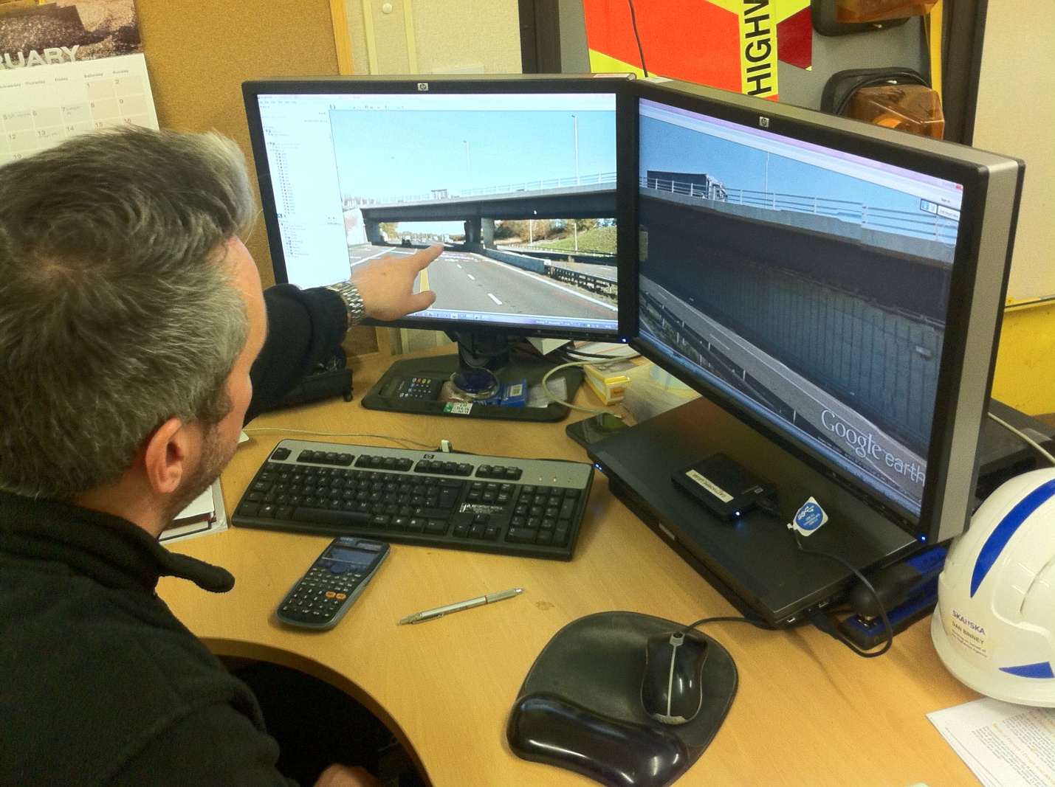

Figure 3
Assessment area covered by Skanska-Google initiative in red

Figure 4.1

Key Markup Language (KML) file exported from the BIM model plan view into Google maps. Used for location only.
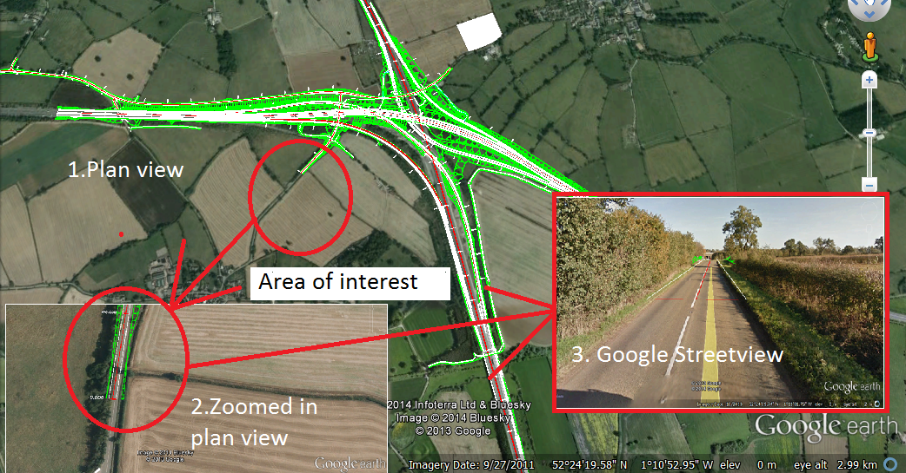
Figure 4.2

Key Markup Language (KML) file exported from the BIM model and used in the updated Google Streetview.This imagery shows the tie in and allows the users to understand the future enviroment.The Dilapidation is also captured.

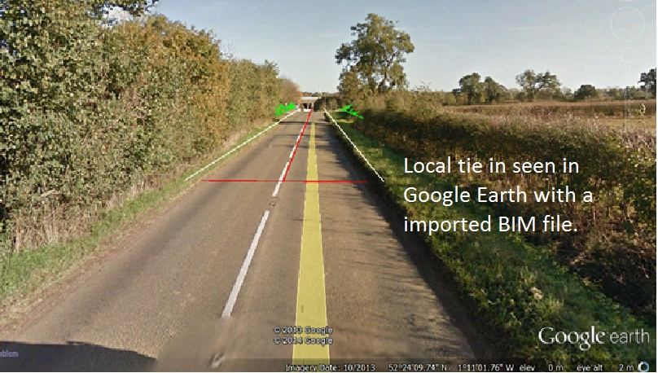
Major Projects Knowledge sharing project ground rules and selectivity matrix

- The idea/lesson learnt must fit with one or more Highways Agency (HA) Strategic Plan goals and measures. These are as follows:

- Provide a service customers can trust by improving the reliability of journey time.
- Set the standard for delivery by producing deliverable, affordable and value for money services.
- Deliver sustainable solutions by reducing carbon emissions from our activities.
- Deliver the safest roads in the world by reducing deaths and injuries in line with Government targets, including risks for our own on-road workforce.
- Reducing the cost of improving, maintaining and managing the Strategic Road Network.
- As part of the strategic vision we must also meet the diverse needs of all our customers with due regard to those with protected characteristics under the Equality Act.

- The idea/lesson learnt must be transferrable to other projects as follows:
  - Major Improvement
  - Small Improvement
  - Maintenance
  - Technology
  - Managed Motorways (this is the accepted umbrella term for HSR/MM etc)

- The idea/lesson learnt must be innovative and not standard industry practice.

- The idea/lesson learnt must meet the selectivity criteria. (See Table below)

- Ideas/lesson learnt must not refer to or promote proprietary products.

Criteria for selection

Consider
- 1 High or more boxes, irrespective of any neutral/adverse impact.
- More Moderates than neutral/adverse impact.
- Ideas that may have low initial cost value, but could bring greater cost benefits if re-used many times

Discount
- Any combinations of Low and/or neutral and/or adverse impact.

Use the ideas/lessons learnt pro-forma to submit those that meet the criteria as set out above for consideration by the Verification Group. Please provide sufficient detail that the idea/lesson learnt can be applied elsewhere.

Rating | Cost saving for project | Delivery | Journey Reliability | Health and Safety | Reputation/Diversity and Integration | Sustainability/Environment
High | £1M + Saving | Significant savings to agreed schedule of programme and target of 20% efficiencies against budget have been exceeded | Significant Improvement to journey time that exceeds the average of 3 minutes during peak time  - Traffic Flow  - Accident Frequency  - Incident Clear-up Times | Significant improvement where the accident frequency rate target 0.10 has been greatly reduced | Potential National/International Media Interest  Advance equality of opportunity | Significant Enhancement (of any 1 with no detriment to rest)  - Carbon  - Waste  - SPAs, SSIs etc  - Air  - Noise
Medium | £0.1 - £1M Saving | Moderate savings to agreed schedule of programme and target of 20% efficiencies against budget | Moderate Improvement in journey time that meets the average of 3 minutes during peak time  - Traffic Flow  - Accident Frequency  - Incident Clear-up Times | Moderate improvement where the accident frequency rate target 0.10 has been reduced | Regional Media Interest  (Government Office Regions)  Prevent discrimination | Moderate Enhancement (of any 1 with no detriment to rest)  - Carbon  - Waste  - SPAs, SSIs etc  - Air  - Noise
Low | < £0.1M Saving | Slight savings to agreed schedule of programme and target of 20% efficiencies against budget  . | Slight Improvement in journey time that is working towards the average of 3 minutes during peak time  - Traffic Flow  - Accident Frequency  - Incident Clear-up Times | Slight improvement where the project is working towards achieving the accident frequency rate target 0.10 | Local Media Interest  (Scheme/MAC)  Foster good relations | Slight Enhancement (of any 1 with no detriment to rest)  - Carbon  - Waste  - SPAs, SSIs etc  - Air  - Noise
Neutral | Neutral | Neutral | Neutral | Neutral | Neutral | Neutral
Adverse Impact | Adverse Impact | Adverse Impact | Adverse Impact | Adverse Impact | Adverse Impact | Adverse Impact

Selectivity criteria

