BACKGROUND

Personnel being struck by vehicles and plant cause on average ten fatal injuries and approximately 150 major injuries in the construction industry each year. Hence the control of risks associated with plant, passing through or working within our worksites is of paramount importance.

APPROACHING PLANT & VEHICLES!

- Anyone approaching plant must make eye contact with the operator (and banksman if applicable) and wait until signalled. Use the ‘THUMBS UP APPROACH’. See below.
- DO NOT enter the area until they have signalled it is safe to do so!
- Operators must ensure that any safety levers are activated and machines switched off before people approach, with buckets (or attachments) grounded.
- If driving and needing to pass an item of plant, stop a safe distance away, gain eye contact with the operator and banksman if applicable and wait for a signal that it is safe to pass. If passing an excavator, the bucket must be grounded.

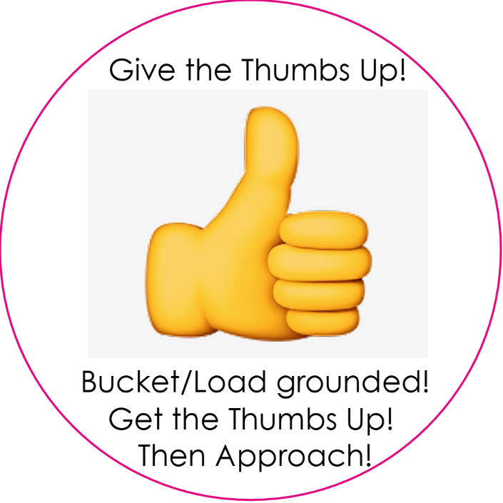

BANKSMAN/VEHICLE MARSHALS

- If working with plant, stand in the recommended safe position, as detailed in the risk assessment. Do not stand on the blind side of the plant where the operator cannot see you or has restricted visibility. Plant/Vehicle Marshalls must be competent to undertake their role, however please note: as part of the risk assessment process for using mobile plant the use of a marshall ‘must not ‘be the default position. The preference must always be to remove the plant/people interface wherever practicable and therefore the use a marshall should be ‘risk assessed in’.

EXCLUSION ZONES!

The diagrams in this toolbox talk give an understanding of the safe zones applicable to a range of plant machinery likely to be used on our sites.

Zone 1 | Always signal the plant operator and receive a positive response before entering this zone.
Zone 2 | KEEP OUT OF THIS AREA AT ALL TIMES (unless machine is fully isolated).
Machine Operator Site line Controlled access zone. | Area within operators line of sight – This is the best zone for approaching an excavator as it provides the greatest chance of you being seen by the operator. Stand in this area to attract operators attention. This includes Machine controllers/banksman.

 | 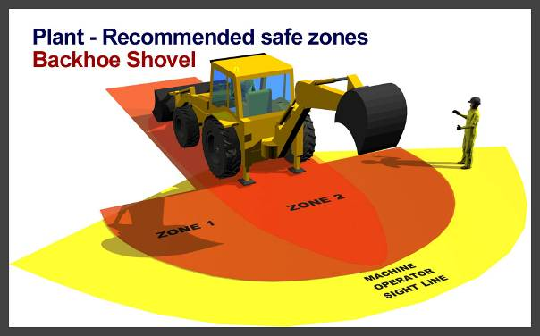
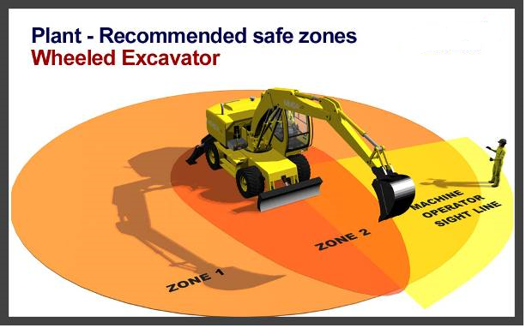 | 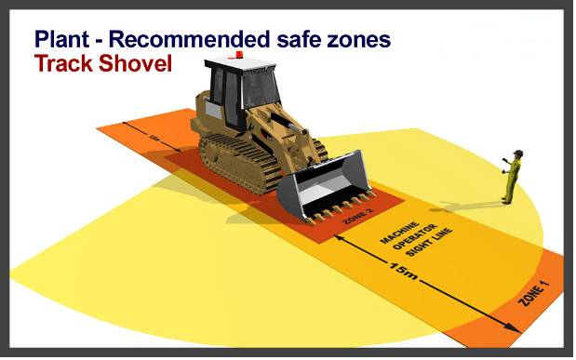
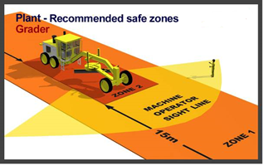 | 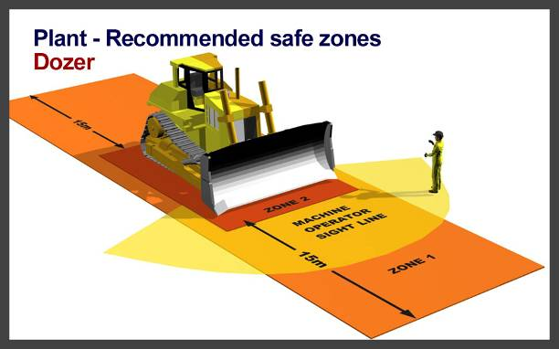
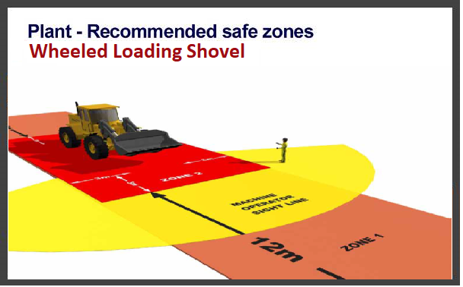 | 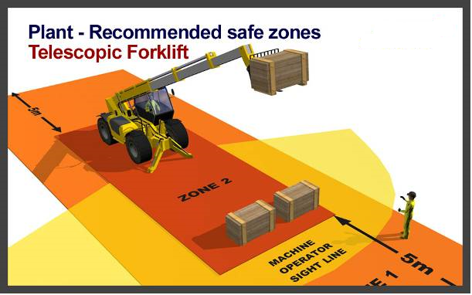
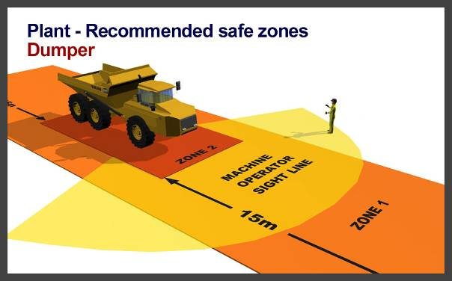 | 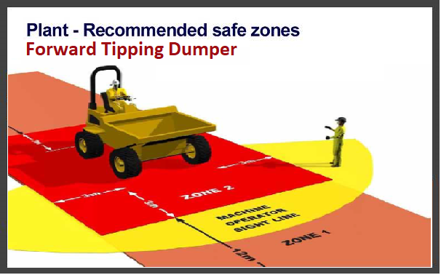
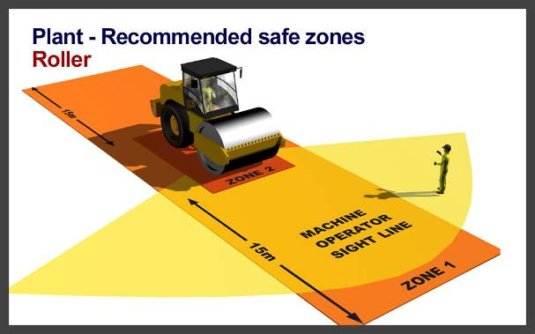
ALWAYS USE THUMBS UP APPROACH - BE SEEN & BE SAFE!

