Raising the Bar 9 - Service Avoidance - Issued July 2013 Revised June 2017
Objective
Scope
Background
Minimum requirements
Risk assessment and planning
Design process
Detailed planning of work tasks
People requirements
Equipment requirements
Cable avoidance tools
Mark services
Risks / controls
Permits
Responsibilities of Personnel
Emergency arrangements
Incident Investigation
Minimum Mandatory Requirements
References
Appendix 1 – USAG Investigation Checklist
Appendix 2 – Minimum Mandatory Requirements Poster

Objective
This raising the bar guidance provides mandatory minimum standards for excavation in order to prevent service strikes and the associated risk of harm.

The guidance covers accurate location of services, clear identification and safe working controls in the vicinity of underground services.

Scope
This guidance is relevant to ALL services including:
- Electrical, gas, water, sewerage and other drainage
- Telecommunications and other fibre optic cables
- NRTS road technology cables
- And above ground services (but not overhead) e.g. CCTV cables and above ground gas installations

Background
This area was chosen as a raising the bar topic as there have been repeated service strikes on various projects and contracts.

Minimum requirements
The expectation is that all the guidance contained within should be considered mandatory minimum requirements.
Risk assessment and planning
Physically mark services
Permits and cable avoidance
Emergency arrangements
Check and review

Risk assessment and planning
Prestart meetings with the statutory undertaker and supply chain should be held prior to start on site to set expectations with regards to competency and working standards. Agreement must also be reached with the utility owner about what methods and techniques can be utilised within the proximity of their asset.

The responsibility for works (who is principal contractor under the Construction, Design and Management Regulations) should be clearly recorded for each element of the works as this may change depending on the location of the works.

Design Process
The hazard of excavation around services must be initially identified at the design stage and be included on the design risk register. Efforts must be made and works considered to eliminate or reduce this activity wherever practical.
Early engagement with utility companies and the client to collate data and information on services must be undertaken, together with commissioning of relevant surveys.

Detailed planning of work tasks
Principal Contractors must plan excavation tasks ensuring that current service drawings are obtained and fully reviewed.
Service drawings may give an indication as to the location of a service, however, the accuracy can vary. The location must be confirmed via scanning and digging. Once the service is located, in one trial hole the depth / offset can vary significantly a very short distance away especially where there are physical constraints. Multiple trial holes should be made on each service as appropriate.
Be aware that when working in close proximity to services it is possible that they may run through material that is to be removed, e.g. ducting that has been overlaid with concrete. If not appropriately managed this can lead to services being unintentionally removed with other items such as kerbs. Where possible services should be isolated or items removed in small controlled quantities.

Before any works start, a site walkthrough must be undertaken by all persons who will be involved in the operation.
Where no services are shown, conduct an onsite survey looking for:
- Items that may have a power supply e.g. street lamps, signage or gantries
- Scarring or depressions in the road where there may have been a repair or new service laid
- Manhole covers and frames including hydrants and valves.
In addition look for any above ground services which may be hidden in the verges by grass such as:
- Trailing CCTV cables
- Above ground gas installations (illustrated below)
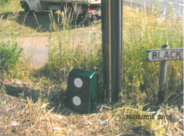

People Requirements
The minimum training requirement for all Managers, Supervisors and Operatives who are required to locate underground services during planned excavations is an accredited course either IOSH or CITB fulfilling the requirements of HSG47 (Avoiding danger from underground services).

Labourers and other individuals working in close proximity to services digging trial holes for example must be made aware of the standard types and coloured ducting used for each service. This may form part of induction or be delivered through service related training on site. Personnel should also be aware of the dangers of poorly maintained services that could conduct in water or leak hazardous substances. Be aware that whilst the table below should be followed, any type of service can be any colour. Black and clay ducts for example are frequently found.

Tool box talks and regular refresher sessions should be delivered to workers. Resources to help can be found here: http://www.highwayssafetyhub.com/buried-services-2017.html

Table 1 Standard Service Colours:

Utility Colour |  | Utility Colour
Electricity | Red | BT | Grey
Gas | Yellow | Data cables | Purple
Water main | Blue | Cable TV | Green
Sewer/drainage | Brown | Road lighting | Orange

Equipment Requirements
As part of the risk assessment process a safe excavation method should be agreed. When hand-digging, insulated tools must be used to protect the user from current leakage or service strikes.
Before starting any excavation ensure that edge protection is installed to protect operatives and/or the public from falls into the excavation.
Vacuum extraction can be a useful method of extracting material without damaging services. Suppliers of vacuum extraction equipment can be found by typing ‘vacuum extraction’ into a popular internet search engine. Please see Highways Agency health and safety toolkit 346 air excavation.
The air pick (soil pick or air spade) is used when compacted ground conditions are encountered. It is connected to a mobile compressor via an air hose. High speed air is used to fracture and displace the hard material. Loose material is removed from the trial hole with an insulated hand shovel. Manufacturer’s instructions should be followed as methods of use can vary with model. When using the air pick full PPE and impact resistant goggles must be worn at all times by all personnel within the vicinity of the operation.
Consideration should be made to any additional risks introduced with use of this equipment, for example, noise, vibration or scattering of material.

Cable avoidance tools
There are a variety of cable avoidance tools on the market each with slightly different features. The mandatory requirement for cable avoidance tools is that they have a data logging capability e.g. Radio Detection CAT 4 or Cable Detection EZiCAT i750. This enables supervisors and others to interrogate which mode the tool has been used in and exactly which location the tool has been used in.

Trials of data logging CATs have resulted in a positive change in people’s behaviour and a reduction in service strikes.

Cable avoidance tools must always be used with a genny.

Cable avoidance tools must be calibrated by an authorised dealer. Personnel should be aware that this service is unlikely to be offered by tool hire companies.

Cable avoidance tools should also be tested before each use to ensure they are in good working order.

Any personnel using a CAT and genny must have training on the specific model they are using.

Be aware cable avoidance tools are not fool proof and are less likely to detect pot ends, services without a live current (e.g. street lighting that is off) and when there are multiple services one can mask another. Safety fencing and cables that are no longer live confuse the situation. This is a support tool, and in no way a definitive tool.

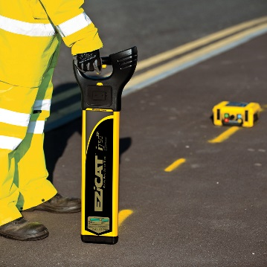
Mark services
Where services are known them must be marked on the ground to make them clear to anyone. They should be marked in the colour that relates to the service (see Table 1 above). Do not mark services solely on the basis of the location shown on a drawing.
Where works are not starting within 48 hours or there are services in difficult to mark areas like soft verges a more permanent system of marking should be considered.
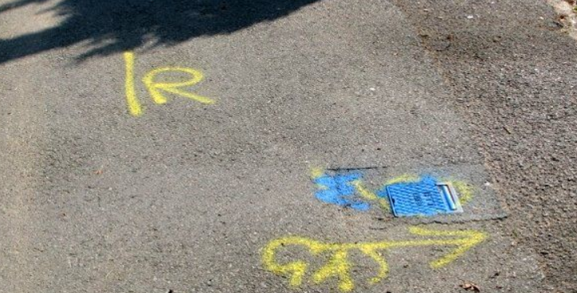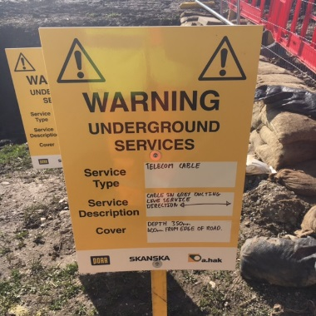

Risks/controls
When writing risk assessments and method statements significant risks / controls (risks verses controls) which should be considered include:

Striking buried services | Follow extraction and permit system. Isolation of electrical equipment.  Cable removal / spiking and cutting of any redundant cables.
Falls into excavations | Before starting an excavation, ensure that there is edge protection available for protecting the work area.
Vehicle movements | Ensure stop blocks are adequate to prevent vehicles entering excavations.
Contaminated land | Soil testing to assess risk.
HAVs / noise from tools | Assessments to be in place including health surveillance where necessary.

Life Saver Rules
- Conductive metal setting out pins are banned on all Highways England sites
- A CAT must always be used with a genny
- Insulated hand digging tools must be used

Permits

Before any activity is undertaken that breaks the surface of the ground a permit to break ground/ dig must be issued. The permit system is designed to ensure that only competent and authorised people conduct the task and that adequate consideration of risk has been taken. The issue of the permit cannot by itself make the task safe.

Any work outside of the scope of the permit is not permitted, if anything changes during the task work must be stopped and the situation re-assessed with a new permit issued if necessary.

In the raising of a permit a trained cable avoidance tool operator must scan the ground using a cable avoidance tool.

Responsibilities of Personnel

There are several people involved in creating a permit. The permit raiser will gather information and write the permit. The permit authoriser will verify the information in the permit and the responsible person will supervise the works ensuring adherence to the permit. Responsibilities are detailed below.

A copy of the permit must be held at the work site and a copy held at the site office on the notice board.

Permit Raisers:
- Review service drawings
- Check the location
- Ensure CAT scanning and marking of services on the ground has been undertaken
- Raise the permit and get it authorised
- Communicate the contents of the permit to the supervisor ensuring full understanding
- Close out the permit when work is completed
- Look for evidence of services
- Open chambers and manhole covers to verify service routes
- Look for things which will require services – lighting columns, telecom boxes etc.

Permit authorisers:
  - Check the services are clearly identified
  - Check the control measures can be fully implemented
  - Check the drawings are clear and concise
  - Check the responsible person is clearly identified.

Permit responsible person:
  - Ensure that all of the details, control measures or restrictions contained in the permit are strictly met
  - Supervise the operation throughout. If there is reason to leave the operation (even for a short duration) work must stop. The authorised person must be informed, who will approve a suitable replacement
  - Stop works if anything is encountered which is not indicated on the permit and inform the authorised person
  - Check where hand digging is a requirement, that all engaged in the task have received formal instructions on safe hand digging techniques
  - Communicate the full contents of the permit to all necessary personnel ensuring they are clear about hazards and permit restrictions
  - Ensure adequate inspections of existing excavations affected by the work have been undertaken before work starts

Emergency Arrangements
In the event of a service strike works must be cease immediately.
Site emergency arrangements should detail contacts for service providers in the event of a service strike and the action that site personnel are expected to take. This should include consideration of strikes involving unchartered services.
Personnel should be made aware that in the event of an injury, not to place them- selves in danger when assisting others and must be clear about site first aid procedures and reporting procedures.
The Highways England Project Manager or Sponsor must be informed immediately.
Incident Investigation
It is mandatory for all service strike incident investigations to follow the USAG Incident Investigation format. See Appendix 1.
Minimum Mandatory Requirements
A poster illustrating clearly the minimum mandatory requirements of this document is included for use at Appendix 2.

References

HSE Publication - Avoiding danger from underground services:
HSG47 Avoiding danger from underground services.
Appendix 1: USAG Checklist UTILITY DAMAGE INVESTIGATION

Date of Investigation: | Investigation by:

General Information
Incident Day and Date: | Incident Time: |  | Date:
Supervisor:
Type of Work: |  |  | Project/contract/Gang Code:
Subcontractor: | Yes / No | Name of Subcontractor:
Incident Address:

Utility Information (identify utility damaged)
Gas |  | Water |  |  |  |  |  | Electric |  |  |  |  |  | BT |  |  |  | Cable |  |  |  |  |  | Sewer |  |  |  |  | Other
Shown on drawings? |  |  | Yes/No |  |  |  | Pressure / Voltage? |  |  |  |  |  | High / Low |  |  |  | Size of the utility? |  |  |  |  |  |  |  |  |  | Service / Main
Where is the utility |  |  |  | Overhead / Footpath / Carriageway / Other |  |  |  |  |  | Depth of utility |  |  |  |  |  |  |  |  |  |  |  |  | Measured or estimated
What caused the damage? |  |  |  |  |  |  |  |  |  |  |  |  |  |  | Ground Conditions
Team Members |  |  |  |  |  | Name |  |  |  |  |  | Employee No. |  |  |  |  |  |  |  | Service Length |  |  |  |  |  | Qualifications
Event Description (giving details of precautions observed, unsafe acts, location of apparatus/ operative in trench,):

Plan Information
Were plans on site  COMMENTS |  |  |  |  |  |  |  |  | Yes |  |  |  |  |  |  |  |  |  | No |  |  |  |  |  |  |  |  |  |  | MUST ATTACH
Plans clear and accurate  COMMENTS |  |  |  |  |  |  |  |  | Yes |  |  |  |  |  |  |  |  |  | No
Suitable Risk Assessment  COMMENTS |  |  |  |  |  |  |  |  | Yes |  |  |  |  |  |  |  |  |  | No |  |  |  |  |  |  |  |  |  |  | MUST ATTACH

Location Equipment Information
 | If no then comments must be made:
Was CAT available | Yes |  | No
CAT Serial Number
CAT calibration due.
Was Genny available | Yes |  | No
Genny Serial Number
Genny calibration due.
Was CAT functioning correctly | Yes |  | No
Was Genny functioning correctly | Yes |  | No
Survey- Prior and During Operations
 |  | If no then comments must be made:
Was CAT survey completed prior to works commencing |  | Yes |  | No
Was CAT used in conjunction with Genny. |  | Yes |  | No
Were plans available and used with CAT and Genny |  | Yes |  | No
Were all located utilities marked prior to excavation |  | Yes |  | No
Was the CAT used during excavation |  | Yes |  | No
What depth was the CAT used during excavation
Which operative completed the CAT/Genny Survey
What modes were utilised during CAT survey e.g Radio
During investigation did site manager confirm location of apparatus by conducting his own survey (what were the results) |  | Date |  |  |  | Time | Results

Operation/ Excavation
Comments must be made where applicable: PHOTOGRAPHS REQUIRED
Was all underground plant located and marked by survey |  | Yes | No
Was plant located within 500mm of surface |  | Yes | No
Was mechanical excavation used |  | Yes | No
Which operative was excavating
If mechanical plant was used, who was the operator
If hand excavation, what tools were used and by whom
Was all relevant PPE worn |  | Yes | No
Details of PPE Worn
Was the utility damage avoidable? | Avoidable |  |  |  | Unavoidable
Reason

Any further comments including previous damage history to the same location or different locations?

Cause Analysis
Immediate Cause
Contributory Causes
Root Cause(s)

Action Taken- Corrective Action and Preventative Measures.
Action | Owner | Date Required | Completed | Confirmed Completed

Check List- The form must not be accepted without the following (list documents attached by reference)
Utility plans attached
Risk assessment attached
Photographs of damaged utility
Photographs of mark up

Signatures.
 | Name | Date | Signature
Team Leader/supervisor
Site / Team Manager
Operations Manager
Administrator

Appendix 2:
MANDATORY MINIMUM REQUIREMENTS
7. Ensure work gangs are briefed before starting works and check that they fully understand the scope of the work and hazards.
3. Use location devices to trace the services and mark the ground accordingly

4. Use safe digging practices, locate and dig trial holes by hand, no machines within 500 mm of a service.
6. Make sure the supervisor of the works has service drawings and knows how to use them. Everyone carrying out the work should know about safe digging practises and emergency procedures. 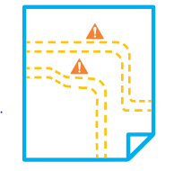
5. The responsible person overseeing the excavation must be familiar with the requirements of how to avoid the danger posed by buried services AND understand the specific risk assessment.
1. Isolate services if possible

2. Look around for obvious signs of services – lighting, manhole covers, patching of the road surface

