Jim Gallagher.
Previously in discussion with HSE, they were concerned with taking on designer’s responsibility on getting into too much detail.
Re gantry design, Jim referred to IAN 193 stated "provision of pedestrian access is designer's choice" further info in the chat below.
Gantry standard CD 365 states designer must do a risk assessment and the decision should be identified in that RA.
Including for ladders.
DR note. Jim is only on point for the gantry structure design. Raised the question of the holistic design including wider environment and safe refuge areas and access routes.
Had seen a couple of options for rotating gantries but mechanics and associated costs in budget conscious schemes meant that they defaulted to traditional types.
E.g. The small cantilever gantry in the photograph would cost the same as the full traditional.
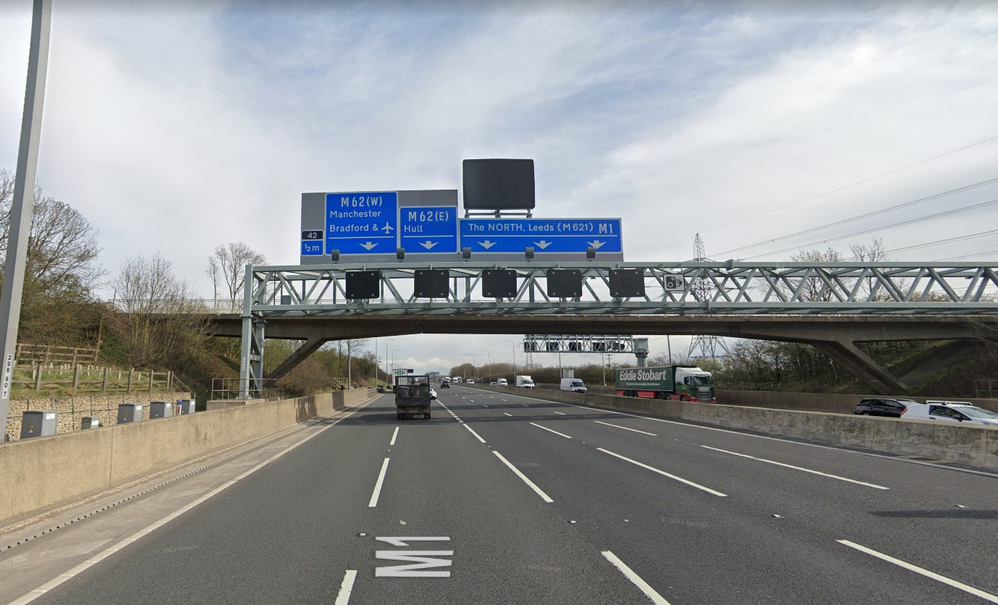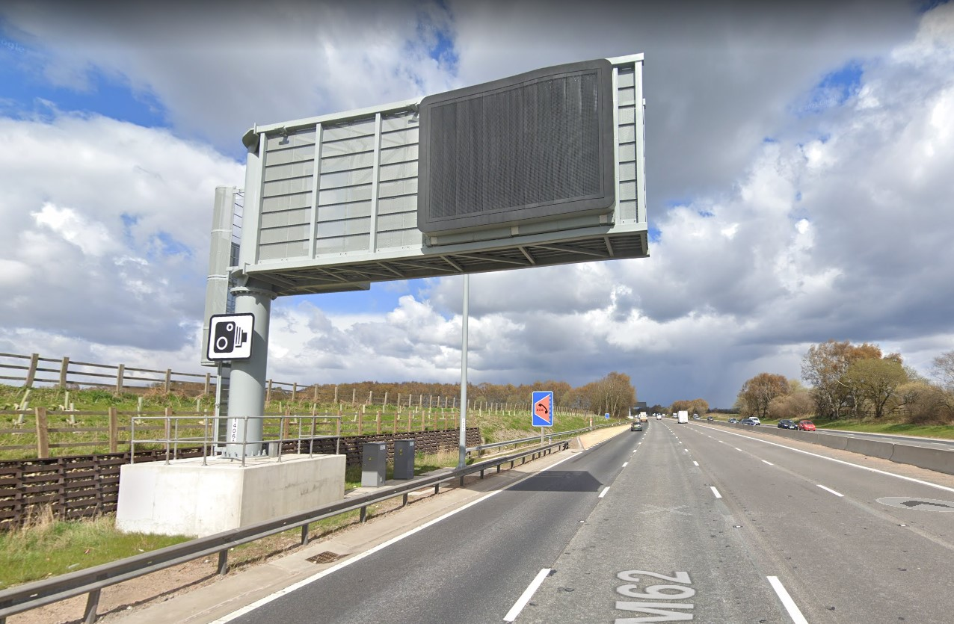
Dave Riley asked if when budgeting for installation, do they estimate ongoing maintenance costs (inc TM) throughout the life of the asset. Jim stated ongoing costs are supposed to be considered in the options report.
NB Structural requirements for gantries are in this document
https://www.standardsforhighways.co.uk/prod/attachments/6df58b73-a71f-48dc-8b76-b073220c8702?inline=true
All highway structures (including gantries) require technical approval. This is the relevant standard: https://www.standardsforhighways.co.uk/prod/attachments/17dadcc6-8e01-455d-b93e-c827d280839a?inline=true
Marcus Manning. Covers Ops for NH in SW.
Recognised the points on the presentation as valid but had additional views.
Suggested needs a more joined up approach considering both structure and wider access and environment; it seems from the meeting discussion that the gantry design team focuses on the gantry design only, not interested in the general access.
Some accessible gantries might still require TM. This related to exceptions where tools were dropped from overhead which is an avoidable event.
Argued that £30K for a 50p fuse was good value compared to the alternatives.
Lack of Opex funding means they don’t get to maintain all the access paths; they get overgrown because spending limited money elsewhere; even though the path is a safety feature it competes with other safety features they need to maintain.
When Smart Motorways were installed there were refuge areas and overlapping VRS walkways; they were not installed in Smart Motorways in SW because had no room for them.
Tim Goddard
At M4 around Cardiff there was a scheme for a pivoting MS4. It was not implemented ultimately – possibly due to cost.
From years of working with Techmach, there were years of problems with hoop ladders - back packs getting caught on hoop ladders and taking materials up and down was a problem.
Pav Singh
Had to do risk assessment – they relocated technology, so it is readily accessible, including fuses. One comment in reply was that such fuses were more vulnerable to deterioration when not with the asset.
Paul Brown
Do have too much reliance on individual designers making individual decisions. Not sure if the community will get to the point where that can be minimised. Not sure if we will have a single design for all schemes for next 7 or 8 years. We need a more consistent approach.
Countered that designers will still need to make decision – (DR note) but it seems the framework for consistent decisions is partly lacking.
Nick Harris is against working on the roadside, would prefer items are removed to be repaired rather than repaired on site. (DR note) but that does not address the core issue of parking and access.
Last week there were some photos safe man access gantries ladder too close to carriageway. PB will try to find them.
Consider working group with Jim. Smart motorways are looking at standard gantry designs.
Any comments on the structural standards come to Jim. If issues with regards to standards. (DR note) but Jim is only concerned with the structure itself, and the wider environment.
AN Other.
Recall one reason for removing access was recovery in the event of electrocution or other immediate incapacity. (DR note) the core issue remains, and that risk needs to be managed and suitable emergency procedure in place whatever the means of access. Is this a genuine reason or useful cover?
Dave Riley closing comments.
CDM 2015 put greater emphasis on identifying and eliminating or minimising so far as reasonably practicable, risks relating to construction maintenance and decommissioning of structures; would we have seen a significant shift in design for safe access after that April 2015?
Eliminating risk so far as reasonably practicable is to be seen as the best we can achieve, not the least we can get away with, so commercial factors are relevant but not all consuming, - the time, trouble and expense needs to be grossly disproportionate to the risk to render an option not reasonably practicable. And the risk being countered here is impact form high speed adjacent traffic.
From info shared on the call and in DR’s preparatory discussions, it raises the question as to the importance of technology / operational people inputting to help designers understand the details of and minimise by design the operational risks.
Comments in the Chat
Robert Legg (External) 10:24
re access consider off network accesses - footways up /down from the local road network, might work in some cases.
Brathwaite, Liz (External) 10:32
I think the real problem here is commercial – at the M42 J6 where we are doing improvements, the scheme scope does not cover improving access to existing assets
Singh, Pav Singh (External) 10:38
The other key point is that we if we have man access then we may need to consider how the person is to be evacuated in emergency.
Swainston, Roger/MME (External) 10:43
Consider in the balance of the discussion on why non-accessible gantries come about. Often it is due to constraints on land take, location of SRN boundaries. These are a site by site decision. The other is the problem access to maintenance hard standings on high speed roads.
Bowes, Tim S (External) 10:44
A14 moved to person-access gantries relatively late on due to the reasons Jim outlined. Alongside this a significant number (about 80+% from memory) of safety critical equipment sites were made accessible from off-network or safe parking/access locations with simple or no additional facilities, avoiding need for TM in these cases.
Gallagher, Jim (External) 10:54
Structural requirements for gantries are in this document: https://www.standardsforhighways.co.uk/prod/attachments/6df58b73-a71f-48dc-8b76-b073220c8702?inline=true
All highway structures (including gantries)... by Gallagher, Jim
Gallagher, Jim (External)10:55
All highway structures (including gantries) require technical approval. This is the relevant standard: https://www.standardsforhighways.co.uk/prod/attachments/17dadcc6-8e01-455d-b93e-c827d280839a?inline=true
Re gantry design, Jim referred to IAN 193 stated "provision of pedestrian access is designer's choice" that looks to now be withdrawn, where is that statement now documented?
Gallagher, Jim (External) 11:20
IAN 193 was incorporated into CD 365 - Section 2
Gallagher, Jim (External)11:21
Basically IAN 193 stated that the designer had to undertake a risk assessment to decide if the gantry was to have a walkway or not

