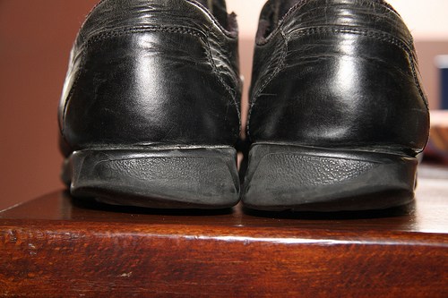
KNOW WHICH SIDE YOU ARE ON !
Most people walk on either the inside or outside of their feet; couple this with uneven ground and people will easily twist/break their ankle.
People should make sure the heel on their footwear is square and not worn away on any side/edge. Young football players have to check that their studs are ok before they are allowed on a football pitch.
Regularly check that your shoe/boot heels and soles are not excessively worn and level.

