Water and drinks
Your body needs water or other fluids to work properly and to avoid dehydration.

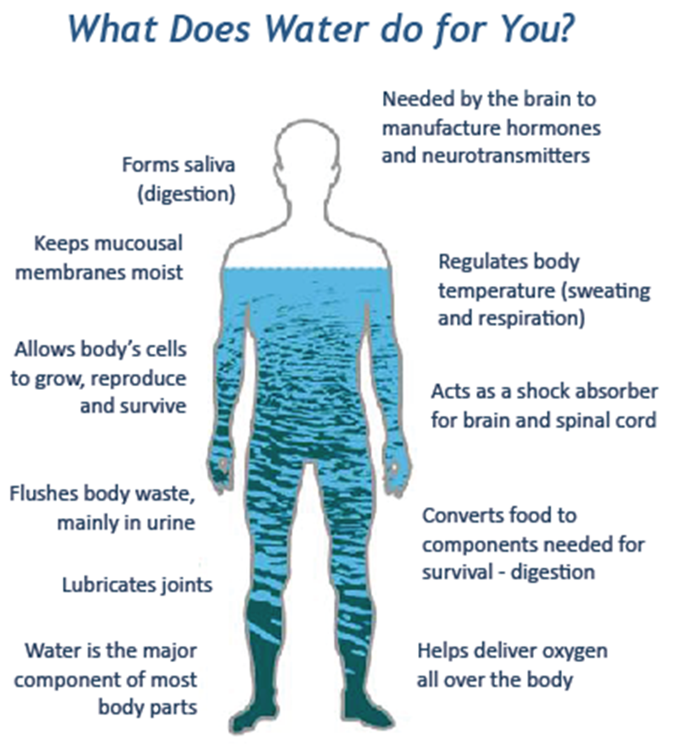
Water makes up about two-thirds of the weight of a healthy body

