Home safe and well approach – frequently asked questions

Why are we changing to a new approach?

At Highways England we want everyone who works with us and everyone who travels on our network to get home safe and well. This matters to us more than anything else. We have come a long way since our five-year safety plan was first published but our home safe and well approach takes this one step further. It is more than a set of actions it is an approach which should be marbled through everything we do.

Home safe and well;

- Places central importance on health and wellbeing
- Builds a positive health, safety and wellbeing culture
- Supports our customers to have safe and reliable journeys
- Promotes greater ownership
- Embraces innovation

What happened to the H&S five-year plan?

The health and safety five-year plan built a strong foundation from which to learn and improve from. Since 2015 we have;

- Reduced the frequency of customers being injured
- Reduced the rate of reportable accidents amongst our suppliers by 2 thirds
- More than halved the reportable accident rate with our traffic officers
- Improved out safety culture maturity by one level
- Attained the highest increased scores in our employee engagement survey, against the following questions:
  - Highways England takes safety seriously (from 81% to 89%
  - My work area is safe (from 79% to 83%)

How do I see progress of the approach?

Delivery of our Home Safe and Well ambition will be through two areas of focus:
- A Corporate Plan where actions are owned by our Executive Team and may be delivered in conjunction with our supply chain partners
- Directorate Plans where actions have been created by Executive Directors to reflect the different needs of our company.
Corporate Plan - Corporate plan actions will be reported by the executive owner to the Executive and Board Safety Committee

Directorate Plans - Executive Directors own their respective directorate plans and have overall accountability for the delivery of their directorate plan. They are accountable for ensuring appropriate and sufficient resource is allocated to the delivery of actions in the plan.

How are we launching the approach with our supply chain?

Our home safe and well approach will be launched with our supply chain at the Engagement Council webinar on 12 June. We will also be using existing meetings forums, letters from our Contract and Procurement teams and various supply newsletters and websites such as the Safety Hub.

The home safe and well approach will then be followed, in autumn, by our home safe and well supply chain approach. This places clear direction on our 6 focus areas and will provide our supply chain with clear direction of the expectation we have.

I have just refreshed my on-line H&S training. Rather than having to rely on Share links for the WAFO documents, would it be possible to have these accessible on a mobile phone App so that we can remind ourselves easily of their content instead of having to log-on etc?
At present we do not have a mobile app available for our portal and that is where our HSMS is housed. Currently all our documents need to be stored in Share as its HE’s Records Management System and then linked onto the portal.
SharePoint does have the capabilities to allow us to store all our documents within SharePoint and then we can make that available through an app. If we were to store a document set within SharePoint on line:
- there would need to be a strong practical or operational case for the exception
- We would need buy in from Information Management Division (as business owners for record management policy)
It is something we will investigate.
Is it our intention to socialise the 'Home Safe Well' strapline with road users now/in the future or is intended to be a business-to-business brand, ie for us and our supply chain?
It’s is intended for all but will mostly be used for business to business. However, it will be used in external comms and has already been used is some interviews such as on BBC breakfast and in the customer service plan. It has also been integrated into the NCRIP approach.
What does home safe and well mean to the execs and how can we utilise what it means to them, when applying this across the business. Will Jim et al be sharing their perspectives of home safe and well to ensure that there is a safety leadership approach?
We have taken a collaborative approach from the start, involving a range of people from inside and outside our organisation. It was important to do this to ensure the way we go about managing health, safety and wellbeing in Highways England reflects the unique issues we face. We have a Corporate plan for which actions are owned by Executive Directors and in addition to the Corporate Plan, each Executive Director will own, develop and manage their own health, safety and wellbeing plan for their part of our Company, supported by their health and safety managers. These plans will focus on any specific priority areas that are unique to that business area. This gives the ownership to each Executive Director and their teams, and places improvement right at the heart of what we do – with our people. These plans will support delivery of our imperatives and help to bring our values to life. Each directorate will use their usual governance and scrutiny, and others will audit their compliance with the spirit of this approach. Directorates will be called upon regularly to report their progress to our Executive Safety Committee.
A video from Jim, Alan Cumming, our Board safety lead and a number of employees and supply chain will also form part of the launch material sent to line managers. This video shows messages about what getting home safe and well means to them.
How do we find out who the Exec sponsors are for the corporate actions?

Please see below table for information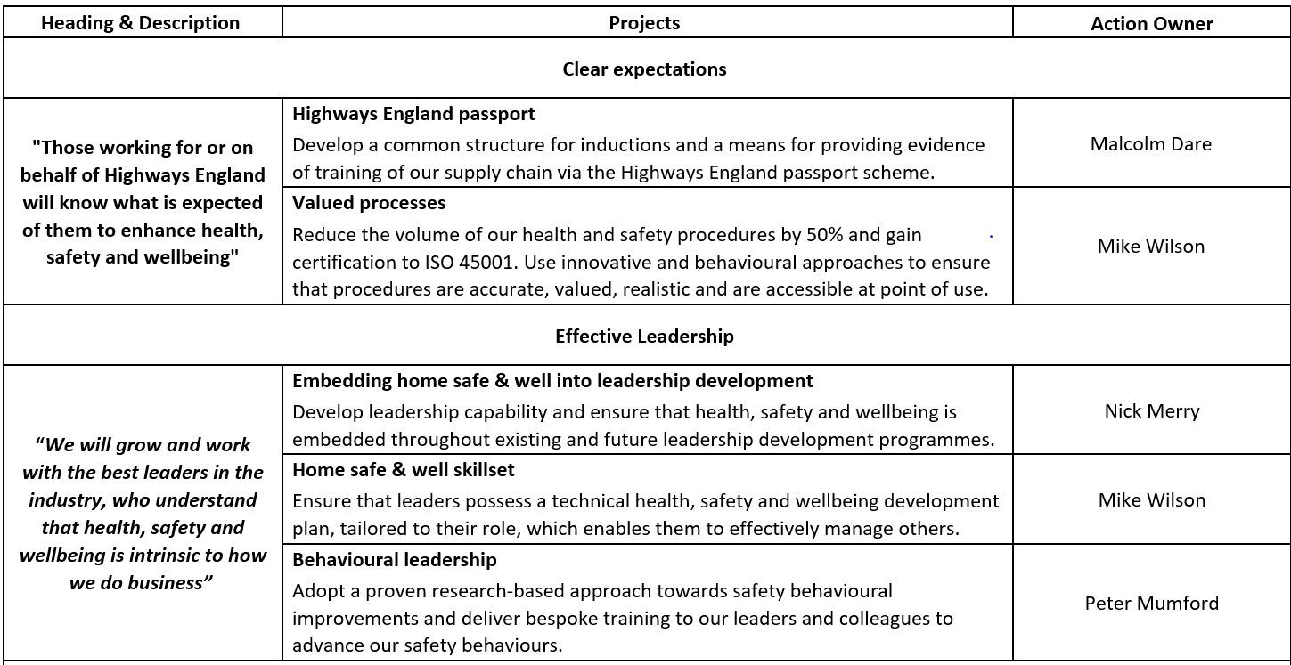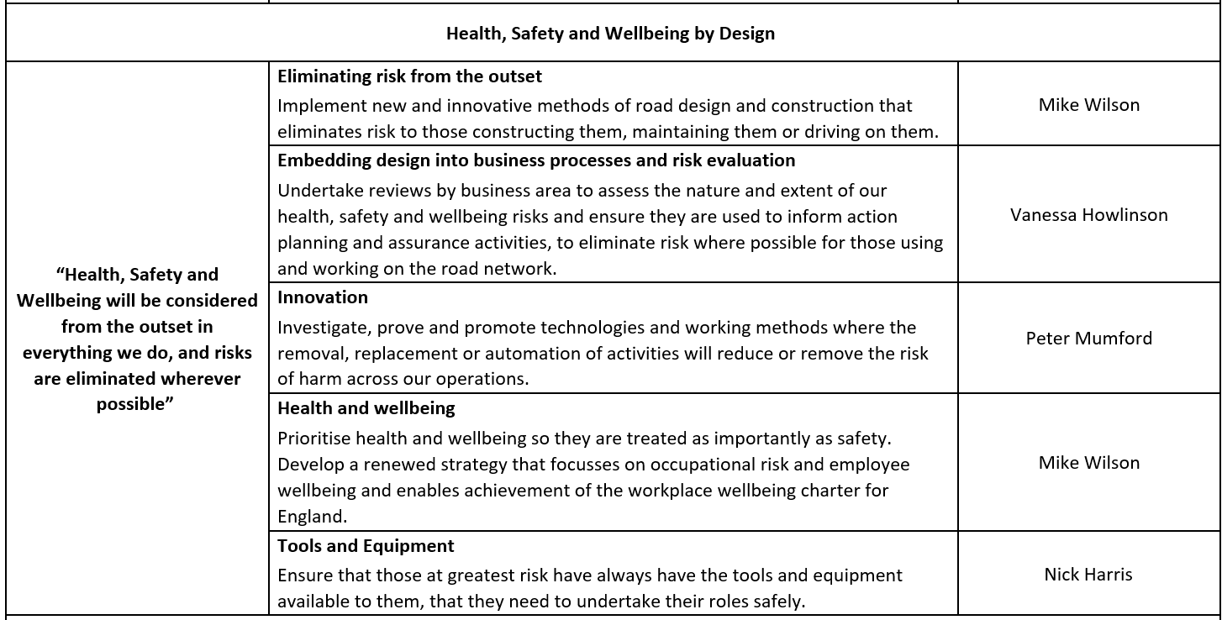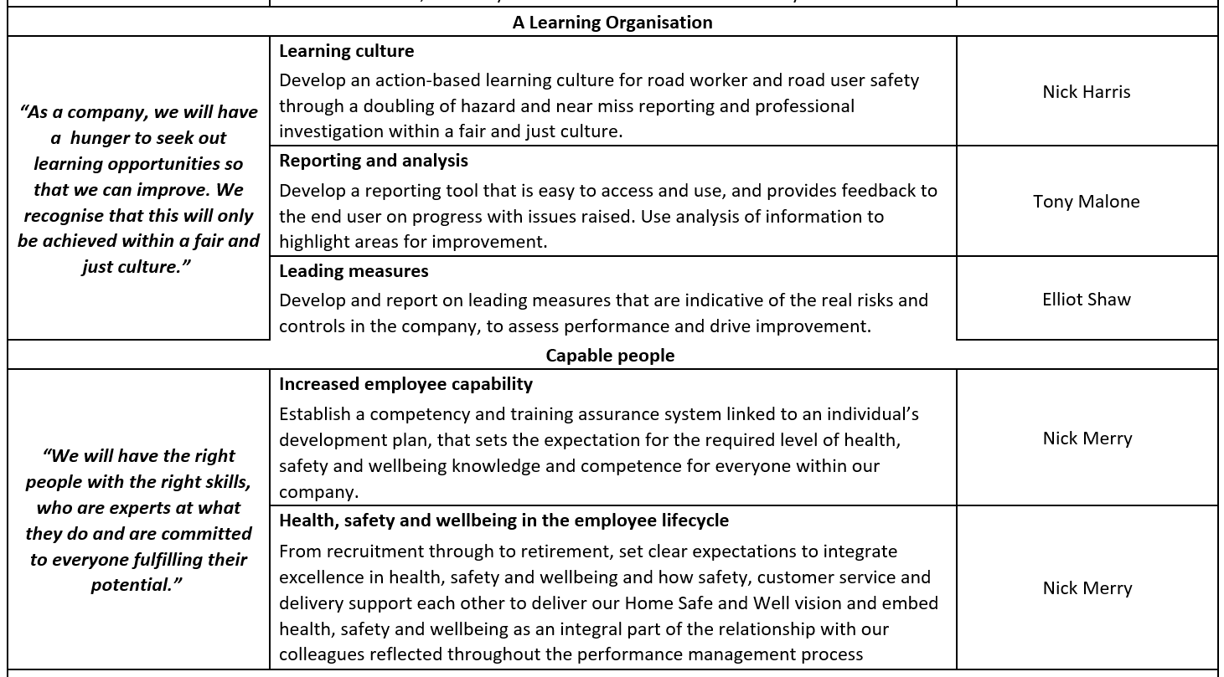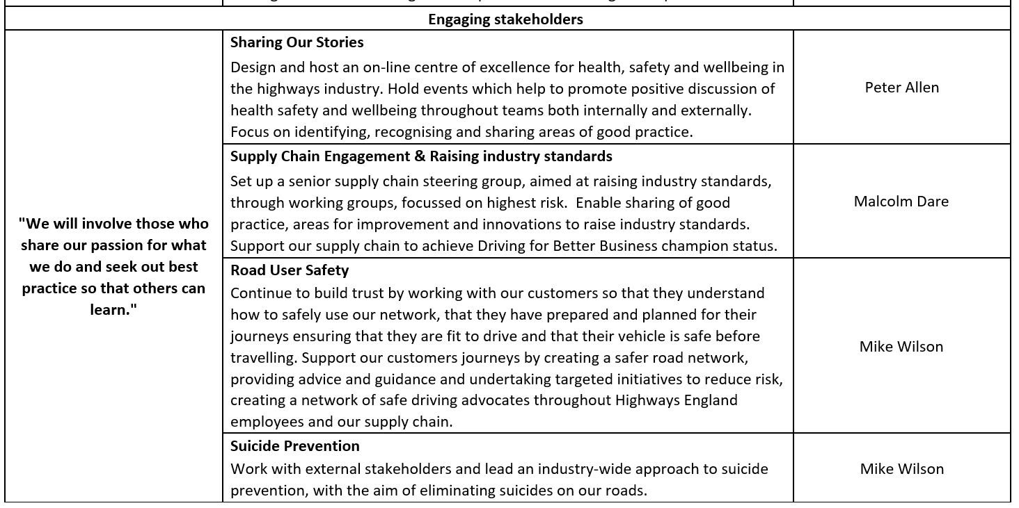
What is the business actively doing to address mental health and well-being, particularly with a growing trend of staff shortages, budget cuts, tighter targets and the resulting significant increase in stress related absences?
Rebecca Eaton, our new Occupational Health and Wellbeing Manager, is looking at the overall strategy in relation to mental health and wellbeing. Lots of great work has already happened in terms of raising awareness and improving support services for mental health, such as training over mental health first aiders We have been running workshops over the last few weeks in relation to what people can do to improve their mental wellbeing and built resilience. There are still some workshops running this week, go to click2learn, under wellbeing to find out more. We will be doing more of this as self-care is important. Mental health is no different from physical health if we don’t do things to look after our health we will deteriorate. However, a big difference with mental health is people don’t know how to look after their mental health. There is also employee and manager mental wellbeing eLearning courses available on click2learn.
Highways England will be putting forward a proposal for more training, particularly for line managers and leaders around wellbeing and mental health. It will help increase understanding of everyone’s role, and how to improve mental wellbeing in teams by setting the right environment, providing appropriate support and enabling people to thrive at work.
Our family pic made me think - when I worked somewhere that wasn't hot desking, we had family (or other) photos on desks or divides - everyone knew people's reasons to get home. Our offices are impersonal and devoid of 'place'. Do you think our hot desking arrangements have an adverse impact on our welfare?
In order for HE to live within its funding requirements we need to operate a very efficient estate. In order to do this hot desking is the right thing to do. If you wish to have photos of family and personal items on the desk you can but all we ask is that these are cleared away at the end of the day and placed in lockers to enable others to use the desk if needed. Leaving personal items limits everyone’s choice about where to work.
Any hints and tips on less formal methods of presenting the toolkit for those of us who have a team of one?
The line managers briefing has been designed for conversation regardless of the size of your team and includes a video message from people across the company. To make it more personal and focused you could amend the picture on the ‘what it means to you’ slide and just talk about hobbies interests, or even what you did at the weekend. It's all about conversation and how your/their role will help play a part in this.
Protecting ourselves is just as much about being safe at work as healthy eating, exercise and relaxation - will you be able to cover off if the initiative is addressing these factors as I believe a clear mind and healthy body impact on how we can concentrate and react to risks and issues at work. Looking forward to the webinar - thanks Mark! Submitted by Caroline Hinchcliffe.
The health and wellbeing of our people is immensely important. We know that people who have good physical and mental wellbeing will perform better at work, look out for colleagues and are less likely to be injured. Both physical and mental health are important, and our aim is that working at Highways England will enhance physical and mental health. We will do this by providing the culture where we can look after ourselves and each other. We want to provide engaging and rewarding work, control health risks, make it easier to be healthy and look at how we can promote healthy behaviours in the workplace.
How will the initiative be governed and resourced at regional level? What are the success criteria?
Corporate actions are sponsored by Executive members. These will be reported upon and governed by the health and safety team to the Safety Executive Committee and Safety Board each month.
Directorate plans – These are owned by each directorate and therefore self-governed, we have provided some guidance on this to the Executive Directors. Each directorate will use their usual governance and scrutiny, and others will audit their compliance with the spirit of this approach. Directorates will be called upon regularly to report their progress to our Executive Safety Committee and Safety Board.
How to get good engagement in this space, particularly for people who work in an office environment, which they generally associate with being a safe space.
Encourage and challenge your teams to use the focus areas in their work. The focus areas are to be used to help us integrate health, safety and wellbeing into everything we do.
Home Safe and Well should be reflected in everyone’s performance goals. Use your regular one to one conversation with your teams to review progress and think where you can make a positive difference to people’s lives. There are also discussions to be had with your Executive Director on how you and your teams can contribute to your directorate plans and ensure this is communicated and understood by your teams.
How do we plan to roll this launch out to staff working shifts at remote locations? Will it be a safety stand-down, toolbox talk?
Briefings have been specifically designed for those working on shifts and will form the official shift briefing across 4 weeks as part of the Operational Excellence programme. These will be provided to the Operational Shift Briefing team for further cascade and feedback. We have also developed some slides for the screens in the outstations and we are working with the service delivery teams across the regions to roll this out. An article will also be included in the 9-day regional briefing sent out by your regional teams.
What are the changes that managers of small teams can make to have a real impact on safety performance?
Encourage and challenge your teams to use the focus areas in their work. The focus areas are to be used to help us integrate health, safety and wellbeing into everything we do.
Home Safe and Well should be reflected in everyone’s performance goals. Use your regular one to one conversation with your teams to review progress and think where you can make a positive difference to people’s lives. There are also discussions to be had with your Executive Director on how you and your teams can contribute to your directorate plans and ensure this is communicated and understood by your teams.
What's the difference between the Highways England Passport and the CSCS scheme?
The CSCS (Construction Skills Certification Scheme) card along with all CSCS partner cards are skill cards; whereas Passport is an authority to work card specific to individuals working on the Highways England estate. The Passport system does allow competences held on an individual’s CSCS card to be added to their Passport record however.
Is there any additional funding allocated to HS&W?
There is no one discrete ‘H&S pot’ which covers everything, but our business planning cycle allows us to bid for improvements in several ways. We’re investing in road user safety, occupational safety, health and wellbeing and have a significant designated funds budget which includes safety, and innovations which will improve safety. These are extensively used by colleagues around the company.

Talking of Health & Wellbeing, have HE suspended the Cycle to work scheme?
Cycle to work is on the Extra Mile platform. It’s now just via the Evans Cycles scheme though rather than the old Cycle scheme.
Once we have briefed this, will it be captured in the corporate induction for new starters going forward?
Yes, we’re going to review our HSW input to the corporate induction after the launch. We’ve updated it twice already in the last year and the H&S team are one of two teams who personally present at every single corporate induction, including what getting home safe and well means to us!
I feel the need to share the importance of our natural surroundings, fresh air and wildlife in terms of our wellbeing. If there are links we can highlight between wellbeing and the environment then that would also help to share the value of our environmental assets that we have as a company.
Absolutely! There are proven links between mental health/wellbeing, and exercise, our wonderful environment, and getting out in it. We could write pages on this but if you’re interested then a quick internet search on these themes will bring back loads of ideas and practical examples such as this. See the response below too.
We can also encourage employees to use volunteer days to help wellbeing?
Yes of course. There is one answer to wellbeing, so it’s as much about knowing your people and finding out how they relax and maintain their wellbeing. Anything that brings team together and has a charitable outcome is wonderful, and ‘giving’ has a proven benefit to mental health.
Will we need to keep a register (of attendance) and where do we send it?
With this launch, we’re relying on ownership and integrity, rather than keeping track of who does what, where and when. There is no need to keep any record, but we ask you make use of our Home Safe and Well Yammer channel and post pictures / stories about your briefings, how they went, what you heard and felt, and so on.

