The Delivery Hub health, safety and environment
Raising the bar 19
Noise
Version 1 - November 2013
Highways Safety Hub
Raising the Bar 9
Service Avoidance

Issued July 2013 Revised June 2020
Objective
Scope
Background
Minimum requirements
Guidance
Eliminate
Isolation
Minimise
People Requirements
Governance Requirements
Emergency Arrangements
References
Appendix 1 – Minimum Exclusion zones for Underground Services
Appendix 2 – Definitions
Appendix 3 – Responsibility Definitions
Appendix 4 – Service Colour Coding
Appendix 5 – Responsibility Process Map
Contents

Objective
This Raising the Bar Guidance Document provides practical guidance on how to the comply with the Supply Chain Safety Leadership Council Common Intent Document on Service Strike Avoidance as well as providing guidance to the Designer and Contractor as to the standardised method of compliance preferred by Highways England.

Scope
The expectation is that this Raising the Bar Guidance Document will apply to all elements of working around underground, above ground or overhead services. From planning and design through to location, verification, safe excavation and update of drawings and plans to be passed on to the client and maintainers. It also includes both permanent, existing utilities and to temporarily installed services on Highways England worksites and will be implemented by all supply chain partners working with Highways England.
It will be used by:
- Highways England/ Principal Designers – when commissioning, designing and planning works
- Supply Chain Partners – when working for Highways England
- Highways England and Supply Chain Partners when assuring compliance.
Additionally - when following any risk control methodology, the Principal Designer or Contractor will often identify more than one compliant solution to a problem.

This guidance is relevant to ALL services including:
- Electrical, gas, water, sewerage and other drainage
- Telecommunications and other fibre optic cables
- NRTS road technology cables
- Overhead Services (See also RTB7)
- Above ground services e.g. CCTV cables
- Above ground gas installations

This standard does not replace Standards and Codes of Practice such as: GS6, HSG47, PAS128 or PAS256 but will identify expectations for implementing requirements contained within these documents and other Industry Guidance. It is expected that all designers and contractors will check their own adherence to legislative and Utility Asset Owner Requirements as well as compliance with their own company procedures. Guidance contained in this document is in line with recommendations from the Utility Strike Avoidance Group (USAG) and their toolkits.

Background
Utility Service strikes continue to be one of the biggest health and safety hazards in our industry. Across key suppliers to Highways England, there can be as many as one service strike per day on average. The most significant incidents have tragically resulted in fatalities and life changing injuries.
Routinely, the root cause of these incidents includes poor quality or inaccurate information about buried service locations, little or no consideration of diversion during design development, lack of consistency of safe working practices across the industry and inadequate or inconsistent control measures on site.

Minimum requirements
The following elements are considered mandatory requirements and suppliers shall ensure these are applied fully on Highways England sites.

Mandatory Element
Conductive metal setting out pins are banned on all Highways England sites
Interpretation of survey data must be undertaken by experienced qualified personnel in accordance with PAS128 and HSG47
Cable avoidance tools must have GPS and a data logging capability
A CAT must always be used with a genny
Insulated hand digging tools must be used
investigations to follow the USAG Incident Investigation format

Guidance:

The following guidance is written with the expectation that it represents best practice and as such if you are involved in this type of activity will normally be followed unless a better local solution has been devised to meet the overall objective.

Eliminate

Development and Planning
Early engagement with statutory undertakers and supply chain undertaking the work (if appointed) should be held as early in the design process as possible to set expectations with regards to competency and working standards. Agreement must also be reached with the utility owner about what methods and techniques can be utilised within the proximity of their asset. The responsibility for works (who is principal contractor under the Construction, Design and Management Regulations) should be clearly recorded for each element of the works as this may change depending on the location of the works. All excavation tasks must be planned to ensure that current service drawings are obtained and fully reviewed. Service drawings may give an indication as to the location of a service; however, the accuracy can vary. The location must be confirmed via scanning and digging. Once the service is located, in one trial hole the depth / offset can vary significantly a very short distance away especially where there are physical constraints. Multiple trial holes should be made on each service as appropriate. Be aware that when working in close proximity to services it is possible that they may run through material that is to be removed, e.g. ducting that has been overlaid with concrete. If not appropriately managed this can lead to services being unintentionally removed with other items such as kerbs. Where possible services should be isolated, or items removed in small controlled quantities.
Before any works start, a site walkthrough must be undertaken by all persons who will be involved in the operation.
Where no services are shown, conduct an onsite survey looking for:
- Items that may have a power supply e.g. streetlamps, signage or gantries
- Scarring or depressions in the road where there may have been a repair or new service laid
- Manhole covers and frames including hydrants and valves.
- In addition, look for any above ground services which may be hidden in the verges by grass such as Trailing CCTV cables
- Above ground gas installations (illustrated below)

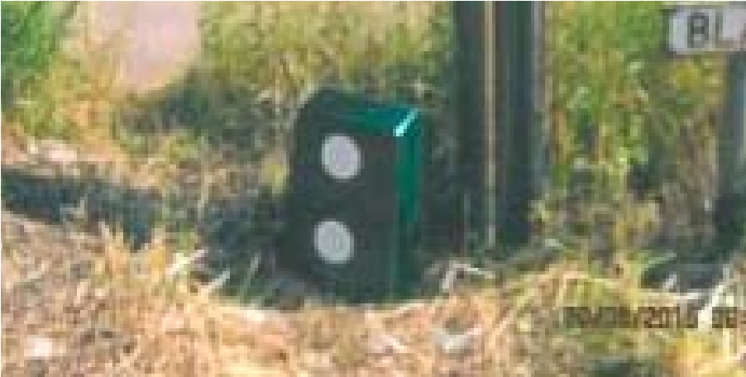

Risks/controls
When writing risk assessments and method statements significant risks / controls (risks verses controls) which should be considered include:

Striking buried services | Follow extraction and permit system.  Isolation of electrical equipment. Cable removal / spiking and cutting of any redundant cables.
Falls into excavations | Before starting an excavation, ensure that there is edge protection available for protecting the work area.
Vehicle movements | Ensure stop blocks are adequate to prevent vehicles entering excavations.
Contaminated land | Soil testing to assess risk.
HAVs / noise from tools | Assessments to be in place including health surveillance where necessary.

Accurate and robust capture of data
Hazards can only be eliminated if they are known and the capture and access to accurate and robust data relating to existing services is key to ensuring we are basing decisions on the best available information.
The hazard of excavation around services must be initially identified at the design stage and be included on the design risk register. Efforts must be made and works considered to eliminate or reduce this activity wherever practical. Early engagement with utility companies and the client to collate data and information on services must be undertaken, together with commissioning of relevant surveys.

By integrating verified locations of services and structures the designer can validate data available from Highways England and service owners – and use that data to inform safer design choices.

All overhead services must be assessed prior to works and a suitable safe system of work must be established and documented to prevent mobile plant equipment and vehicles striking any overhead structures, services and other fixed hazards. Where there is a potential during construction for an overhead service to be struck then a hierarchy shall be adopted, with the avoidance of carrying out works or inspections under and adjacent to overhead services and other fixed hazards, being the first consideration followed by consideration to that service being diverted or isolated prior to the construction phase should be identified early in the design process.
Assess Provision of Statutory Drawings by a Competent Person
All Utility plans must be:
- In colour (if available in colour)
- At a scale of 1 to 500 (minimum) when printed or viewed on a device
- When printed, at the scale indicated on the drawing (e.g. drawing is 1 to 500 if printed in A3)
- Current i.e. within the specified date range stated by the plan provider, which is within 28 days for gas (mandated) and 90 days for other services (advisory).

Design Process
Eliminating hazards through design is a crucial aspect of the hierarchy of control and the design that avoids the need to work over/under/adjacent to live services should be the optimal solution. A sub-optimal solution is to seek to divert the services in advance of any works undertaken. That design choice enables the designer to propose a working method to the Principal Contractor. This should be the Best Available Technique taking cost and technology available.

Designers must confirm the “legend” on plans received as these can vary.

Note: Plans will provide a specification e.g. 400Kv or 7 bar gas and a material but only give an indication of the location of services. They are rarely drawn accurately to scale and scales might have changed during copying. Utility Plans must be used only as a guide to help tracing using locating devices. Proven information should be entered into working drawings.

Minimum “air gaps” should also be identified on drawings when there is a need to travel beneath overhead cables. This includes travelling and tracking of mobile plant equipment, travelling of vehicles, and erection, use and dismantling of temporary works systems etc. For existing overhead cables minimum “air gaps” can be obtained by contacting the cable owner (Statutory provider), who will provide a “GS6 Safe Clearance Assessment Report” for each overhead cable location
At request, Statutory providers will also provide guidance of the minimum “air gaps” when working and travelling beneath 11kV (11,000v), 33kV (33,000v), 66kV (66,000v) and 132kV (132,000v) overhead power lines

If plans and information are not available (e.g. for emergency work) the work must be planned on the assumption that there are buried/encased services in the area.

Establish best practice in mapping existing services to combined plans
- Start with high quality, accurate CUDs (Combined Utility Drawings) so that design teams can be certain that their designs do not clash with services.
- Adopting best practice for the project, encouraging a minimum standard of CUDs and the use of GIS to map services across the route.
- The use of High-Density Array Ground Penetrating Radar is preferred over less advanced systems. Whilst more expensive initially the accuracy and time saved prove economical and the use of this, and ongoing improvements in such technology, is the preferred method of location and a Best Available Technique
- Map utility locations in GIS and incorporate key asset data – utility type, size, asset owner, feeder location. This could also include contact details of asset owner and brief outline of their protection requirements/processes within the asset data.
- Combining the work scopes for a whole site to reduce the need of partial surveys for individual tasks.
- Consider existing easements as may apply to services
- It is essential that combined plans are checked for completeness, accuracy of position and that the legends match the way that the services are marked on the plans
- Dependent on the plan scale it is likely that marking multiple services on it will make those services appear as one line – the designer must consider how to present the correct information to the Principal Contractor
It is essential that the design of works has been allocated sufficient funding, time and resources to check that services have been identified, confirmed and risks eliminated - or that residual risk is clearly identified when work is handed to the Principal Contractor and a practicable mitigation is proposed.
As a general principle any service that does NOT need to be within the works should be removed from the work either by re-planning the works – or by altering the service outside the works where practicable. This will ensure safety during construction and for ongoing maintenance. Where a cost benefit analysis shows not to be practicable then identification, structural support and physical protection is required.

Note that the presence of that service must be considered in the maintenance and repair statement

Design for maintenance
- By combining BIM and GIS the interface between existing and proposed can be seen and optimum locations maintenance points can be established.
- All newly laid cables (cameras, traffic signs etc.) on the Highways England network should be within appropriately coloured ducting and provided with additional warning or protection. Accurate records of location are essential – particularly if the cable is isolated via a “pot end”. Pot ends should ideally be removed from the works to facilitate works and ongoing maintenance. The use of resonance balls on pot ends that must remain will assist in ongoing location for maintenance
- A maintenance and repair statement (MRS) shall be prepared during the design stage see GD 304 Section 2

Preparatory works
As damage is frequently associated with preparatory work or ancillary work the designer should consider services during the investigation phase of the works and the possible location of compounds and storage facilities. This includes any situation where the ground will be broken/penetrated or may move – not just excavated. Typical situations include:
- Putting in posts for site hoardings
- Creating temporary fence lines or setting out using metal road pins
- Movement of heavy plant and equipment

Protection of services
- Consider temporary access routes as a permanent design with same rigorous utility searches and consideration.
- Consider technical interfaces when designing protection slabs and engage with Highways England throughout the process to avoid assumptions or future reconstruction.
- It is not acceptable to concrete around cables, gas or fuel pipes.

The flexibility to work around services
- Diversions can often be avoided by comprehensive engineering impact assessment (EIA). How should be understood and incorporated into the common standard
- If possible, allow for provision to be made for services to ensure they remain in their traditional locations (i.e. ensuring footpaths/verges are wide enough that all existing services will sit within them).

Consider;
- Movement of ground containing services adjacent to the actual works
- Ground loading during construction – from machinery or spoil
- Reduction in ground level that may affect the service by decreasing the protection from damage
- Increases in ground level that may affect structural integrity or make future access difficult
- Service condition – to be discussed with the owner as the concept of betterment may apply
- Liaison with service owners or operators, and other interested parties such as landowners and other utility providers
- The stability of ground supporting structures and services

Diversions
Where diversions must take place the Designer should engage the Service Owner and Principal Contractor to determine suitable work phasing as only limited work will be possible before diversions are complete and, typically, the service owner is not working directly for or under the immediate control of the PC – all of which can seriously affect work phasing. As an example
- Phase 1 – PC Sets up on site, grade ground to new levels, lay out new route
- Phase 2 – Stop work and hand site to Service Owner to complete works
- Phase 3 – PC returns to complete works
Costs for diversion of services must be considered in the context of the scale/complexity of the project/activities and unless prohibitively expensive/disproportionate for the context, then this option must be thoroughly exhausted before a lesser control measure is accepted.

Isolate
Where the hazard can’t be eliminated, the supply chain safety leadership group common intent document on service strike avoidance requires delivery partners to always seek to isolate the service during construction and maintenance activities by having the supply temporarily stopped.
Supply Chain Partners must check any requirement for the isolation of services as these are frequently difficult to schedule in a timely manner. If Isolation is delayed – The Supply Chain Partner must be prepared to delay other works to match – as not doing so is likely to increase risk.

Services encased in concrete
Where it is believed services are encased in concrete and cannot economically be moved/diverted, it may be necessary to isolate so as to be able to work around the service safely. The Designer must confirm with the Service Owner how this will happen, how long it will take and if supporting works (e.g. excavations within the Highways England working area) will be required. This is key information needed by the PC for planning as the concrete must not be broken up until such time a solution is identified, and the cable is made dead / confirmed in writing by the cable owner.

Engineering Controls applied in safe digging practices
If a service can not be eliminated or isolated then the senior leader of each project will need to sign off a safe system of work in order to work around live services that focuses heavily on robust engineering controls, that physically prevent any people, plant or equipment coming into contact with the service, as part of the safe digging procedures.

All excavation work must be carried out carefully, following recognised safe digging practices, and must only begin after a locating device has confirmed the position and route of the expected underground services and that no other services are detected.

The following hierarchy of methods of excavation should be formally considered, those which are discounted (with reasons) must be included in a works planning record.
- Remote excavation
- Directional drilling for underground works
- Vacuum excavation – where conditions are suitable
- Air lance – except in clay soils
- Hand dig using 'safety graft' with rounded blade edges and non-conductive shaft
- Hand dig using standard shovel with non-conductive shaft

NB: Use of hand tools/digging, and air lances is not considered to be an Engineering Control and should be included in the approvals noted under governance below.

All services must be considered live until they are disconnected and proven safe at the point of work. Documented proof to confirm must be available at the work site
The use of bars, forks and picks is prohibited. Handheld power tools and mechanical excavators close to buried services must not be used above the service unless:
- The service has already been exposed by digging under the surface to be broken out and it is at a safe depth (at least 300mm) below the bottom of the hard surface material: or physical precautions have been taken to prevent the tool striking the surface.
- Where practicable, do not use handheld power tools within 500mm of the indicated line of a service buried in or below a hard surface.
- The 500mm safety margin may be reduced:
  - Where congestion of services renders it impracticable; or
  - Where surface obstructions limit the space available.
- But only if the line of the cable has been positively identified by plans, confirmed by a locator and additional precautions are used to prevent damage to the services.

Mechanical excavators and power tools can be used to break up hard surfaces where the survey has proved that there are no services, or the services are deep enough so as not to be damaged by such tools.

Equipment Requirements
- Insulated Tools - When hand-digging, insulated tools must be used to protect the user from current leakage or service strikes.
- Vacuum Excavation - Vacuum extraction can be a useful method of extracting material without damaging services. Suppliers of vacuum extraction equipment can be found by typing ‘vacuum extraction’ into a popular internet search engine. Please see Highways England health and safety toolkit 346 air excavation.
- Air Picks - The air pick (soil pick or air spade) is used when compacted ground conditions are encountered. It is connected to a mobile compressor via an air hose. High speed air is used to fracture and displace the hard material. Loose material is removed from the trial hole with an insulated hand shovel. Manufacturer’s instructions should be followed as methods of use can vary with model. When using the air pick full PPE and impact resistant goggles must always be worn by all personnel within the vicinity of the operation. Consideration should be made to any additional risks introduced with use of this equipment, for example, noise, vibration or scattering of material.

Before starting any excavation ensure that edge protection is installed to protect operatives and/or the public from falls into the excavation (See Raising the Bar 13).

Cable Detection and Avoidance Equipment
Cable avoidance tools must be used in line with formal training and manufacturer's guidance. There are a variety of cable avoidance tools on the market each with slightly different features. The mandatory requirement for cable avoidance tools is that they have GPS and a data logging capability. This enables supervisors and others to interrogate which mode the tool has been used in and exactly which location the tool has been used in.

Trials of data logging CATs have resulted in a positive change in people’s behaviour and a reduction in service strikes.
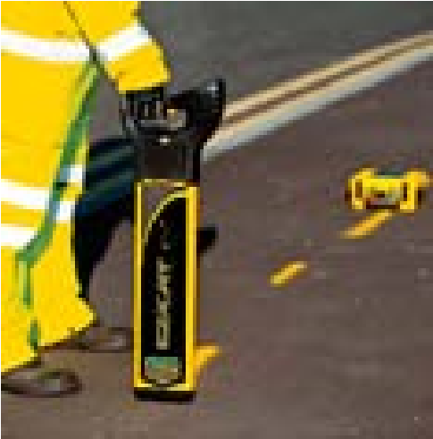
Cable avoidance tools must always be used with a genny.

Cable avoidance tools must be calibrated by an authorised dealer. Personnel should be aware that this service is unlikely to be offered by tool hire companies.

Cable avoidance tools should also be tested before each use to ensure they are in good working order.

Any personnel using a CAT and genny must have training on the specific model they are using.

Be aware cable avoidance tools are not fool proof and are less likely to detect pot ends, services without a live current (e.g. street lighting that is off) and when there are multiple services one can mask another. Safety fencing and cables that are no longer live confuse the situation. This is a support tool, and in no way a definitive tool.

Locating Services
As part of any safe digging procedure the location of services, accurately determined/confirmed on site prior to commencement of any work, at every location and the presence visibly identified using appropriate means on site must be applied.

For reactive/minor works the use of 'ground mapping' with radar should be considered but may not be practicable. In this case results of previous surveys from the H&S file may be used with care and supported by conventional Cable Detection Techniques – see Cable Avoidance Tools below

Checking Designs and Plans
All Supply Chain Partners must have in place competent people systems to check, review and, as appropriate, challenge designs and information supplied – this must include services

Supply Chain Partners must confirm that they have the ability, in terms of:
- Material availability to the design specification
- Having access to equipment and tools specified
- Employing enough competent people to construct the design as proposed – without creating a previously unrecognised risk to services.

Care must be taken in checking information provided in relation to services – and confirming that the working method and residual risk are understood – and any requirement for support of that service as work progresses.

Minimise Phase

Permits
Before any activity is undertaken that breaks the surface of the ground a permit to break ground/ dig must be issued. The permit system is designed to ensure that only competent and authorised people conduct the task and that adequate consideration of risk has been taken. The issue of the permit cannot by itself make the task safe.

Any work outside of the scope of the permit is not permitted, if anything changes during the task work must be stopped and the situation re-assessed with a new permit issued if necessary.
In the raising of a permit a trained cable avoidance tool operator must scan the ground using a cable avoidance tool.

Authority for breaking ground
Breaking ground is defined as any work activity which involves breaking the surface of the ground including mechanical/hand/vacuum excavation, driving nonconductive pins or posts (including setting out), drilling/boring/cutting/planning.

Prior to any ground penetration/excavation a formal pre-start review/hold point - 'Authority to commence' record must be completed - this can be a Permit or a ‘hold point’ built into a recognised workflow. Hazards and safe working requirements are to be clearly communicated to those undertaking the work.

It is anticipated that the 'Authority to commence' record will be SCP specific.

Each Supply Chain Partner must define and implement process/procedure(s) that meet these basic requirements:
- A person(s) is responsible for authorising works is formally nominated by a senior person and that nomination is recorded
- That person(s) is required to review, confirm and record:
  - who is responsible for doing the work
  - who is responsible for supervising the work
  - the scope of the works
  - the method of working
  - the start time/date, the duration of the works and how the authority is removed/re-given each shift
  - the emergency action plan
  - the competency of those involved in the planning and implementation stages
  - all the required information is available
  - all pre-excavation activity has been completed
  - that the works may continue.
  - when the works must stop
- Permits need to be briefed to site teams by the permit issuer, prior to work commencing and at the point of work. Where relevant they then need to be re-briefed on a shift/daily basis.
- Permits must be time bound (7 days maximum) and identify a clear process for managing changes within the working environment.

Marking Underground Services
Where services are known they must be marked on the ground to make them clear to anyone. They should be marked in the colour that relates to the service.

Table 1: Standard Service Colours:

Utility Colour Utility Colour
Electricity | Red | BT | Grey
Gas | Yellow | Data cables | Purple
Water main | Blue | Cable TV | Green
Sewer/drainage | Brown | Road lighting | Orange

Do not mark services solely on the basis of the location shown on a drawing. Where works are not starting within 48 hours or there are services in difficult to mark areas like soft verges a more permanent system of marking should be considered.

Be aware that whilst the table above should be followed, any type of existing service can be any colour. Black and clay ducts for example are frequently found.

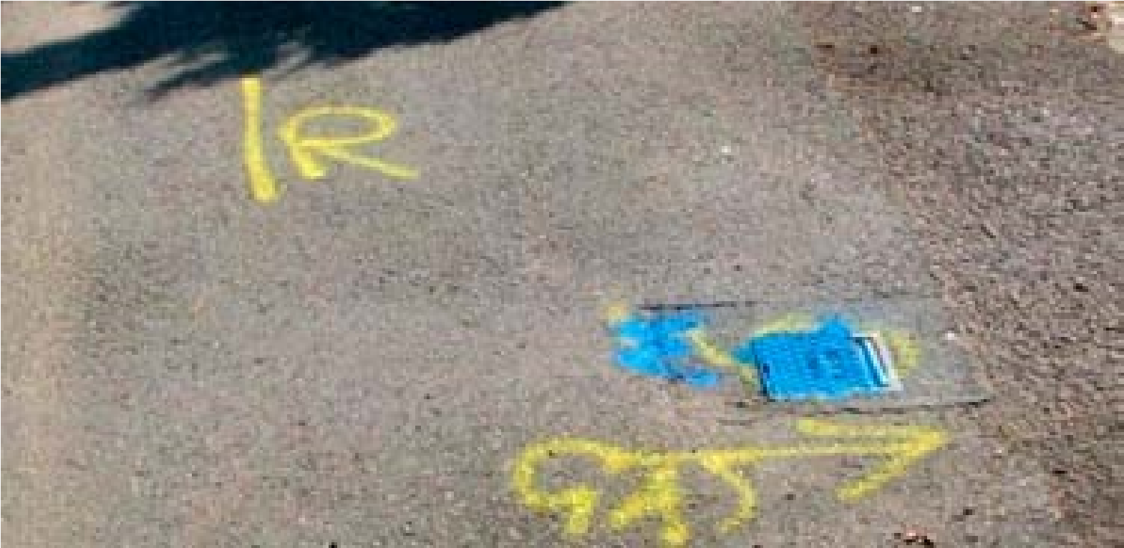
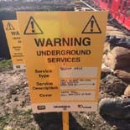
Marking Overhead Services
Goal posts that span traffic routes and provide a physical barrier to vehicles that may impact with overhead structures and services must be used in accordance with Health and Safety Executive publication GS6

As an additional control, and where practicable, sets of goal posts, together with blue coloured road cones and combination safety signage, should be placed at the end of construction areas. Refer to Raising the bar 7 for further details relating to overhead protection measures.

This will serve to provide driver/operators with an addition visual message “reminder” of the need to ensure that boom/body/accessories are stowed correctly prior to leaving the construction area. However, height restrictors should be used on any plant that could come into contact with overhead services if unrestricted. Refer to Raising the bar 1 and 7 for further details relating to mobile plant and equipment.

Gates/barriers/exclusion zones/other measures (e.g. audible warnings and physical limiters in cabs for drivers as hazards are approached) to physically prevent uncontrolled access to areas where overhead cables are present.

People Requirements

Training and Competency Requirements
The minimum training requirement for all Managers, Supervisors and Operatives who are required to locate underground services during planned excavations is an accredited course either IOSH or CITB fulfilling the requirements of HSG47 (Avoiding danger from underground services).

Supply Chain Partners must ensure that persons assessing surveys and results are trained and competent

Communications and briefings
Supply Chain Partners must have robust procedures for ensuring that hazards and risks identified in the design and their risk assessments are briefed to all who are potentially at risk on site. Labourers and other individuals working in close proximity to services digging trial holes for example must be made aware of the standard types and coloured ducting used for each service. This may form part of induction or be delivered through service-related training on site. Personnel should also be aware of the dangers of poorly maintained services that could conduct in water or leak hazardous substances. Toolbox talks and regular refresher sessions should be delivered to workers.

Stop Work, Hold and Review Points
Workers must be given the ability to challenge information and operations and temporarily stop work without fear of penalty through the inclusion of “hold” or “review” points as each stage of work is completed.

Responsibilities of Personnel
There are several people involved in creating a permit. The permit raiser will gather information and write the permit. The permit authoriser will verify the information in the permit and the responsible person will supervise the works ensuring adherence to the permit. Responsibilities are detailed below.

A copy of the permit must be held at the work site and a copy held at the site office on the notice board.

Permit Raisers:
- Review service drawings
- Check the location
- Ensure CAT scanning and marking of services on the ground has been undertaken
- Raise the permit and get it authorised
- Communicate the contents of the permit to the supervisor ensuring full understanding
- Close out the permit when work is completed
- Look for evidence of services
- Open chambers and manhole cover to verify service routes
- Look for things which will require services – lighting columns, telecom boxes etc.

Permit authorisers:
- Check the services are clearly identified
- Check the control measures can be fully implemented
- Check the drawings are clear and concise
- Check the responsible person is clearly identified.

Permit responsible person:
- Ensure that all the details, control measures or restrictions contained in the permit are strictly met
- Supervise the operation throughout. If there is reason to leave the operation (even for a short duration) work must stop. The authorised person must be informed, who will approve a suitable replacement
- Stop works if anything is encountered which is not indicated on the permit and inform the authorised person
- Check where hand digging is a requirement, that all engaged in the task have received formal instructions on safe hand digging techniques
- Communicate the full contents of the permit to all necessary personnel ensuring they are clear about hazards and permit restrictions
- Ensure adequate inspections of existing excavations affected by the work have been undertaken before work starts

Governance Requirements
There is a clear expectation within the Supply Chain Safety Leadership Group Common Intent Document on Service Strike Avoidance that where working around live services cannot be designed out then the Senior Representative for the Principal Contractor needs to be satisfied that all mitigation measures have been considered and exhausted in order to sign off the authority to work around or under live services.

Emergency Arrangements

Site Emergency Plan
In the event of a service strike work in the immediate area must stop. A Site Emergency Plan created by the Principal Contractor should detail contacts for service providers in the event of a service strike and the action that site personnel are expected to take. This should include consideration of strikes involving unchartered services.

Personnel should be made aware that in the event of an injury, not to place themselves in danger when assisting others and must be clear about site first aid procedures and reporting procedures.

Reporting and Recording
All strikes, incidents or near miss events involving any service must be reported immediately to the Highways England Project Manager or Sponsor and investigated in accordance with their potential severity. All service strikes, regardless of whether the service is live or not, must be logged onto Highways England AIRSweb incident reporting system in line with the individual organisation requirements and compliant with GG128.

Incident Investigation
It is mandatory for all service strike incident investigations to follow the USAG Incident Investigation format. http://www.highwayssafetyhub.com/uploads/5/1/2/9/51294565/usag_checklist.docx

References
PAS 128: 2014: Specification for underground utility detection, verification and location
HSE Publication - Avoiding danger from underground services:
HSG47 Avoiding danger from underground services.
Utility Strike Avoidance Toolkit Link http://www.utilitystrikeavoidancegroup.org/toolkit.html
http://www.hse.gov.uk/pubns/books/gs6.htm
http://www.hse.gov.uk/electricity/information/overhead.htm
Appendix 1 Minimum Exclusion zones for Underground Services
Type of utility | Air Lance & Vacuum excavator | Hand Dig | 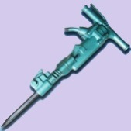  Powered hand tool | Mechanical Excavation | 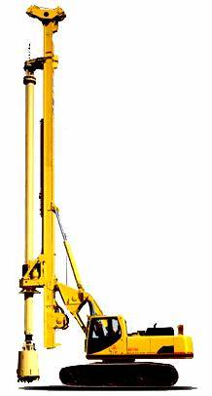  Piling
High Voltage (132Kv)  Electric Cables | 0.0m if supervised by SU or 3m without SU supervision | 0.0m if supervised by SU and safe digging techniques applied, or 3m without supervision | 5m | 5m | 10m
High Voltage (11 & 25Kv)  Electric Cables |  |  | 3m | 3m | 5m
High Pressure Gas > 7 bar |  |  | 3m | 3m | 15m
Intermediate Pressure Gas 2-7bar |  |  | 3m | 3m | 15m
High Pressure clean/waste water |  |  | 3m | 3m | 3m
Fuel pipelines |  |  | 10m | 10m | 30m
Medium pressure gas  75mb - 2bar | 0.0m | 0.0m if safe digging techniques applied | 1m | 1m | 15m
Low Pressure Gas 0–75mb |  |  | 1m | 1m | 15m
Low Voltage Electric Cables |  |  | 1m | 1m | 1m
Telecom cable |  |  | 1m | 1m | 10m
Low pressure water |  |  | 1m | 1m | 1m

Appendix 2: Definitions
Phrase | Description
Client | HE who commission the design, construction, installation and maintenance of works on the Highway
Design | A plan or proposal for the construction of a structure or system. It includes drawings, design details and specifications and bills of quantities
Designer | A person who prepares or modifies designs for example, people planning the routes of cables are designers and are responsible for applying the 'hierarchy of risk control' prior to designing or specifying the works
Authorised/ Nominated person | A competent person trained, appointed and responsible for managing and implementing all the requirements of this guidance including but not limited to the issuing and management of the ‘Authority to commence’ system on site. Specific job titles will vary dependent on who employs them
Team Leader | The competent person trained in underground services and responsible for the implementation of the requirements of the ‘Authority to Commence’. This person must present during the works either carrying out or supervising the work. Specific job titles will vary dependent on who employs them
Risk assessment | A process of hazard identification, assessment of risk and determination of controls.
Competent | A person with sufficient skills, training and experience necessary to be able to execute the works safely
Underground services | All outdoor pipes, cables and equipment associated with electricity, gas, water (including sewerage), other fluid transporting pipelines and telecommunication services that may be in the ground, fixed to walls and/or lying on the surface
Overhead services | Services that are supported or suspended from metal towers / pylons or wooden poles that are often referred to as transmission or distribution lines. The services can be uninsulated or insulated and carry electricity and telecommunications.
Structures | Built engineering associated with underground or overhead services e.g. pylon bases and sewer access shafts
Practicable | Weighing a risk against the trouble, time and money needed to control it to the extent that if the controls are possible to do and the costs aren't disproportionate to the risk, the controls should be provided/implemented
Reasonably practicable | Weighing a risk against the trouble, time, and money needed to control it to the extent that the costs don't outweigh the risks
Safe system of work (SSoW) | A clear and concise mechanism that translates requirements – including those identified in the task (or other) risk assessment – into an easy to understand set of hazards, controls and emergency arrangements for the supervisor/operative to be briefed into and follow. The SSoW leads to a prescribed method of work that implements the control measures and minimises the risk of harm to people and property.
Authority to commence | Formalised approval by authorised person for work to commence. Authorisation is given following a satisfactory assessment of the intended safe system of work. Authorisation can be included as part of a defined work flow or managed via permitting.
Permit to Dig | A formal sector level management system used to control the risks associated with digging. This enables an assessment of the risks to be made and to specify detailed control measures which will be put in place in order to minimise the risk as low as is reasonably practicable
Appendix 3: Responsibility Definitions
Role category | example roles | Responsible and accountable for: | Accountable to
Highways England Board and Executive Committee | HE Board, CEO | - Providing HSEQ leadership in setting policy, business objectives and strategy aligned to, and informed by, HSEQ performance  - HSEQ performance across HE  - Reviewing significant HSEQ incidents, the outcomes of investigations into their causes and the lessons
HE operational staff | ???? | - ???
Supply Chain Business Leader | Managing Director, Business Unit Director, | - Implementing HSEQ strategy and objectives across their companies  - Ensuring adequate resources are provided to deliver HE strategy and objectives.  - Strategic decision maker to adopt work practices other than in accordance with HE common intent | HE Board & CEO
Operational Directors/ Managers | Account Director, Account Manager, Operations Manager, Depot Manager, Site Manager, Quality Manager | - Ensuring those under their management adhere to HE policies, processes, procedures as defined in the management system(s)  - Ensuring adequate resources are provided to deliver HE strategy and objectives. | Operational or Functional Business Leader or Account Director/Manager
Nominated Person | Manager, Works Supervisor, Team Leader, Gang Supervisor | - Obtain all the necessary drawings/specification/information from the designer/specifier of the works relating to the residual risks that exist for the works being undertaken.  - Undertake a ‘risk assessment’ of the works to be undertaken.
Designer/ Specifier | Designer | - Obtain asset data and information from service owners  - Design out risks as far as is reasonably practicable working with asset owners to understand hazards, measures and mitigation  - Verify data provided using techniques such as 'ground penetrating radar' for planned scheme works;  - Apply the 'hierarchy of risk control' to all designs;  - Provide the Nominated person with the information relating to the residual risk | Operational or Functional Business Leader or Account Director/Manager as appropriate
Supervisor | Works Supervisor, Team Leader, Gang Supervisor | - Supervising staff and operatives as they perform day-to-day tasks based on managers' expectations. | Manager
CAT and Genny user | Works Supervisor,  Gang Supervisor, Operative | - Understand the drawing s from the Utility Asset Owner  - Before using the CAT and Genny check it has been serviced and calibrated within 12 months and calibration certificates are available on site; | Manager, Works Supervisor, Team Leader, Gangers Supervisor,
Operative | Any role carrying out an activity | - Carrying out the tasks as assigned by the supervisor  - Following safe Systems  - Challenging not right  - Complying with hold and review points  - Accepting their personal | Supervisor
Utility companies providing 3rd party support and services to HW |  | - Provide accurate asset data  - Provide information on support and protection  - Cost diversions in a timely manner  - Complete diversions as planned and to schedule

Appendix 4: Service Colour Coding
There are recognised colours for utility services. Whilst useful on modern plastic piping these can be wholly relied on as metallic gas and water pipes are often black or metallic grey.
Utility | Duct  (Typically) | Pipe  (Typically) | Cable  (Typically) | Marker / Warning tape (if used)
Gas – low and medium pressure |  | Cast Iron or Yellow |  | Yellow with black legend
Gas – intermediate and high pressure |  | Yellow
Water |  | Blue, in MDPE/MOPVC or blue-coated ductile iron  Can be black in blue sheathing |  | Blue or blue/black
Water pipes for special purposes (contaminated ground) |  | Blue with brown stripes, in polyethylene or blue-coated ductile iron
Sewerage |  | No distinguishing colour/material (eg: ductile Iron may be red; PVC may be brown | N/A
'Grey' water |  | Black with green stripes
Communications | Grey, white, green, black, purple | N/A | Black or light grey | Various
Electricity | Black or red duct or tile |  | Black (red for some high-voltage, orange for some traffic signal power cables) | Yellow with black legend
Government pipelines (MOD)
Private oil and chemical pipelines
Appendix 5: Responsibility Process Map
 | Action |  |  | Client | Designer / Principal Designer | Contractor | References
 |  | Clearly scope works |  |  |  |  | BPAUS 04 – Client,  Principal Designer,  Designer and Contractor  Opportunities,  Responsibilities and Checklists  http://www.hse.gov.uk/ pUbns/priced/l153.pdf  BPAUS 04 – Client,  Principal Designer,  Designer and Contractor  Opportunities,  Responsibilities and Checklists  http://www.hse.gov.uk/  construction/cdm/2015/ designers.htm  BPAUS 05 –Training Framework for  Principal Designers and Designers.
Ensure clarity of known areas of service interaction
Define requirement for management of work
near underground services
Define communication channels inc Principal
Designers, Designers and supply chain
Ensure clear understanding of communication
internally and with
Clients, Principal
Designer, Designer,
Planners and
Contractors
Define change management process
Understand
responsibilities for coordination and
management of
underground services information.
Follow change management process
Location of services included in scope and
price
Tender submissions include management of underground services
Encourage supply chain to sign up to
USAG charter
Principal Designer and
Designers demonstrably competent in
underground services aspects.

If you need help accessing this or any other Highways England information, please call 0300 123 5000 and we will help you.

© Crown copyright 2017.
You may re-use this information (not including logos) free of charge in any format or medium,
under the terms of the Open Government Licence. To view this licence,
visit http://www.nationalarchives.gov.uk/doc/open-government-licence/
or write to the Information Policy Team, The National Archives, Kew, London TW9 4DU,
or email: psi@nationalarchives.gsi.gov.uk.

This document is also available on our website at www.highways.gov.uk

If you have any enquiries about this publication email
ha_info@highways.gsi.gov.uk or call 0300 123 5000*
Please quote Highways England publications code PR119/13
Highways England media services Bedford S160684

* Calls to 03 numbers cost no more than a national rate call to a 01 or 02 number and must count towards any
inclusive minutes in the same way as 01 and 02 calls. These rules apply to calls from any type of line including
mobile, BT, other fixed line or payphone. Calls may be recorded or monitored.

