Highways England
Principal Designer Working Group
Meeting No.16

Thursday, 30th April 10.00 am – 12.45 pm
(Teams Call)

 | Minutes
Attendees
Name | Initials | Position | Organisation
Richard Wilson (Chair) | RW | H&S Director (Major Projects) | Highways England
Ian Scott | IS | NIP Health & Safety Lead | Highways England
Doug Potter (Secretary) | DP | Principal Designer Manager | Arcadis
Mark Lamport | ML | Technical Director / Principal Designer Manager | Arcadis
Pav Singh | PSi | Associate. Technical Director / Principal Designer Manager | Arcadis
Tim Bowes | TB | Principal Designer Manager | Atkins
Ed French | EF | Principal Designer Manager | Arcadis
Paul Brown | PB | Technical Manager | WSP Group
Nicola Knowles | NK | Principal Designer Manager | Arcadis
Andrew Finch | AF | Director of Operations | Jacobs
Roger Swainston | RS | PD / CDM Advisor | Jacobs
Robert Legg | RL | Highways Safety Coordinator | Motts
Simon Wilkinson | SWi | Technical Director | AECOM
Tim Goddard | TG | Principal Designer Manager | Arcadis
Toria Thomas | TT | Principal Designer | Arup
Paul Claydon | PC | H&S Manager | WSP Group
Dave Owen | DO | Regional Director | Galliford Try
Sulagna Ghosh | SG | Ass. H&S Rep Leeds | WSP Group
Phil Samms | PS | Engineering Manager (Area 3) | Kier
Jim Tod | JT | TW Director | Tony Gee
Robert Butcher | RB | Technical Director CDM | Jacobs
Jim Gallagher | JG | Principal Structures Advisor | Highways England
Mike Boyland | MB | Project Manager | Highways England
Dave Olorenshaw | DO | Area Manager | Keir
Elizabeth Bennett | EB | Director | Safety in Design
Samuel Hogan | SH | Principal Engineering Manager | Balfour Beatty
Jon Horrill | JH | Principal Designer / H & S | WSP Group
Jerry Cutter | JC | Lowe Thames Crossing | COWI
Jon Webster | JW | H&S Lead | Kier
Thomas Merry | TM | H&S Lead | Highways England
Kevin Morgan | KM | PD / CDM Advisor | Jacobs
Martin Partington | MP | Principal Engineering Manager | Jacobs
Mark Riordan | MoR | Principal Engineering Manager | Amey
Sean Connon | SC | Principal Designer Manager | Costain
Nina Warminger | NW | H&S Manager SWAD | Highways England
Paul Wilkins | PW | Associate Technical Director (Structures) | Arcadis
Mike Wilson | MW | Chief Highway Engineer | Highways England
Lesley Waud (part) | LW | Technical Director | Atkins
Apologies:
Dave Avery | DA | H&S Manager | Arcadis
Malcolm Shaw | MS | Principal Designer SMP M1 23-25a | Arup
Paul Boddy | PB | Director | Interserve
Clare Brown | CB | H&S Advisor | Bam Nuttall
Katie Swanick | KS | Contracts Manager | Motts
Chris Gee | CG | Head of Utility Diversions | Highways England
Aimee Blay | AB | Design Manager | Galliford Try
Clare Brown | CB | Safety Lead | Link Connex (Bam Nuttall)

1.0 | (10.00 – 10.15) Welcome and Safety / Wellbeing Moment (Richard Wilson)  - RW - Safety Moment – Covid-19 - ensuring Wellbeing for us all during the pandemic.  - Listening to people, respecting people’s differences  - Productivity has improved - more planning is taking place  - As lockdown eases (when it eases) - we need to capture what has worked well and not rush back into old habits we used to have or was expected of us.  - Achieve wellbeing and health and maintain it in the future.  - Note presentations are provided within the minutes below (slide quality is variable) so also attached if size permits to the circulation email and will also be uploaded to the Hub website http://www.highwayssafetyhub.com/principal-designers-working-group.html  - A video of the final session (35 mins approx.) will also be made available on the Hub  - An Online Comments Register is attached to the minutes – please note there are a number of actions for members of the group within. Could actionee’s provide feedback to DP so we can collate responses. | Actions  All  DP
2.0 | (10.15 – 10.45) Eliminating Risk from the Outset (Mike Wilson)  2.1 Designing Beautiful Roads - Eliminating Risk from the Outset  Importance of good design from a number of perspectives - user/community/place and also from a HS  and wellbeing perspective. This is sometimes overlooked in design.  2.1.1 Great design will deliver great outcomes for those building and ultimately using the assets.  2.1.2 Strategic Design Panel role:  - What does good design look like - the strategic design panel brings together many organisations as part of the panel - including National Trust, English Heritage etc.  - The 10 Principles have been developed by the panel. The application of these principles are mandated for all Highways England Projects - and included in GG103.  - GG103 details how these principles shall be implemented.  - The principles are not prescriptive - so designer is required to think about the projects - landscape, communities etc.  - See also Good_road_design_Jan_18.  - Road clutter can be an example of bad design - too many signs - cluttered instructions. Good designs is just as important in the temporary situation as in the permanent situation.  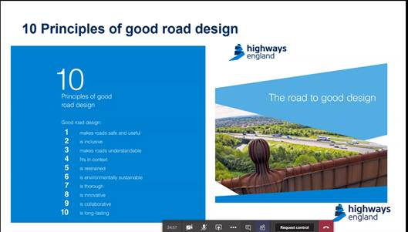  2.1.3 The panel have instigated a design review process.  - They offer a free of charge design review service.  - The earlier this is brought into the project - the greater the impact achievable. Good design should enable good community support - journey time reliability, good maintenance / operation.  2.1.4 We as designers need to really challenge how we are eliminating risk and not relying on the contractors to manage risk. Put simply if the risk no longer exists - people can't be exposed to it!  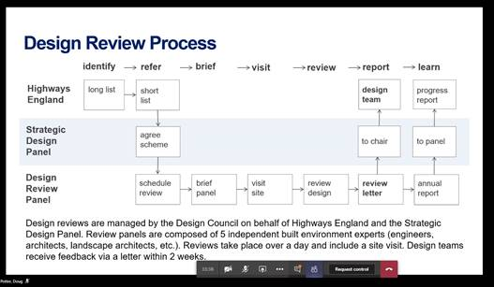  2.2 Task and Finish Group Outputs – Toria Thomas – (Arup)  2.2.1 Slide pack included below  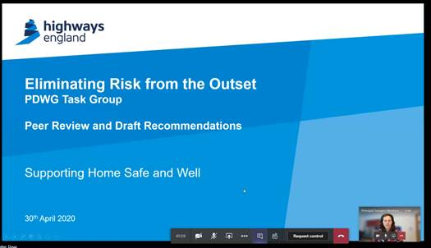  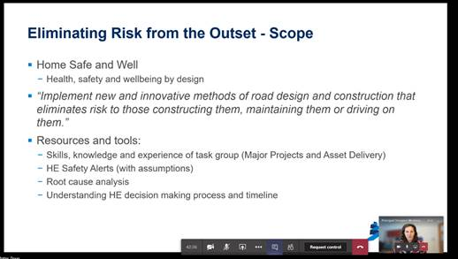  2.2.2 Eliminating Risk from the Outset - Task and Finish Group - set up to achieve the scope above.  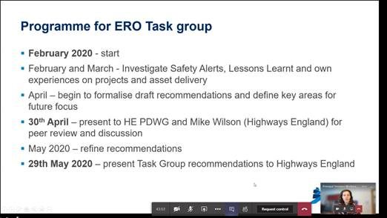  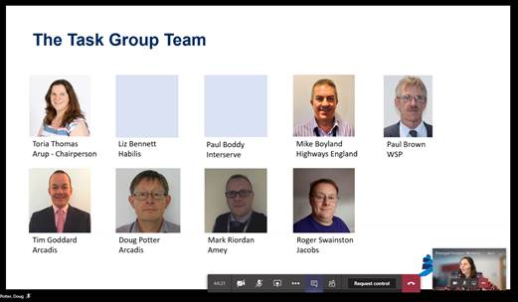  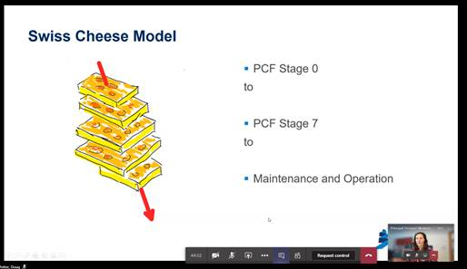  - The following categories are the key areas that were identified as points during a project where things can go wrong.  - Operation and Maintenance  - Technical Approval  - Red Line Boundaries  - Lighting  - Stage 0/Stage 1 decisions  - Standards & Specifications  - Design Phase Plan  - Road Worker Safety  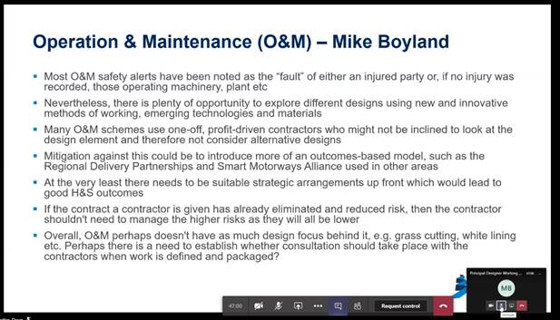  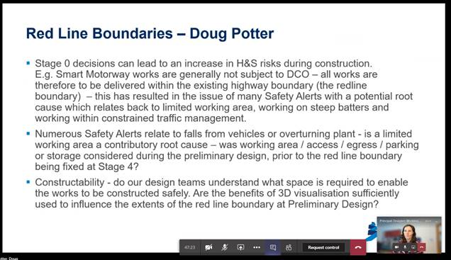  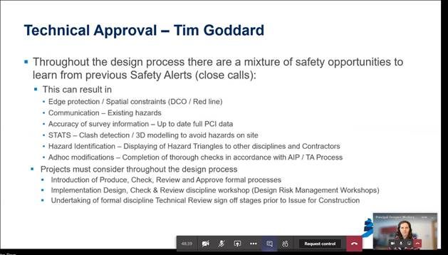  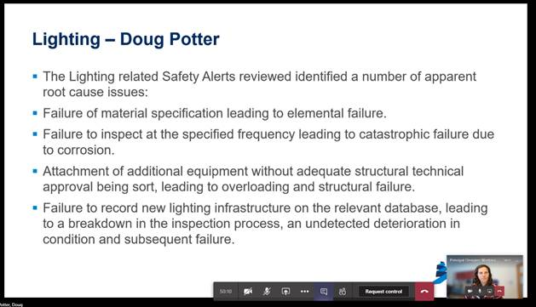  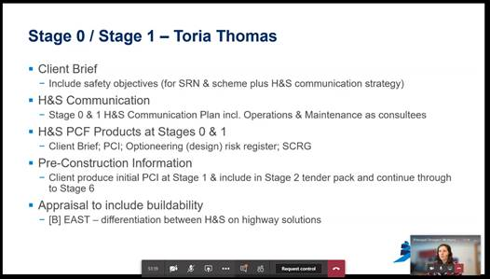  - The initial Client brief is very important  - PCI needs to be a product at an every stage – and then pick up new information gathered throughout the project  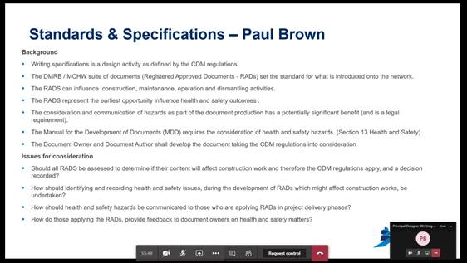  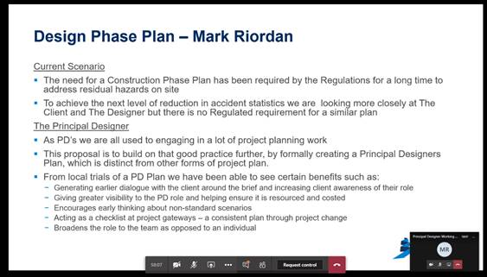  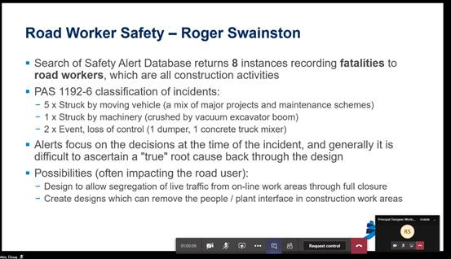  - High level summary -  - Root cause analysis needed as a follow up to Safety Alerts for better understanding of why things happened on site and to prevent them happening again in the future.  - Client is PD unless appointed - key at the earlier stages as duties still apply.  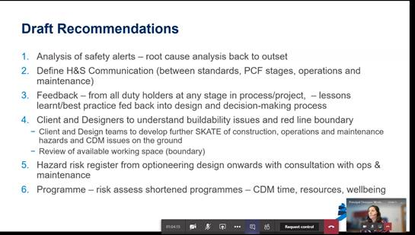  - MW - too many people are still being hurt building and maintaining the SRN.  - What can we do now that individual organisations can take on without internal/commercial arrangements getting in the way;  - What things can be implemented now by organisations who are committed to improving health and safety in the same way HE are;  - We need better decision-making records to trace back to the reasons why the design has taken the route it has throughout the project; and  - We can achieve a lot in our design community by doing this better. If design standards need changing because we keep making the same mistakes due to the standards themselves, then changes can be made.  - RW - Designers need to be involved in the investigation of safety alerts to get better safety alert information to the design community.
3.0 | (10.45 – 11.15) SCSLG Update - (Lesley Ward)  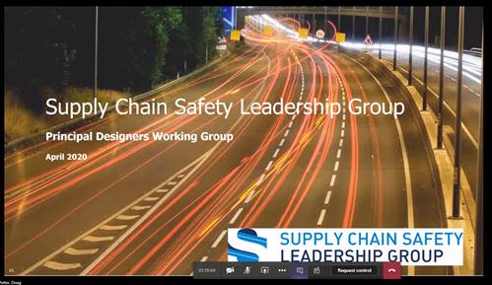  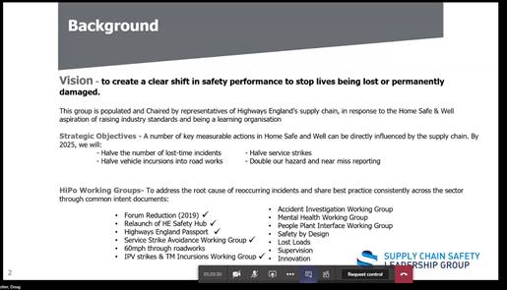  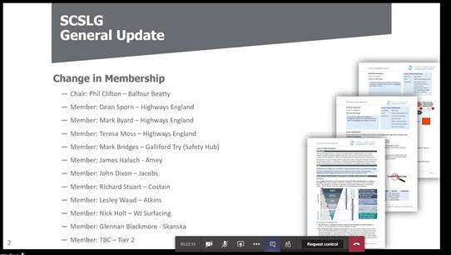  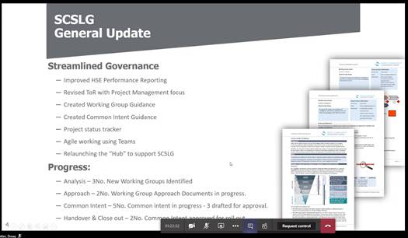  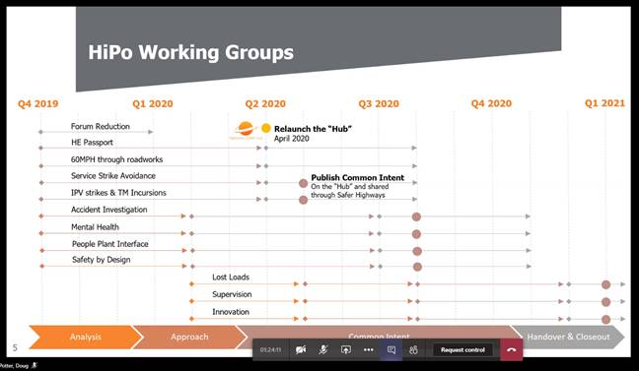  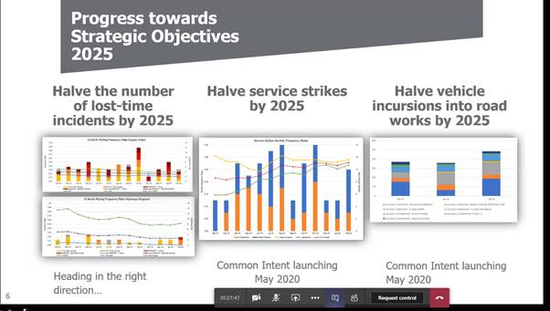  - Service strikes continue to be a major issue!  - The working groups are reinforcing the hierarchy of risk control.  - Avoidance/diversion and then isolation should be considered – LW felt the industry required more of a network rail approach.  - Not enough challenge is made to our projects, clients and each other.  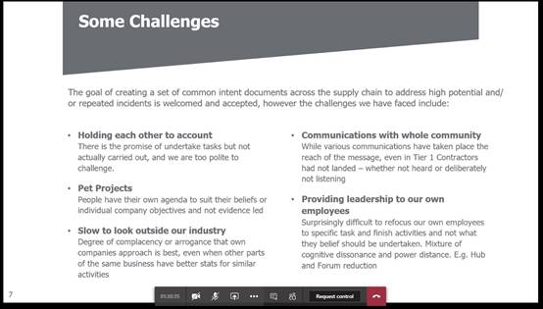  - We don’t look outside our own industry enough and don't adopt the best practices used by other industries, where applicable and which we could benefit from.  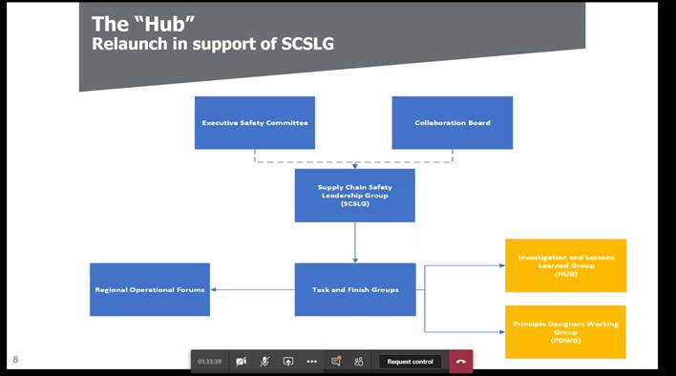  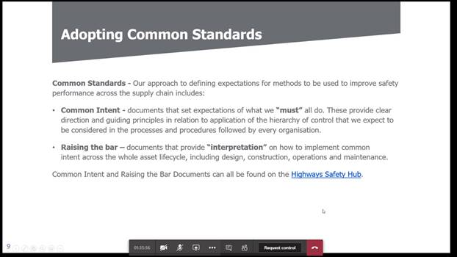  - Common intent documents will be placed on the Highways Safety hub website.  - Mark Bridges is now the link between SCSLG and the hub.  - RW asked if a communication and output strategy was in place. LW to provide.  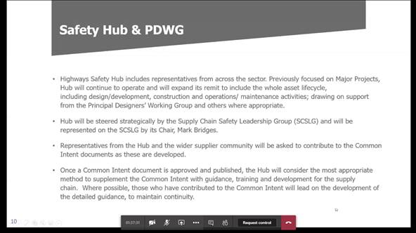 | LW
4.0 | (11.15 – 11.35) New HE CDM Delivery Processes (Ian Scott)  - Progress / Launch update  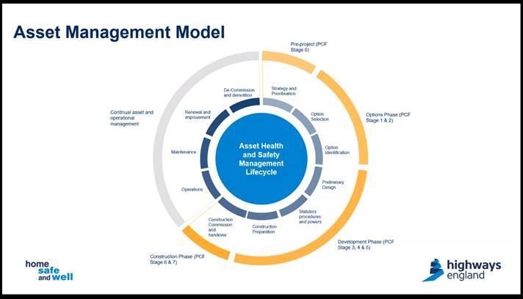  - IS indicated that the new CDM delivery processes needed to align with PCF process to ensure understanding by HE PM's and consistent delivery throughout the project.  - The new procedures will provide a step by step approach identifying when things need to be implemented, by who and has templates for each element.  - The plan was to develop a one size fits all - for all stages.  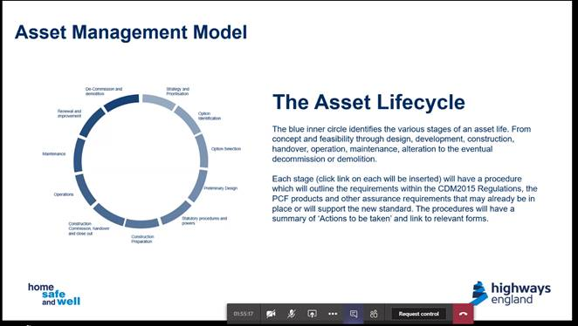  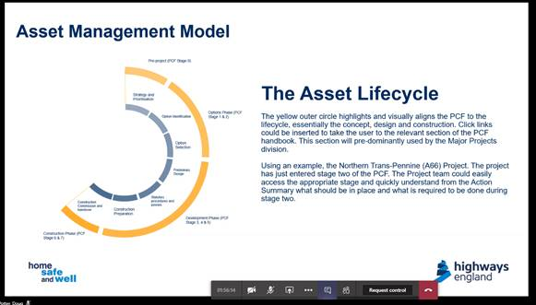  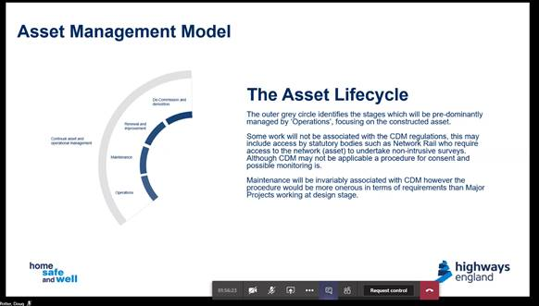  - Each blue box on the wheel has a procedure attached to it.  - The orange/yellow section represents the design and construction phase  - The grey section represents the O&M phase  - Each stage has an introduction page and an actions information sheet with links to all the related sources.  - 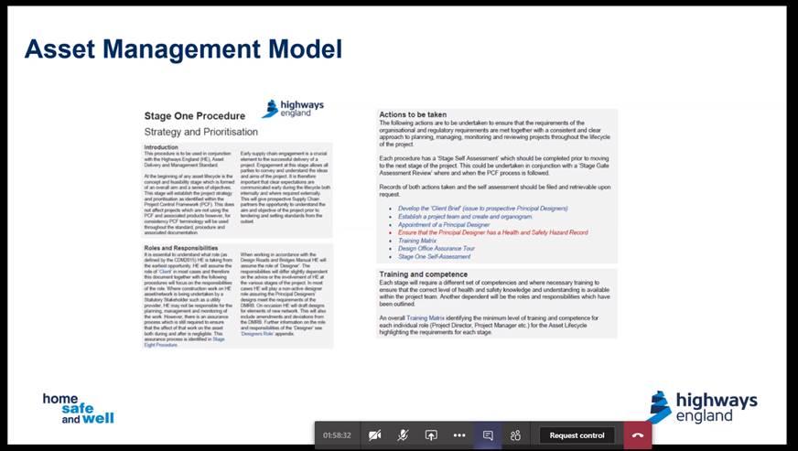  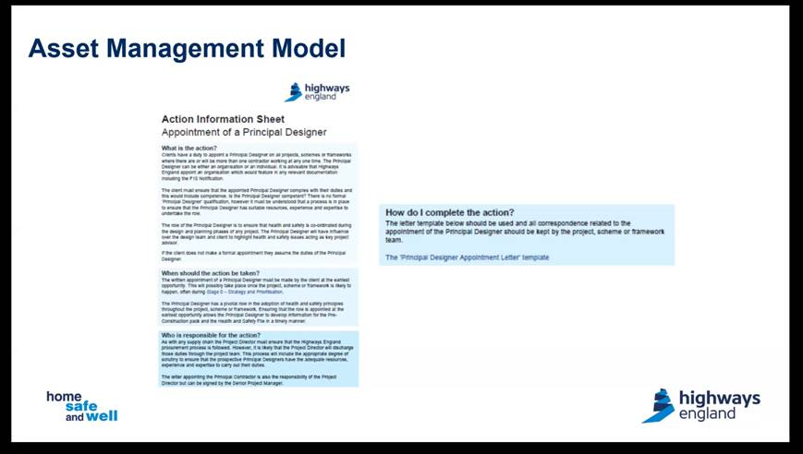  - Operations Directorate have introduced the 3D model and the alignment of the 2 systems is set out below.  - The model is currently being made interactive by software developer Jimcom.  - The Launch date is expected to be in July / August.  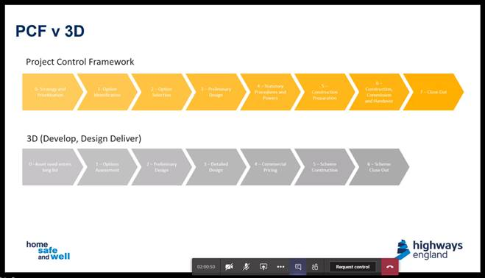  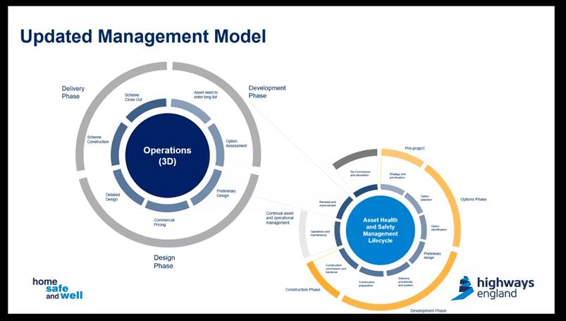  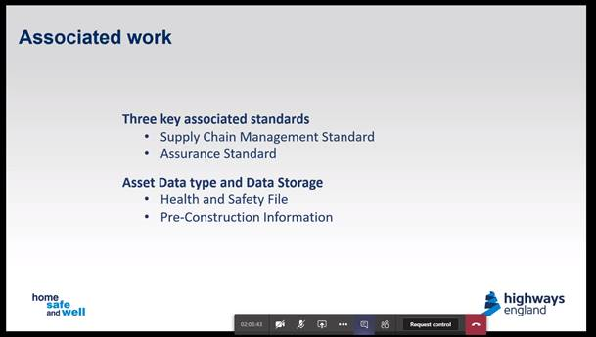  - IS will welcome any ongoing review and development suggestions following launch.  - PCF products will require updating to link with the new CDM standards.  - A new HSF template forms part of the new procedure – the retention of the HSF, where it is stored and how it is recorded does not form part of the current work but will be addressed later.  - It is recognised that the management processes for the HSF should be captured within the ADMM guidance.  - IAN 105 will subsequently be withdrawn and an update developed as part of the DRMB upgrade through Dave Townsend.  - IS confirmed that the Residual Risk Capture work Phil Whitley was progressing for OD would be brought into this initiative.  - Hazard reviews and design reviews are included in the management process above. Ian can share with the group.  - PB asked whether it would be possible to review the procedures prior to issue. IS indicated that the documents had already been reviewed but was happy to share with individuals by request.  - IS indicated that the target audience of this model was the HE management and workforce, but he recognised that it required full alignment by the Supply Chain.  - Principal Designer (Additional Duties) – (Richard Wilson)  - RW confirmed that the PDM Additional Duties letter was no longer being issued by Highways England - if anyone receives the letter please let Richard Wilson know. | IS  IS  All
6.0 | (11.45 - 12.20) PDWG Task and Finish Group Feedback  - Whole Life Design T&F Group - Andrew Finch (Jacobs)  - AF indicated outputs from the Group are now available on the Hub website here - http://www.highwayssafetyhub.com/whole-life-safety.html  - Some examples include:  - Utility Strikes - http://www.highwayssafetyhub.com/uploads/5/1/2/9/51294565/0100.002_preliminaries_-_statutory_undertakers_-_utility_strikes_v.1.pdf  - Earthworks on Slopes  - Red Line Boundary - Working on Slopes  - Revetment Paving - http://www.highwayssafetyhub.com/uploads/5/1/2/9/51294565/1100.002_kerb_and_footways_-_revetment_paving_v.1.pdf  - Access for inspection and Testing - http://www.highwayssafetyhub.com/uploads/5/1/2/9/51294565/1500.002_technology_-_access_for_inspection_and_testing_v.1.pdf  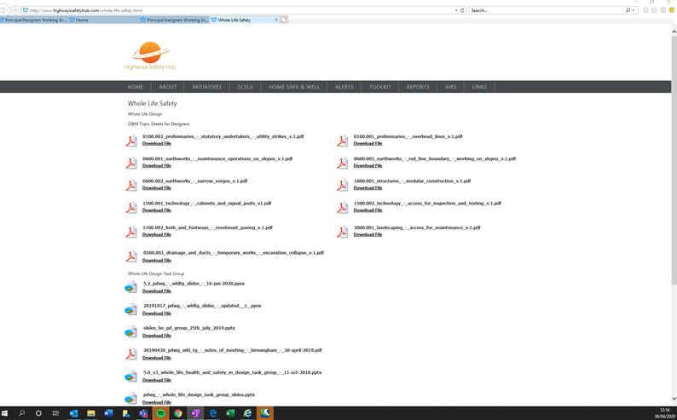  Whole Life Safety  http://www.highwayssafetyhub.com/whole-life-safety.html  - Accident Investigation – Root Cause – Tim Goddard (Arcadis)  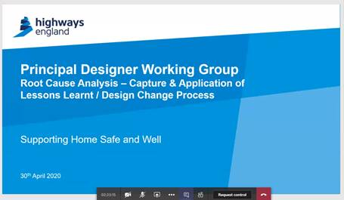  Safety alerts shared on hub website here - http://www.highwayssafetyhub.com/alerts---highways-england.html  - Recent safety alerts that have been received and reviewed  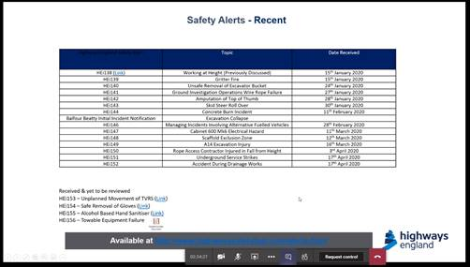  - Results/Findings on 146 alerts received so far:  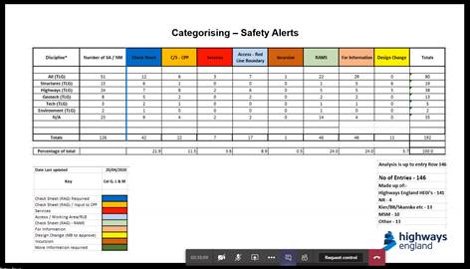  - RB - Root Cause is often mis-used. A description of the various cause investigations can be:  - Immediate cause: the most obvious reason why an adverse event happens, e.g. the guard is missing; the employee slips etc. There may be several immediate causes identified in any one adverse event.  - Underlying cause: the less obvious ‘system’ or ’organisational’ reason for an adverse event happening, e.g. pre-start-up machinery checks are not carried out by supervisors; the hazard has not been adequately considered via a suitable and sufficient risk assessment; production pressures are too great etc.  - Root cause: an initiating event or failing from which all other causes or failings spring. Root causes are generally management, planning or organisational failings. The root cause seems to rarely get back to the organisation  - PS -  - RSA's need to have a feedback loop back into design  - Also, (Common) Departures need to be applied on a consistent basis – it would be good if their application could be shared to make the process more efficient and speed up design delivery. Could these be shared in some form of lessons learned table – potential this could be held by PDWG on the Hub website?  - Constructability– Jim Tod (TwF - Tony Gee)  - JT is leading a Constructability Working Group on behalf of the Temporary Works Forum. The objective is to share best Constructability practice  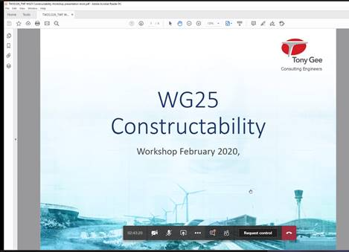  - Only 3 members are client organisations currently.  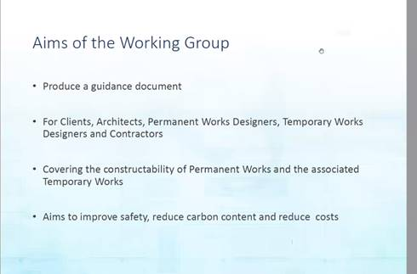  - Participants in the TWF Constructability Working Group.  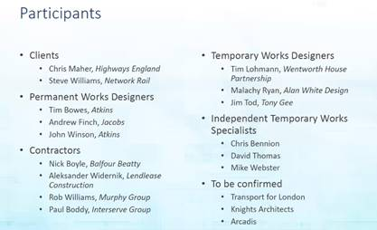  - Timetable for production of the document:  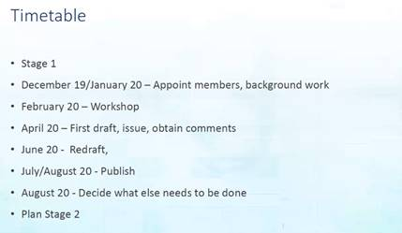  - The purpose of the Working Group is to issue something out into the community as a first draft to gain interest and 2nd draft to identify next steps.  - JT asked if the group felt that design could be scored for Constructability?  - Case studies are needed to review and trigger thoughts on what other designers have done and how these may be applied to their current project.  - Current draft looks at what constructability is, looks at ways of offsite procurement/fabrication, lean, procurement strategies and when they can be applied.  - Different stages allow different approaches for constructability - see the image below.  - Includes the influence possible at the start of a project and the associated costs.  - Some research (albeit very old) says that 40% of accidents happen as a result of design decisions. This is old data and needs new feedback and new research to be carried out.  - Becoming a member of the TWF allows members to discuss and influence the future of documents and guidance. TWF has a budget for research into Temporary Works.  - TWf has sister branches in the Middle East and New Zealand as well as America. TG fells TWf are becoming an influential body.  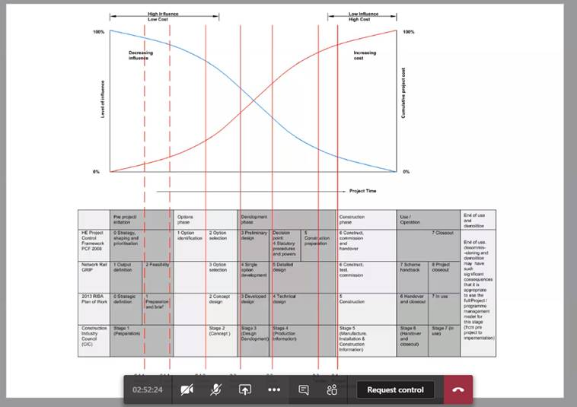  - RTB 26 Development T&F Group – Paul Brown (WSP)  Tom Merry was unavailable on the call, RW indicated he is working with Sean Pidcock and can hopefully share updates on this piece of work at the next PDWG mtg. | RW  RW  TM
7.0 | (12.20 – 12.30) Improving Stats Management Update  - (Mark Lamport – Arcadis) on behalf of Chris Gee  - Apologies from Chris Gee  - ML explained that stats companies don't really like diversions - new to old joints don't always work well  - Stats companies challenged back to ask HE what they are doing not to damage their assets  - Engagement strategy is a key development with stats/utility companies at a senior level.  - More updates at next PDWG in July 2020.  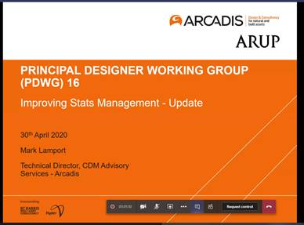  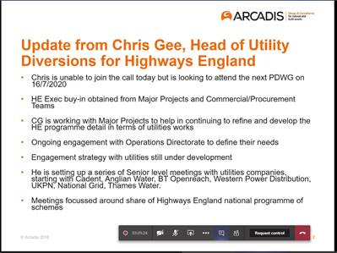 | ML/CG
8.0 | (12.30 – 12.40) 2020 Deliverables  - Update on 2020 Deliverables (Richard Wilson)  - HE are looking to set targets for deliverables  - Great to have Mike Wilson involved in the Task and Finish Groups  - Amy Williams to be invited next time to share the work she is doing in this area.  - PS - communication problem – limited or no feedback from the senior groups – PS felt there was a need to improve communication around the existing material available – RW indicated Amy Williams and Victoria Moss are working with this and the digital communication from other groups.  - RW would like to see these meetings held via webinar/teams more frequently say every 2 months and then the third meeting face to face perhaps.  - HSW - Goals and new KPI's are being tabled at the next HSE meeting which will be shared at the next Working Group. | RW  RW  DP  RW
9.0 | (12.40 – 12.45) AOB  - RW - Safety passport and Common Induction have been agreed by Jim O’Sullivan and are now being taken forward. The Common Induction needs a contributor from this group to help update the details. Volunteers required.  - David Olorenshaw, Jon Horrill, Liz Bennett and Nicola Knowles volunteered to contribute. | RW/DO/LB/NK/JH
10.0 | Next Meeting – 9th July 2020 – Teams Meeting

