Automated Saw Cutting of Concrete Slipform Barrier (CSB)
In an era where 99% of deaths caused by work can be attributed to ill-health and only 1% to poor safety measures* the significance of utilising engineering controls to reduce exposure to occupational health hazards has never been so vital. Extrudakerb have been challenging their traditional work methods on Costain’s M1 Smart Motorway Contract J28-31 in recent months.
As part of the Britpave design for concrete slipform barrier, crack inducement cuts are required to be inserted every 3m to induce cracking of the concrete at approximately 40mm depth. Using the traditional method these cuts are carried out manually using petrol cut-off saws, which leaves the operator susceptible to increased risk from manual handling, noise, vibration and silica dust. Extrudakerb pursued the latest innovation from Germany to challenge this previously accepted norm, sourcing an automated saw cutting device.
The automated saw is operated remotely enabling the operator to stand away from the saw creating an exclusion zone which is delineated using markers therefore ensuring no person enters within 900mm of the saw, additional benefits include:
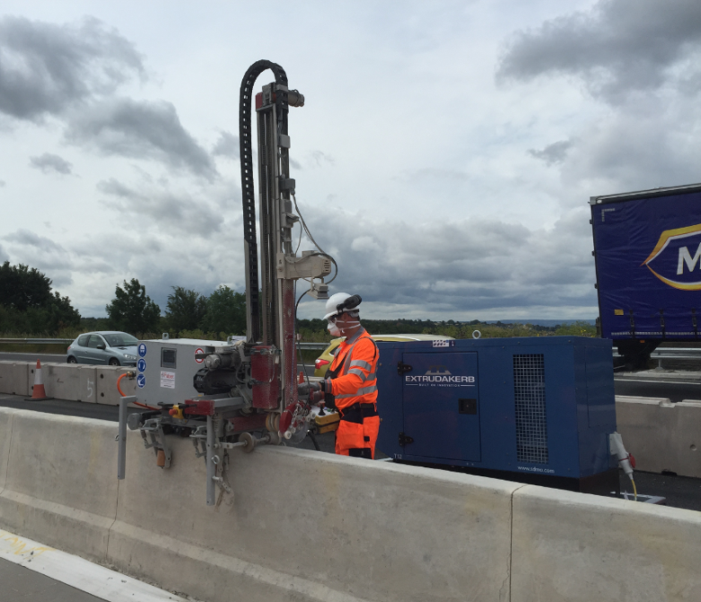
- Less noise exposure
- Less dust exposure
- No HAVS
- No Manual Handling
- Improved quality (straight cut & consistent depth)

Personal noise and dust monitoring has recently been undertaken to establish baseline data for personal exposure, comparing the traditional method to the automated method. The HSE have welcomed this innovative engineering solution commenting that ‘’…the automated saw cutting method that has been developed looks very promising’’

Extrudakerb’s next step is to explore alternatives to the manual method of cutting and widening of surface water channels, whilst continuing to roll out the utilisation of the automated saw across the UK.
For more information contact;
Danny.Wake@extrudakerb.co.uk

