GOOD PRACTICE FOR ROAD WORKS SITE TRAFFIC SAFETY SIGNING
Managing site traffic within road works is an important part of ensuring the safe and efficient operation of the site. Site traffic (including the movement of road workers on site) must be managed in a way that is lawful, effective in reducing health and safety risk and provides a clear and understandable message to road workers and site vehicle drivers.
Health and safety regulations define how the legal obligation to manage risk from site traffic within road works sites must be addressed. Risk assessment must be used to determine if there is risk and so whether safety signs must be used to warn of this risk. The regulations also define the signs that must be used to warn of risks from traffic, but where a risk remains after a defined sign is used other device(s) may be used to reduce risk.
This Good Practice document sets out a process that allows designers to comply with the regulations and should be followed when designing road works site traffic safety signing. The process, which is shown in the flowchart on page 3 of this document, starts with a risk assessment followed by application of the design principles given in the safety signing regulations. For ease of reference, the design principles in the safety signing and traffic signing regulations have been condensed into four basic rules which are summarised on page 2.
This document also gives examples of applying the four rules to common site traffic risks, together with the typical residual risks in these situations and devices that are recommended for use to reduce these risks in a consistent and effective way. Following these examples will improve consistency and understanding of signing at road work sites and so improve safety
When designing site traffic safety signing using innovative techniques or good practice (such as that shown in the H&S Toolkit), the principles in this document must always be followed to ensure site signing is legal.
Key Features
- Ensures road works site traffic signs are legal and consistent

- Helps reduce site risk associated with vehicle traffic movements

- Provides a clear process to determine how and when to use site signing

- Allows simple rules to be used to define appropriate site traffic signing

- Enables use of non-prescribed devices to control site traffic residual risk

- Promotes consistency, clarity and cost-effectiveness

- Enables a quick and simple good practice method to improve safety

Technical Information

Requirements for selecting and positioning site traffic safety signing within road works can be summarised in four simple rules:
- If there is an appropriate TSRGD sign or device that can be used correctly as a safety sign to warn of a safety risk connected with the presence or movement of traffic and/or pedestrians within a work site, it must be used.

- Where there is no appropriate TSRGD sign to use as a safety sign warning of a risk connected with the presence or movement of traffic and/or pedestrians within a work site and it is necessary to warn of that risk, then a non-prescribed device can be used to warn of the risk.

- The use of an appropriate TSRGD sign in association with a non-prescribed device may be necessary if a risk connected with the presence or movement of traffic and/or pedestrians on a work site is not completely addressed solely by the use of the appropriate TSRGD sign, resulting in a residual uncontrolled risk.

- All safety signs (whether or not they are TSRGD prescribed signs) must not be put in a place where they could confuse road users or contradict a prescribed sign placed to convey a message to traffic on the part of carriageway that does not form part of the construction site.

Within these rules:
“appropriate TSRGD sign or device” means any sign prescribed in the Traffic Signs Regulations and General Directions or separately authorised by the Secretary of State that convey the required safety message when used within the site as prescribed/authorised.
“non-prescribed device” means any other sign or device. This includes cones that are not red/white, signs that are not a prescribed size or signs that have wording that is not prescribed or authorised.
In practice, the application of Rule 4 means that the safety signs or non-prescribed device(s):

  - must always be placed completely inside the work site

(“inside the work site” is defined as completely inside the line of safety barriers or red traffic cones [prescribed by Regulation 56 / Diagram 7101.1 of TSRGD 2002] that define the outer boundary of the work site)

  - should be kept separate from signs placed to convey messages to traffic on the carriageway

  - ideally should not be visible from the closest lane on the carriageway. (this will contradict the reason that they are being placed)

Examples of applying these four rules are given on the next page, along with the appropriate TSRGD sign needed to comply with the Safety Signs Regulations, potential residual risk and non-prescribed device that are recommended for used to address this residual risk:

Warning/instruction of risk arising from: | Appropriate TSRGD sign | Residual risk and non-prescribed device(s) used in addition to statutory warning sign to reduce residual risk
Overhead structures |  | The overhead hazard may not be visible, particularly at night  Mark the extent of the overhead hazard with blue cones with white sleeves
Overhead cables | 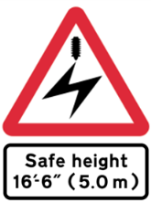 | The overhead cables may not be visible, particularly at night  Mark the extent of the risk zone for the cables using blue cones with yellow sleeves carrying an electrical hazard symbol and message(n.b. use in conjunction with HSE guidance GS6?) | 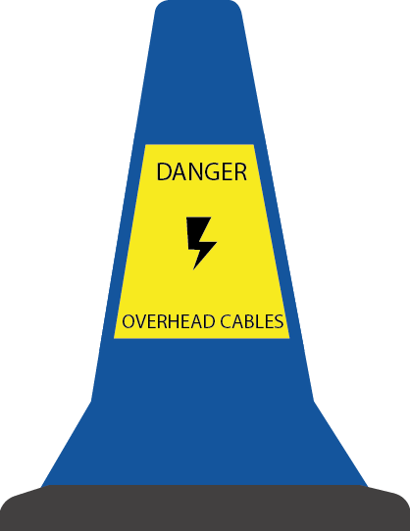
Works accesses |  | Signs face oncoming traffic; workers cannot see them and so will be unaware of the works access location.  Place green cones with white sleeves on either side of works access point completely inside the works, not as part of the site boundary cone line
Restriction on stopping in a deceleration zone within the works |  | Vehicles stopping in any part of a deceleration zone just inside the works access or on a haul route increase the risk of works vehicle collisions  Place yellow cones with white sleeves inside the works throughout the no-stopping zone as a reminder for drivers
Process flowchart for selecting site safety signs
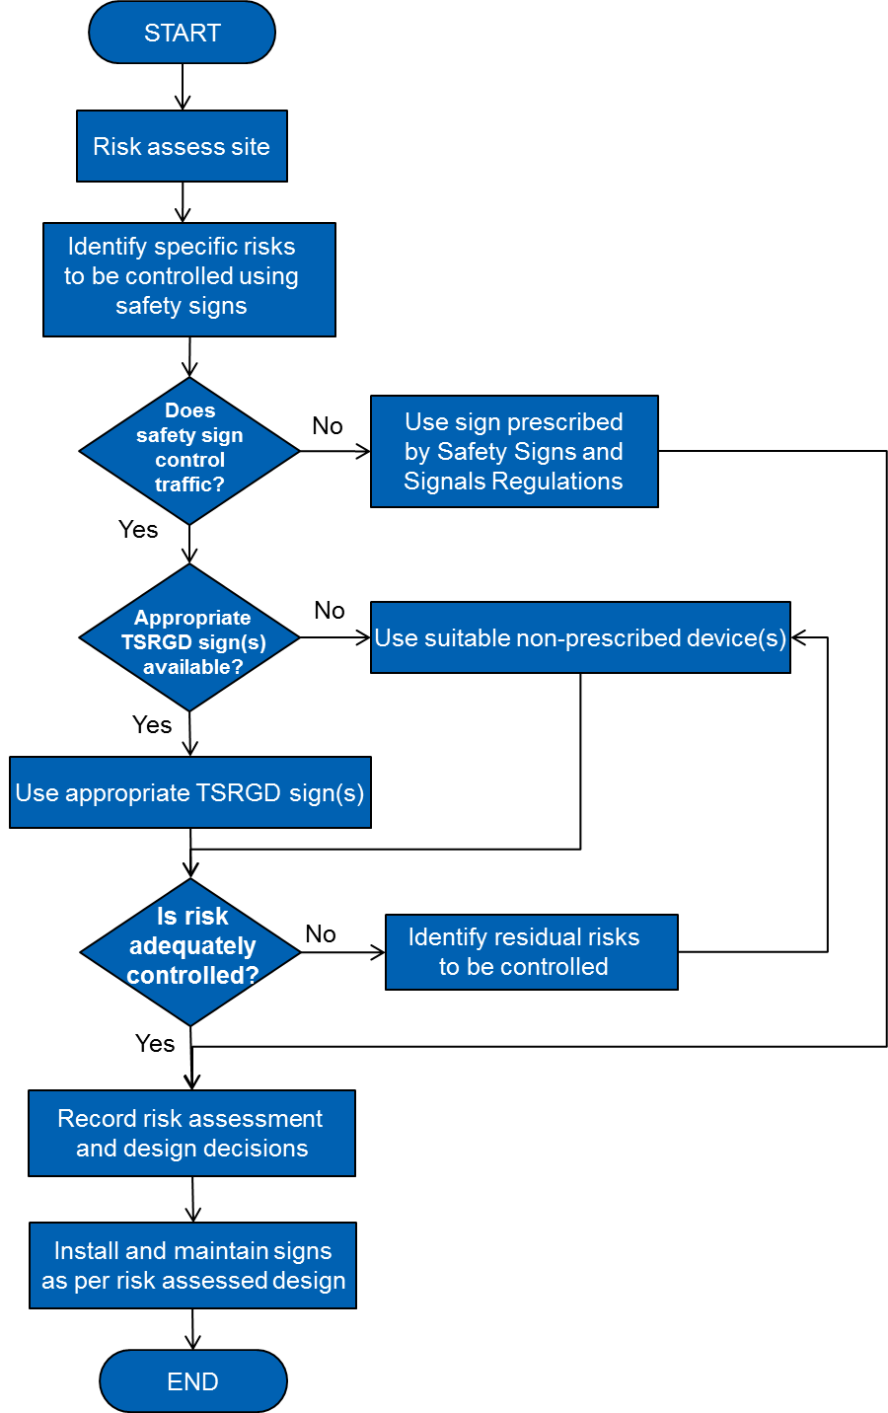

Legal Information
UK Law (in the Road Traffic Regulation Act 1984) says that traffic signs placed on a road to convey a message to traffic must be as prescribed in the Traffic Signs Regulations and General Directions 2002 (TSRGD 2002) or specifically authorised on behalf of the Secretary of State. Any sign or cone that is placed on a road but is not an authorised or prescribed sign is a non-prescribed device; placing a non-prescribed device on a road is unlawful obstruction of the highway and so against the law.
The public’s right to use a highway can be lawfully restricted or prohibited when a road is closed for construction, repair or maintenance. The lawful restriction or prohibition may be achieved by road works that are covered by a Traffic Regulation Order (TRO) made under s.14 of the 1984 Act or by road works that are carried out on behalf of the highway authority (to discharge the duty to maintain the highway under Section 41 of the Highways Act 1980) where the start of the length of road closed to traffic is marked using a prescribed traffic sign to Diagram 7105 in TSRGD 2002.
During road works, the area of highway that is closed off is a “construction site” for the purposes of health and safety legislation, including the Construction (Design and Management) Regulations 2007. These, and other health and safety regulations, require that traffic within the site should be organised in such a way as to ensure (as far as reasonably practicable) pedestrians and vehicles can move safely and without risks to health.
Additionally, health and safety law requires that people working within the site are given appropriate safety instructions so that the “general principles of prevention” can apply. The Health and Safety (Safety Signs and Signals) Regulations 1996 require that an employer, who having adopted all means and techniques for collective protection cannot avoid or adequately reduce risks to employees, must use safety signs to warn or instruct (or both) people working within the site of the nature of the risk and how they should behave to protect themselves against it.
Signs used for this purpose are referred to as “safety signs” and their use is covered by the 1996 Regulations. These regulations say that where a safety sign is needed because of the presence or movement of traffic on a site and there is an appropriate prescribed sign in TSRGD 2002 that could be used, then the prescribed sign must be used within the work site (Regulation 4(6)). Only if no prescribed traffic sign is appropriate can a non-prescribed alternative be used.
Although the law requires that traffic signs placed on a road to convey a message to traffic must be prescribed or authorised, within a work site where the road is in use as a work zone and the public’s “highway rights” have been suspended as described above, advice from the Department for Transport is that the use of signs within the works other than those that are authorised or prescribed by TSRGD 2002 (i.e. a ‘non-prescribed device’) is permitted, but only as long as the works remain in place and the Health and Safety (Safety Signs and Signals) Regulations 1996 are followed.

